[](http://www.noloconsulting.com/)

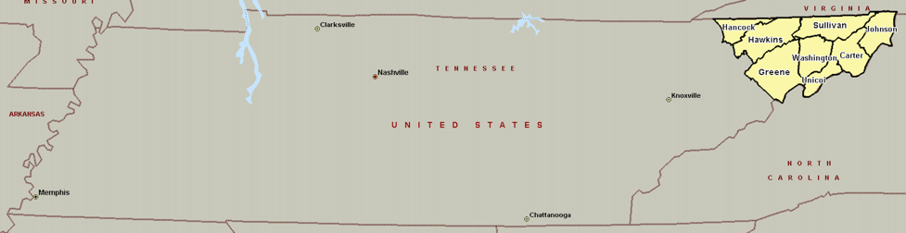

UETHDA Service Area

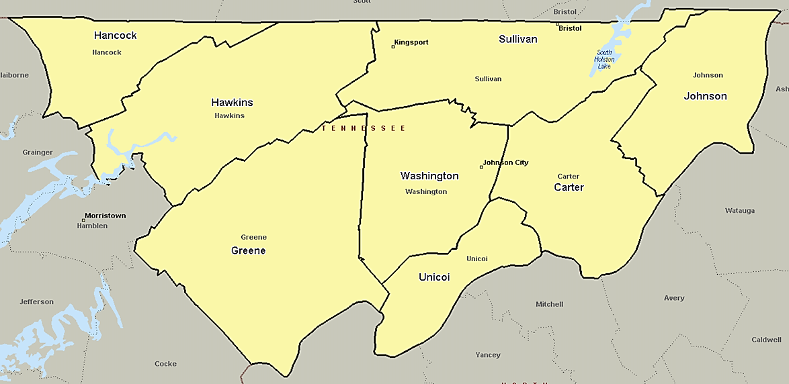

Upper East Tennessee human development agency

2016 Community Assessment

Abstract

This comprehensive community assessment offers detailed information about numerous topics, as well as an examination of the Community Service Block Grant, Head Start, Weatherization, and Low Income Home Energy Assistance Programs’ service area challenges, barriers, and strengths relative to how to solve problems that impede the achievement of self-sufficiency for many residents of eight service area counties. The data included in this document are based on survey responses, interviews, and statistics from local and nationally recognized sources.

# Table of Contents

Executive Summary 5

2016 Community Assessment Highlights 5

Identification of Issues and Recommendations 10

State of the Grantee 12

Methodology: The Community Assessment Process 14

Service Area Data 16

Geography 16

Upper East Tennessee Human Development Agency Service Area 16

Population and Demographic Data 18

Population Growth and Change 18

Racial and Ethnic Characteristics 21

Age and Sex 22

Households 23

Grandparents 25

Language 26

Socioeconomic Status 27

Education 27

Employment Status and Income 29

Occupation and Industries 30

Poverty 32

Federal Assistance Benefits 36

Economic Features and Trends 37

Housing and Homelessness 40

Housing Characteristics 40

Fair Market Rent 42

Public Housing 44

Homelessness 45

Communication and Transportation 50

Access to Phones and Internet 50

Transportation 51

Public Transportation 51

Disabilities 53

U.S. Census 53

TN Department of Education 55

Individuals with Disabilities Education Act (IDEA) 56

Health and Wellness 57

Health Disparities Profile 57

Health Professional Shortage Areas 57

Medically Underserved Areas 58

County Health Rankings 59

Health Insurance 61

Birth Rates and Fertility 63

Obesity 64

Oral Health 66

Nutrition 67

Supplemental Nutrition Assistance Program (SNAP) 67

Women, Infants, and Children (WIC) 67

National School Lunch Program 68

Food Insecurity 69

Food Deserts 70

Child Welfare 71

Tennessee Licensed Child Care Programs 72

Regulated Child Care Programs 73

Geographic Location of Eligible Children and Families 76

Characteristics of HS/EHS Families (PIR) 78

Enrollment Eligibility 80

Race of Head Start Families and Children 80

Ethnicity of Head Start Families and Children 81

Languages Spoken by HS Families and Children 81

Children with Disabilities 81

Head Start Families 82

Child Development Staff 84

Strengths and Needs of Eligible Children and Families 86

Parent Survey Results 87

Key Informant Responses 96

Resources, Collaborative/Formal Agreements and Partnerships 100

Health and Nutrition 100

Dental Health 101

Mental Health 102

Disability Services 103

Education, Employment and Job Training 104

Social Services / Family Support Services 105

Identification of Issues and Recommendations 106

Appendices 108

A. Parents Community Needs Survey 108

B. Key Informant Survey 110

C. Population by Age (2014 ACS 5-Year Estimates) 111

D. Regulated Child Care Programs in UETHDA Service Area 112

END NOTES 116

**LIST OF TABLES**

Table 1: UETHDA Service Area Counties 17

Table 2: Population Change (2010-2015) (US Census) 18

Table 3: Cumulative Estimates of the Components of Population Change (April 1, 2010 to July 1, 2015) (US Census) 19

Table 4: 2015 Population Estimates by Race/Ethnicity (US Census) 21

Table 5: Population – Sex and Age (2014 ACS 5-Year Estimates) 22

Table 6: Households with Own Children < 18 Years (2014 ACS 5-Year Estimates) 23

Table 7: Female householder, no husband present, with own children under 18 (2014 ACS 5-Year Estimates 24

Table 8: Grandparents living with own grandchildren < 18 years (2014 ACS 5-Year Estimates) 25

Table 9: Languages Spoken by Population (age 5+) in Poverty (2014 ACS 5-Year Estimates) 26

Table 10: Limited English Speaking Households (2014 ACS 5-Year Estimates) 26

Table 11: Educational Attainment Population 25 years + (2014 ACS 5-Year Estimates) 27

Table 12: Unemployment Rates by County, not seasonally adjusted (May 2016) 29

Table 13: Income in 2014 Inflation-Adjusted Dollars (2014 ACS 5-Year Estimates) 29

Table 14: 2014 Small Area Income and Poverty Estimates 32

Table 15: Poverty Rates by Race/Ethnicity (2014 ACS 5-Year Estimates) 33

Table 16: Children Ages 0-4 in Poverty (2014 ACS 5-Year Estimates) 35

Table 17: Children Receiving Families First Grants (TANF) (2010-14) 36

Table 18: Number of SSI Recipients by Age - 2014 (released October 2015) 36

Table 19: Top Employers in Johnson City 38

Table 20: Top Employers in Sullivan County 38

Table 21: Top Employers in Green County 39

Table 22: Housing Units and Occupancy (2014 ACS 5-Year Estimates) 40

Table 23: 2016 Out of Reach 42

Table 24: Public Housing 44

Table 25: Point in Time Count (2015) 46

Table 26: Households Without Telephone Service (2014 ACS 5-Year Estimates) 50

Table 27: Disability Characteristics (2014 ACS 5-Year Estimates) 53

Table 28: Civilian Non-Institutionalized Population Under Age 5 with a Disability (2014 ACS 5-Year Estimates) 54

Table 29: Special Education Services (2014-15 TN Department of Education) 55

Table 30: 2014 IDEA Part B Child Count [Ages 3-5] and Part C Child County [Ages 0-3] 56

Table 31: Major Causes of Death among Women in Tennessee (Rate per 100,000) (2014 DHHS Office on Women’s Health) 57

Table 32: Health Professional Shortage Areas (Health Resources and Services Administration) 58

Table 33: Medically Underserved Areas (Health Resources and Services Administration) 59

Table 34: Health Rankings (2014 University of Wisconsin Population Health Institute) 60

Table 35: Health Insurance Coverage (2014 ACS 5-year estimates) 61

Table 36: Health Insurance Coverage of Individuals Aged 0-18 (2014 ACS 5-year estimates) 62

Table 37: Total Births and Birth Rates (2014 Tennessee Department of Health) 63

Table 38: Total Births and Low Birth Weight (2013 Tennessee Department of Health) 63

Table 39: Childhood Overweight/Obesity (2015 TN Dept. of Economic and Community Development) 64

Table 40: Age-adjusted Causes of Death (Rate per 100,000) (2015 US DHHS CDC) 65

Table 41: Children Oral Health 2007 and 2011-12 66

Table 42: SNAP Participation (June, 2016 TN Department of Human Services) 67

Table 43: Percent of Infants and Children Receiving WIC (2010-14) 68

Table 44: Eligibility for the National School Lunch Program 68

Table 45: Food Insecurity (2014 Feeding America) 69

Table 46: Reported Cases of Child Abuse (2014) 71

Table 47: Children Under Age 6 With All Parents in Labor Force (2014 ACS 5-Year Estimates) 72

Table 48: TN Child Care Providers (2016) 73

[Table 49: Child Care Providers excluding HS\}in UETHDA Service Area (July 2016) 75

Table 50: Number of Children (0-4) in Poverty (2014 ACS 5-Year Estimates) 76

Table 51: Number of Children (0-4) in Poverty by ZCTA (2014 ACS 5-Year Estimates) 77

Table 52: 2014-15 UETHDA Enrollment 78

**LIST OF FIGURES**

Figure 1: U.S. Census Data: ACS 1-year, 3-year, 5-year Estimate Features 15

Figure 2: Tennessee 16

Figure 3: UETHDA Service Area 17

Figure 4: Population Change (2010-2015) (US Census) 18

Figure 5: Natural Increase & Net Migration (2010-2015) (US Census) 18

Figure 6: Natural Increase & Net Migration (2010-2015) (US Census) 19

Figure 7: Population Change by Ethnicity (2010-2015) (US Census) 20

Figure 8: Hancock County, TN Population Change by Ethnicity (2010-2015) (US Census) 20

Figure 9: Population Change by Race (2010-2015) (US Census) 20

Figure 10: 2015 Population Estimates by Race (US Census) 21

Figure 11: 2015 Population Estimates by Ethnicity (US Census) 21

KFigure 12: Population by Gender (2014 ACS 5-Year Estimates) 22

Figure 13: Households with Own Children < 18 Years (2014 ACS 5-Year Estimates) 23

Figure 14: Female householder, no husband present, with own children under 18 (2014 ACS 5-Year Estimates 24

Figure 15: Grandparents Years Responsible for Grandchildren (2014 ACS 5-Year Estimates) 25

Figure 16: Educational Attainment Population 25 years + (2014 ACS 5-Year Estimates) 27

Figure 17: TN Schools: Student Membership (Race/Ethnicity) 28

Figure 18: TN Schools: Graduation Rates (2015) 28

Figure 19: Per Capita Income in 2014 Inflation-Adjusted Dollars (2014 ACS 5-Year Estimates) 29

Figure 20: Occupation of Civilian Employed Population Age 16+ (2014 ACS 5-Year Estimates) 30

Figure 21: Industry of Civilian Employed Population Age 16+ (2014 ACS 5-Year Estimates) 31

Figure 22: Poverty Rates by Gender (2014 ACS 5-Year Estimates) 33

Figure 23: Poverty Rates by Race/Ethnicity (2014 ACS 5-Year Estimates) 33

Figure 24: Poverty Rates by Educational Attainment (2014 ACS 5-Year Estimates) 34

Figure 25: Poverty Rates by Employement (2014 ACS 5-Year Estimates) 34

Figure 26: Children Ages 0-4 in Poverty by Race/Ethnicity (2014 ACS 5-Year Estimates) 35

Figure 27: Selected Characteristics of Occupied Housing Units (2013 ACS 5-Year Estimates) 40

Figure 28: House Heating Fuel of Occupied Housing Units (2014 ACS 5-Year Estimates) 41

Figure 29: 2016 Out of Reach - Fair Market Rental Values vs. Income 42

Figure 30: Work Hours/Week 43

Figure 31: Estimates of Homeless People by State (2015 Point in Time Count) 45

Figure 32: Appalachian Regional Continuum of Care (TN-509) 46

Figure 33: Tennessee Homeless Students Enrolled in LEAs (Total) 48

Figure 34: Tennessee Homeless Students Enrolled in LEAs (Total) 48

Figure 35: Households with Vehicle Available (2014 ACS 5-Year Estimates) 51

Figure 36: Civilian Non-Institutionalized Population with a Disability (2014 ACS 5-Year Estimates) 53

Figure 37: Civilian Non-Institutionalized Population with a Disability by Gender (2014 ACS 5-Year Estimates) 54

Figure 38: County Health Rankings Model 59

Figure 39: Lack of Health Insurance Coverage (2014 ACS 5-year estimates) 61

Figure 40: Lack of Health Insurance Coverage (Children ages 0-18) (2014 ACS 5-year estimates) 62

Figure 41: Total Births and Birth Rates (2014 Tennessee Department of Health) 63

Figure 42: State of Obesity in Tennessee (2014) 64

Figure 43: Childhood Overweight/Obesity (2015 Tennessee Department of Economic and Community Development) 65

Figure 44: Age-adjusted Causes of Death (Rate per 100,000) (2015 US DHHS CDC) 65

Figure 45: Food Access Research Atlas – Northeastern Tennessee (2016 USDA ERS Food Desert Atlas) 70

Figure 46: Reported Cases of Child Abuse (2014) 71

Figure 47: Average of Cost Child Care in Tennessee (2015 Child Care Aware Report) 72

Figure 48: Average of Cost Child Care in Tennessee as Percent of Income (2015 Child Care Aware Report) 72

Figure 49: ZCTA 37660 76

Figure 50: ZCTAs 37601, 37634 76

# Executive Summary

Head Start promotes the school readiness of young children from low-income families through agencies in their local community. The Head Start program is authorized by the [Improving Head Start for School Readiness Act of 2007](https://eclkc.ohs.acf.hhs.gov/hslc/standards/law/HS_ACT_PL_110-134.pdf). Head Start and Early Head Start programs support the mental, social, and emotional development of children from birth to age 5. In addition to education services, programs provide children and their families with health, nutrition, social, and other services. Head Start services are responsive to each child and family's ethnic, cultural, and linguistic heritage.

Head Start encourages the role of parents as their child's first and most important teachers. Programs build relationships with families that support positive parent-child relationships, family well-being, and connections to peers and community. Head Start began as a program for preschoolers. Three- and 4-year-olds made up over 80 percent of the children served by Head Start last year.

Early Head Start serves pregnant women, infants, and toddlers. Early Head Start programs are available to the family until the child turns 3 years old and is ready to transition into Head Start or another pre-K program. Early Head Start helps families care for their infants and toddlers through early, continuous, intensive, and comprehensive services.

Local servicesare delivered by about 1,700 public and private nonprofit and for-profit agencies. These agencies receive grants from the [U.S. Department of Health and Human Services (HHS)](http://www.hhs.gov/). Head Start agencies design services for children and families that meet the needs of their local community and the Head Start Program Performance Standards. Some cities, states, and federal programs offer funding to expand Head Start and Early Head Start to include more children within their communities.

Both Head Start and Early Head Start programs offer a variety of service models, depending on the needs of the local community. Programs may be based in centers, schools, or family child care homes. Early Head Start services are provided for at least six hours per day, whereas Head Start preschool services may be half-day (four hours) or full-day. Another program option is home-based services, in which a staff person visits children once a week in their own home and works with the parent as the child's primary teacher. Children and families who receive home-based services meet twice monthly with other enrolled families for a group learning experience facilitated by Head Start staff.

[*https://eclkc.ohs.acf.hhs.gov/hslc/hs/about*](https://eclkc.ohs.acf.hhs.gov/hslc/hs/about)

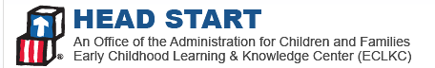

The [**Upper East Tennessee Human Development Agency**](http://uethda.org/) (UETHDA) is located in the northeast corner of Tennessee. Nestled along the Appalachian Mountains, it is in the heart of poverty-ridden America. The following counties are served by the Agency: Carter, Greene, Hancock, Hawkins, Johnson, Sullivan, Unicoi, and Washington.

This comprehensive community assessment offers detailed information about numerous topics, as well as an examination of the Community Service Block Grant (CSBG), Head Start (HS), Weatherization, and Low Income Home Energy Assistance Programs’ (LIHEAP) service area challenges, barriers, and strengths relative to how to solve problems that impede the achievement of self-sufficiency for many residents of eight service area counties. The data included in this document are based on survey responses, interviews, and statistics from local and nationally recognized sources.

### 2016 Community Assessment Highlights

**Population and Demographic Data.** Census estimates from 2015 indicate that Tennessee’s population grew by 4.0 percent (similar to the 4.1 percent for the U.S.) from 2010 to 2015, reaching more than 6.6 million residents. The population decreased in each of the UETHDA service area counties with the exception of Washington County, where a 2.7 percent population increase was seen. The Hispanic/Latino population grew in each of the UETHDA service area counties between 11 and 115.4 percent. The white population decreased in all service area counties with the exception of Washington County. The black/African American population increased in each of the service area counties.

Regardless of the population change, the population in the UETHDA service area is predominantly white (95 to 98 percent) and non-Hispanic/Latino (95 to 100 percent). Between 78 and 83 percent of the population in the service area is over the age of 18, and approximately 4.3 to 5.4 percent is below age 5. The median age in each of the service area counties is over 42, with the exception of Washington County, where the median age is 39.7 years.

On average, approximately two out of three households in the U.S. and Tennessee are family households. Hawkins County has the highest proportion of family households in the UETHDA service area, 70 percent, while Hancock and Washington Counties have the lowest proportion of family households, 64 percent each. Approximately one in four households in the eight-county service area have children under the age of 18.

In the UETHDA service area, more than 11,000 grandparents live with their own grandchildren under age 18, of which more than 6,200 are responsible for their grandchildren (55 percent). In Hancock County 68 percent of grandparents living with their own grandchildren are responsible for them, and 38 percent have been responsible for them for one to two years.

**Socioeconomic Status.** Almost one-quarter of adults in Tennessee have obtained a bachelor’s degree or higher (24.4 percent). Education levels in most of the UETHDA service area counties is significantly lower. In Johnson County less than one in 10 adults over the age of 25 have a bachelor’s degree or higher, 9.3 percent. Sullivan and Washington Counties have the highest educational attainment levels; 21.2 and 30.8 percent of adults, respectively, have a bachelor’s degree or higher.

According to the U.S. Department of Labor, Bureau of Labor Statistics, the unemployment rate in Tennessee (not seasonally adjusted) in May 2016 was 4.1 percent. The unemployment rates for the UETHDA service area counties rage from 3.6 percent (Johnson County) to 5.8 percent (Hancock and Unicoi Counties).

In the UETDHA service area Washington County has the highest percent of its civilian employed population employed in management, business, science and arts occupations, 38 percent, while Hancock County yields the lowest proportion, 23 percent. Five out of eight UETHDA service area counties report having one in five persons employed in production, transportation and material moving occupations: Greene, Hancock, Hawkins, Johnson, and Unicoi Counties.

Per the 2014 Small Area Income and Poverty Estimates (SAIPE), 18.2 percent of the population in Tennessee lives in poverty (more than 1.1 million individuals), and 25.9 percent of children, ages 0-17, live in poverty (more than 380,000 children). The UETHDA service area county with the highest poverty rate is Hancock County, where 29.5 percent of the population lives in poverty and 42.8 percent of children age 0-17 live in poverty.

According to 2014 Small Area Income and Poverty Estimates (SAIPE) from the U.S. Census Bureau, Tennessee is home to approximately 113,943 children, ages 0-4, in poverty. SAIPE estimates for children, ages 0-4, in poverty, are not provided for individual counties, townships, or census tracts. In order to estimate children in poverty in the UETHDA service area, poverty data from the 2014 ACS 5-year estimates are used; based on these estimates there are more than 7,900 children ages 0-4 in poverty in the UETHDA service area.

**Economic Features and Trends.** According to the Center for Business and Economic Research (CBER) at The University of Tennessee, the State of Tennessee’s economy continued to expand in 2015.

Inflation-adjusted gross domestic product (GDP) grew by 2.4 percent for the year, representing an addition of 54,600 new jobs. Job growth in Tennessee was slightly slower than national job gains of 2.1 percent for 2015.

The **Community Services Block Grant** (CSBG) provides funds to alleviate the causes and conditions of poverty in communities.

These grants are available to:

* States
* The District of Columbia
* The Commonwealth of Puerto Rico
* U.S. Territories
* Federally and state-recognized Indian Tribes and tribal organizations
* Community Action Agencies
* Migrant and seasonal farm workers' agencies
* Other organizations specifically designated by the states

CSBG funding supports projects that:

* Lessen poverty in communities
* Address the needs of low-income individuals including the homeless, migrants and the elderly
* Provide services and activities addressing employment, education, better use of available income, housing, nutrition, emergency services and/or health

In addition, discretionary grants are available at the statewide or local level, or for associations with demonstrated expertise in addressing the needs of low-income families, such as Community Action Agencies (CAAs).

With the support of CSBG funding, states and CAAs work together to achieve the following goals for low-income individuals:

* Increased self-sufficiency
* Improved living conditions
* Ownership of and pride in their communities
* Strong family and support systems

Working together, agencies increase their capacity to achieve results. Partnerships among supporters and providers of services play a large role in the successful implementation of CSBG grants.

[*http://www.acf.hhs.gov/programs/ocs/programs/csbg/about*](http://www.acf.hhs.gov/programs/ocs/programs/csbg/about)



**Housing and Homelessness.** In Tennessee a lower percentage of occupied housing units lack complete plumbing facilities (0.4 percent) and kitchen facilities (0.8 percent). In the UETHDA service area 2.8 and 1.7 percent of occupied housing units in Hancock and Johnson Counties lack complete plumbing facilities, respectively. Hancock County also leads in terms of occupied housing units lacking complete kitchen facilities, 1.6 percent.

According to the National Low Income Housing Coalition (NLIHC) in 2015, 33 percent of Tennessee’s households are renters; the Fair Market Rent (FMR) for a two-bedroom home is $779/month. In order to be able to rent a two-bedroom home, without exceeding 30 percent of one’s income, a renter must earn $31,175/year, yet the estimated median household income for a renter in Tennessee is $27,390.[1] With a median income of $27,390, a renter is able to afford $685 for a home, which is less than the fair market rental of a two-bedroom home.

Greene and Hancock Counties are the extremes in terms of affordable rent. In Greene County the rent that is affordable at the renter median income is $15 per month less than the local two-bedroom FMR. In Hancock County, the rent that is affordable at renter median income is $223 per month less than the local two-bedroom FMR. While renters at the median income in Greene County can almost afford their local two-bedroom FMR, similar renters in Hancock County cannot even afford half of the local FMR of a two-bedroom home.

The average annual income of households living in public housing in the UETHDA service area is between $6,658 (Hancock County) and $12,595 (Greene County). Approximately half of the households living in public housing in Tennessee are white, half are black/African American, and 2 percent of households are Hispanic/Latino. Sixteen percent of household members in public housing in Tennessee are children under the age of 5.

In Tennessee 1,625 children under the age of 18 were counted in homeless family households. Thirty-one (31) children under the age of 18 were documented as persons in child-only households in Tennessee, 3 of which were unsheltered at the time of the count.

**Communication and Transportation.** Based on U.S. Census data, more than 2.8 million households, 2.5 percent of total occupied housing units, do not have access to telephone service. In Tennessee almost 66,621 housing units lack telephone service, of which more than 6,070 are located in Carter, Greene, Hancock, Hawkins, Johnson, Sullivan, Unicoi, and Washington Counties.

Almost one in 10 households (9.1 percent) in the U.S. do not have access to a vehicle. In Tennessee the proportion of households without access to a vehicle is lower, 6.4 percent, while more than one in five households has access to three or more vehicles, 22.5 percent. In Hancock County, 9 percent of households do not have access to a vehicle, while in Hawkins County this figure is less than 5 percent.

**Disabilities.** Data from the U.S. Census Bureau indicates that 12.3 percent of the civilian non-institutionalized population in the United Stated has a disability; the rate in Tennessee is higher, at 15.2 percent. In Tennessee less than 1 percent of children under age 5 reportedly have a disability, 6.0 percent of children ages 5 to 17 have a disability, 13.7 percent of adults ages 18 to 64 have a disability, and 40.1 percent of adults over age 65 have a disability.

According to the Tennessee Department of Education, during the 2014-15 school year, the Special Education Program in Tennessee public schools served more than 129,905 children. Almost 7,000 children were served in UETHDA service area county schools. The majority of students receiving special education services had a speech or language impairment, followed by a health impairment, and developmental delay.

**Health and Wellness.** Based on 2015 rankings, Tennessee has a premature death rate of 8,600 (the years of potential life lost before age 75 per 100,000 residents). Of the eight counties in the UETHDA service area, Washington County had the best health outcomes (32 out of 95 counties), with a premature death rate of 8,600. In contrast, Hancock County ranked the lowest, with the worst health outcomes (86 out of 95 counties), with a premature death rate of 10,700. The other counties in the proposal had premature death rates ranging from 8,700 to 11,000.

Within the UETHDA service area, Carter and Hancock Counties had the highest percentages of the civilian non-institutionalized population lacking health insurance, 14.8 and 15.3 percent, respectively. The United States has more than 5.2 million children and adolescents under the age of 18 lacking health insurance, of which more than 80,000 are in Tennessee. Four of eight counties in the UETHDA service area have approximately 5 percent or more of their age 0 to 18 population living without health insurance. Unicoi County has the lowest percent of children without health insurance, 1.3 percent.

According to *The State of Obesity: Better Policies for a Healthier America 2015,* Tennessee has the 14th highest adult obesity rate in the nation, 31.2 percent, up from 20.9 percent in 2000. Highest rates of obesity were seen for those ages 45-64 (38.7 percent) and black/African American residents (40.6 percent). Four of the 10 leading causes of death for adults in Tennessee are related to obesity: heart/cardiovascular disease, stroke, chronic kidney disease, and diabetes.

**Nutrition.** In Tennessee 533,569 households with 1,094,644 individuals received SNAP benefits during the month of June 2016. Of those households, 34,600 received benefits in the UETHDA service area, accounting for a total of 87,028 individuals.

Based on data collected from the Kids Count Data Center in 2014, almost 145,000 infants and children received WIC in 2014, approximately 29.8 percent of the age-eligible population. WIC benefits (both in number and percent) have decreased steadily over the past five years in Tennessee and the UETHDA service area counties. Hancock County has, over the past five years, reported the highest percent of WIC recipients; in 2014 almost 59 percent of infants and children received WIC services.

**Weatherization Assistance Program**

The U.S. Department of Energy (DOE) Weatherization Assistance Program provides grants to states, territories, and some Indian tribes to improve the energy efficiency of the homes of low-income families. These governments, in turn, contract with local governments and nonprofit agencies to provide weatherization services to those in need using the latest technologies for home energy upgrades. Since the program began in 1976, DOE has helped improve the lives of than 7 million families by reducing their energy bills.

[*http://energy.gov/eere/wipo/weatherization-assistance-program*](http://energy.gov/eere/wipo/weatherization-assistance-program)

**Low Income Home Energy Assistance Program (LIHEAP)**

The Low Income Home Energy Assistance Program (LIHEAP) helps keep families safe and healthy through initiatives that assist families with energy costs. We provide federally funded assistance in managing costs associated with:

* Home energy bills
* Energy crises
* Weatherization and energy-related minor home repairs

LIHEAP can help you stay warm in the winter and cool in the summer through programs that reduce the risk of health and safety problems that arise from unsafe heating and cooling practices.

[*http://www.acf.hhs.gov/programs/ocs/programs/liheap/about*](http://www.acf.hhs.gov/programs/ocs/programs/liheap/about)

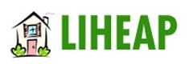

In Tennessee 24 percent, or more than 350,000 children, live without access to enough and nutritious foods. The average cost of a meal is $2.89; 17 percent of food insecure people live between the 135 and 180 percent poverty brackets. Food insecurity for children is highest in Hancock County, 31 percent.

**Child Welfare.** In 2014, there were more than 66,481 children with reported cases of child abuse in Tennessee, 4.4 percent of children, ages 0-18. The number of reported child abuse cases in the UETHDA service area in 2014 ranged from 5.0 percent (Green County) to 7.6 percent (Sullivan County). The rate of child abuse cases increased from 2013 to 2014 in the state of Tennessee, as well as Carter, Greene, Sullivan, and Washington Counties. The rate of child abuse cases decreased from 2013 to 2014 in Hancock, Johnson, and Unicoi Counties and stayed the same in Hawkins County.

**TN Licensed Child Care Programs.** In Tennessee more than 296,000 children under age 6, or 64.0 percent of the total, have all parents in the family in the labor force, of which 18,392 are in the UETHDA service area. Washington County has the highest proportion of children under the age of 6 with all parents in the labor force (67.4 percent), while Hancock County has the lowest proportion of children under the age of 6 with all parents in the labor force (42.8 percent).

The average cost of childcare in a child care center in Tennessee for an infant is $5,857 per year; the cost for care of a 4-year old is $4,515 per year, and the cost of care for a school-age child is $1,838 per year (Fig 47). According to *Child Care Aware America,* the price tag of infant care in Tennessee accounts for 29.3 percent of the income of a single parent family and 8.2 percent of the income of a married couple family (Fig 48).

Based on the Tennessee Department of Human Services, there are a total of 2,435 child care providers in the state, with a capacity to serve 161,897 children. The majority of providers -- 1,906 Department of Education providers and 1,740 Department of Human Services providers -- offer center care for 13 or more children.

Based on a July 2016 Child Care Providers Map search, in the UETHDA service area there are 270 regulated child care centers, with a capacity to serve 18,452 children, ages 0 to 18. Of those 270 regulated child care providers, only 82 centers offer child care assistance to Head Start age-eligible children, with a capacity of 5,824 slots.

### Identification of Issues and Recommendations

1. **Become an active and influential partner in regional efforts to lead economic and social development.**

***Situation.*** All counties, expect for one, within the UETHDA service area, experienced a decrease in population in recent years. Current Census reports show similar population trends in Rural America, which has seen slower population growth as more young people move to urban and suburban areas for jobs, and aging retirees seek out more populated places to live. Economic and social consequences of this population decrease are reductions of tax base for the governments and a greater challenge recruiting skilled workers. Most recent economic development plans in rural TN focus on the need to retain and develop a future workforce that could function in a “knowledge economy,” stay competitive and offer companies a better environment for investment.

***Recommendation.*** UETHDA should focus on becoming an active and engaged network of local leaders that could make tangible recommendations and contributions to the future of dislocated workers and single female head of households. These are two unique and important groups in the region that need particular attention and concentrated backing from leaders in the community.

The dislocated workers represent a unique workforce that has limited opportunities due economic changes that lost traditional manufacturing jobs needing a lower skills’ workforce. For many long-term, older and low skill residents, the possibility to relocate to find employment opportunities is not an option. These are not only the more permanent residents, but also those that the program could serve and enlist to recruit other neighbors, family members and friends that are experiencing similar needs and challenges.

Economic development could also benefit from UETHDA’s efforts to highlight the importance of helping young mothers starting a family, raising the future workforce of the region and living in poverty. There is strong evidence that early childhood development directly influences economic, health and social outcomes for individuals and society. Furthermore, unfavorable early environments create deficits in skills and abilities that drive down productivity and increase social costs, adding to financial deficits experienced by the families.

To support the investment on dislocated workers and single female head of households, UETHDA CSBG staff could benefit from studying and familiarizing themselves with the following work:

1. Family Economic Success Planning Process. This research and application is supported by the Annie E. Casey Foundation, which aims at connecting people to jobs that pay family supporting wages and provide opportunities for advancement—the goal of a place-based workforce development strategy. This research and implementation builds on workforce development strategies that focus on regional labor markets—whether in terms of job readiness, job search or short and long-term training.
2. Investing in early childhood education (particularly the work of [Dr. James J. Heckman](http://heckmanequation.org/about-professor-heckman)) that suggests that is a cost-effective strategy for promoting economic growth.

The economic future for many residents with unique needs and challenges might be influenced by UETHDA interventions to provide the tools for upward mobility and building necessary workforce skills.

1. **Identify the critical prerequisites of workforce skill needs and resources.**

**Situation:** It can be extremely helpful for regional economic development efforts to identify the critical prerequisites needed to any effective workforce development. The comprehensive Community Assessment identified some directly and indirectly related needs or gaps faced by low income residents: poverty, educational attainment, limited transportation, lack childcare, housing condition or limitations, etc. However, it is important to identify gaps that might limit success and measure progress on necessary preconditions to boosting regional prosperity.

**Recommendation:** UETHDA could lead the effort to bring key partners from the region to establish broad-based workforce partnership that focus specifically on the clients they serve; these partners may include:

* Employers – especially in fields with persistent identified workforce shortages
* The regional Workforce Investment Board
* Technical, community and four-year colleges and universities
* Other workforce training organizations
* Welfare (TANF) and related work-first programs
* Disability employment programs
* Childcare service providers and resource and referral agencies
* Other programs serving and supporting working families

Follow up steps in order to maintain partnership collaboration active may include:

* Create stronger cross-sector and cross-organization collaboration
* Conduct a preliminary and ongoing assessments of the status of working families and the various supporting services in the community

This process could generate a customer focused training and employment plan for all. Given the complexity of an effective economic prosperity initiative, it helps to understand, assess, plan, organize and evaluate all of these questions together.

# State of the Grantee

UETHDAThe [**Upper East Tennessee Human Development Agency**](http://uethda.org/) is located in the northeast corner of Tennessee. Nestled along the Appalachian Mountains, it is in the heart of poverty-ridden America. The following counties are served by the Agency: Carter, Greene, Hancock, Hawkins, Johnson, Sullivan, Unicoi, and Washington.

The **mission** of Upper East Tennessee Human Development Agency, Inc. is to provide education, direction and support to individuals, families and organizations in order to strengthen and stabilize the community through collaborative efforts of agency programs and cooperative partnerships.

**What we do**

Each year our Agency has the pleasure of providing assistance to thousands of households, helping people, changing lives.

**Meet Basic Needs** Our agency assists clients in securing basic needs such as food, shelter, clothing, utilities, and other emergency needs. The Neighborhood Service Centers’ staff and Head Start Family Resource Specialists work daily with clients to relieve the hardships they face. Our service team offers specifically targeted services from our emergency assistance to more long term paths for self-sufficiency.

**Empower Individuals and Families** Our agency is changing lives by supporting each individual through asset building with financial literacy, education, entrepreneurship, ensuring school readiness for our children, and helping home owners save energy while focusing on the strengths of each individual and family.

**Promote Communities** Our agency is committed to working together with partners and programs which develop and promote pathways to long-term economic stability, giving hope for the future.

The **vision** of UETHDA, Inc.  is to be the model agency for the community, state and nation by:

* Valuing the intrinsic worth of each individual, family, and organization
* Supporting the community through exemplary, essential, and distinct services
* Empowering consumers to reach their greatest potential
* Enhancing community partnerships through collaborative efforts
* Fostering a seamless continuum of care to consumers

**Our Programs**

|  |  |
| --- | --- |
| **HEALTH** | * Emergency Food Assistance * Children’s Nutrition |
| **EDUCATION** | * Head Start * Education Support – provides financial aid for individuals who want to return to school or continue their education |
| **SENIORS** | Retired Senior Volunteer Program - recruit individuals 55 and older to put their skills and life experiences to work for their communities |
| **HOUSING / ENERGY** | * Weatherization Assistance Program (WAP) – assists households in reducing high fuel costs by improving warmth and cooling of a dwelling * Housing Rehabilitation – helps individuals maintain safe homes by making repairs to bring their homes up to local housing standards * Project Help – pays a one-time stipend of $100.00 to assist with electrical service * Low income home energy assistance program |
| **NEIGHBORHOOD SERVICES** | * Emergency Assistance – provides short-term assistance such as help with deposits, first month’s rent, past due rent, mortgage, meter water assistance, clothing and food * Employment Assistance – provides assistance with clothing-uniforms, safety boots, equipment, tools, payment for training and certification, gas stipends, employment physicals, dental/vision * Self-Sufficiency Program – assists families and individuals in developing and implementing goals which will result in greater self-sufficiency * Health Services – assists elderly (age 55 and older) and disabled individuals with new prescription drug assistance who would otherwise not be able to afford the prescribed medication * Child Care Assistance – helps employed families reduce the cost of child care * Assets for Independence – directs participants to save earned income in special-purpose, matched savings * Accounts, referred to as Individual Development Accounts (IDAs) * I2I Personal Development Program – helps clients reach long-term economic stability |

**Our history**

It was the Economic Opportunities Act of 1964 that established two Community Action Agencies to serve the region, and in October 1973, the two became one. The Johnson, Carter, and Unicoi County Human Development Corp. merged with the Upper East Tennessee Economic Opportunity Authority Inc. (serving Hancock, Hawkins, Greene, Sullivan, and Washington counties), forming the Upper East Tennessee Human Development Agency, Inc. (UETHDA) on Oct. 1, 1973.

The respective County Commissions of each agency adopted resolutions officially recognizing the agency as the designated Community Action Agency.

UETHDA has encountered countless changes and experienced major transformations over the past 50 years. The agency has been successful because it has the flexibility to adapt to the changes. The basic philosophy of “Helping People, Changing Lives” and our mission of helping individuals and families to strengthen and develop, have remained unchanged.

From its humble beginnings consisting of Conduct and Administration, and a summer Head Start Program, UETHDA has grown to an annual budget of $16 million. However, real community impact is not measured in dollars – it is measured in the positive changes that occur in people’s lives because of what Community Action helps them accomplish.

# Methodology: The Community Assessment Process

This comprehensive community assessment offers detailed information about numerous topics, as well as an examination of the Community Service Block Grant (CSBG), Head Start (HS), Weatherization, and Low Income Home Energy Assistance Programs’ (LIHEAP) service area challenges, barriers, and strengths relative to how to solve problems that impede the achievement of self-sufficiency for many residents of eight service area counties. The data included in this document are based on survey responses, interviews, and statistics from local and nationally recognized sources.

This community assessment not only fulfills Upper East Tennessee Human Development Agency’s (UETHDA) federal requirement, but it becomes an integral part of these aforementioned programs’ planning, implementation, and evaluation process. This comprehensive analysis becomes the most current baseline to identify current community needs, design new plans, choose additional community partners, develop strategic collaborations, evaluate progress of recent interventions in the service area, and expeditiously make relevant decisions about program expansion changes.

The community assessment methodology focuses on different levels of analysis to further enhance leadership staff’s understanding and better tailor services to help improve opportunities for low-income persons and families in the service area. Prior to the collection and analysis of the required data, consultants from [Nolo Consulting](http://www.noloconsulting.com/) and UETHDA’s leadership team agreed on key data indicators that are relevant to current issues and program priorities.

The following components of the community assessment represent key methods utilized to complete this report:

1. *Review of most recent secondary data on indicators that have an impact on the program and its service delivery model(s). (Below we offer a rationale and brief description for the use of Census Data: American Community Survey 5-year Estimates).*

The Community Assessment process focuses on the utilization of existing sources of external/secondary data such as census data, local and state planning departments’ reports, state department data, local interagency committee reports, data from local school districts, child care resource and referral agencies, agencies serving individuals with disabilities, health care providers, and social service providers. A list of the some of the data sources used and analyzed were identified and selected after UETHDA’s leadership team approved the critical indicators, topics, and variables that became the meaningful foundation for this comprehensive analysis. When appropriate, data was collected on county, state, and national levels to facilitate analysis and ensure proper context when answering the question of, “Why does this matter to UETHDA’s CSBG program?”

1. *Development and utilization of additional assessments to include data observed or collected directly from first-hand experience using such methods as attitude / perception surveys, key informant interviews, community forums and/or focus group interviews.*

UETHDA’s leadership identified two qualitative methods to collect data from the service area. These included parent surveys (see Appendix A) and interviews with key informants (see Appendix B) -- experts from the service area counties. The parent survey and key informant interviews complement and reinforce the information collected from secondary sources of data (see Strengths and Needs of Eligible Children and Families for a summary and analysis of responses.

The UETHDA’s program staff identified and provided names of key informants to participate, and these individuals provided additional support for secondary data analysis findings. These qualitative data findings generated important implications and connections to program needs and serve to generate strategic discussions in relation to program improvement based on empirical data.

After completion of the data collection and analysis, UETHDA’s leadership team members received a draft community assessment report. This provided an opportunity to ask questions, clarify information presented if needed, and allow for staff input regarding data findings. After obtaining feedback from the leadership team, a final version of the community assessment was presented to UETHDA’s Program leadership team.

#### Census Data: American Community Survey 5-year Estimate

**Census Data.** A predominant data source used for this report is the [U.S. Census Bureau’s](http://www.census.gov/acs/www/) 2014 American Community Survey, 5-year Estimate. *“The American Community Survey (ACS) is an ongoing survey that provides data every year -- giving communities the current information they need to plan investments and services. Information from the survey generates data that help determine how more than $450 billion in federal and state funds are distributed each year.”*[2]

In order to support local governments, communities, and federal programs, data are collected about the following topics: age, sex, race, family and relationships, income and benefits, health insurance, education, veteran status, disabilities, where you work and how you get there, where you live, and how much you pay for some essentials.

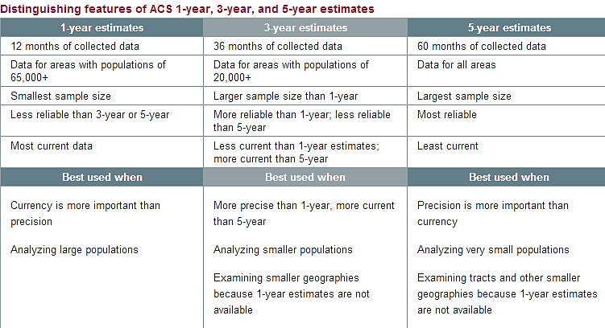Figure 1 is a chart describing the difference between 1-year, 3-year and 5-year Estimates. Although the 5-year Estimate is the “least current” data set, it is the *most reliable* because it allows for comparison and analysis of all counties, townships, or census tracts, required geographic levels when conducting an analysis of various populations and/or other needs and indicators for Early Head Start programs.

Figure : U.S. Census Data: ACS 1-year, 3-year, 5-year Estimate Features

# Service Area Data

## Geography

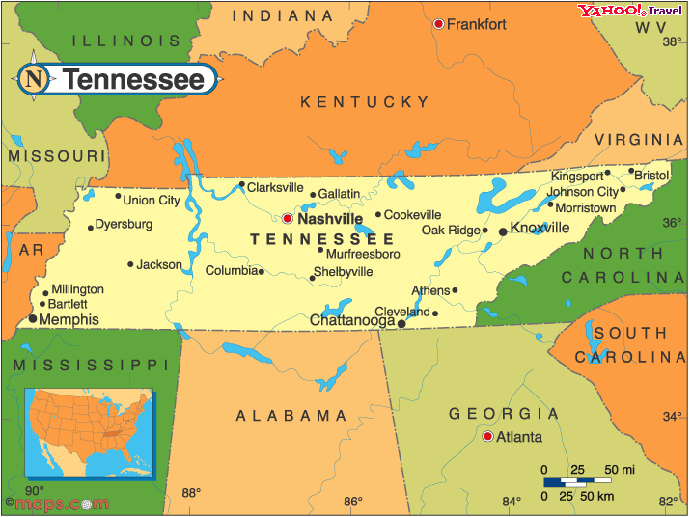Tennessee is located in the southeastern United States, bordered by Virginia, North Carolina, Georgia, Alabama, Mississippi, Arkansas, Missouri, and Kentucky. Tennessee’s capital and second largest city is Nashville. Memphis, located in the southwestern tip of the state is the largest city.

Tennessee has a total area of 42,143 square miles, which makes it the 36th largest state., With a population of 6.6 million, Tennessee is the 20st most densely populated state in the country.

Figure : Tennessee

The state is divided into six geographic regions: the Blue Ridge, the Appalachian Ridge and Valley Region, the Cumberland Plateau, the Highland Rim, the Nashville Basin, and the Gulf Coastal Plain. The state is divided into 95 counties, with Shelby County as the most populous and largest county, and Picket County as the least populous and smallest in size.

### Upper East Tennessee Human Development Agency Service Area

The UETHDA geographic area consists of eight counties in the northeastern tip of the state. Table 1 provides a list of the cities, towns and unincorporated communities located in each of the eight counties.

| **County** | **Total Land Area (sq. mi.)** | **Population Density (per sq. mi)** | **Cities/Towns**  ***BOLD = County Seat*** | **Unincorporated Communities** |
| --- | --- | --- | --- | --- |
| **Carter County** | 341.2 | 167.93 | **Elizabethton**  Johnson City  Watauga | Big Spring, Bitter End, Butler, Fish Springs, Hampton, Milligan, College, Stoney Creek, Tiger Valley, Valley Forge |
| **Greene County** | 622.14 | 110.26 | Baileyton  **Greeneville**  Mosheim  Tusculum | Afton, Camp Creek, Chuckey, Cross Anchor, DeBusk, Grandview, Horse Creek, Jearoldstown, Liberty Hill, Limestone, Midway, Mohawk, Newmansville, Orebank, Ottway, Rheatown, Romeo, South Greene, Warrensburg |
| **Hancock County** | 222.33 | 30.16 | **Sneedville** | Alanthus Hill, Kyles Ford, Mulberry Gap, Treadway, Xenophon |
| **Hawkins County** | 487.05 | 116.5 | Church Hill  Kingsport  Bulls Gap  Mount Carmel  **Rogersville**  Surgoinsville | Austins Mill, Eidson, Midway, Persia, Saint Clair |
| **Johnson County** | 298.47 | 60.61 | **Mountain City** | Butler, Dewey, Doe Valley, Doeville, Crandull, Laurel Bloomery, Maymead, Midway, Neva, Pandora, Shady Valley, Sutherland, Trade |
| **Sullivan County** | 413.41 | 379.41 | Bluff City  **Blountville**  Bristol  Johnson City  Kingsport | Arcadia, Buffalo, Morrison City, Piney Flats, Sullivan Gardens |
| **Unicoi County** | 186.17 | 97.63 | **Erwin**  Unicoi | Bumpas Cove, Flag Pond, Limestone Cove |
| **Washington County** | 326.46 | 382.28 | Johnson City  Kingsport  Watauga  **Jonesborough** | Austin Springs, Boone, Boones Creek, Bowmantown, Bumpus Cove, Embreeville, Lamar, Limestone, Midway, Mountain Home, South Central, Stewart Hill, Sulphur Srings, Washington College |

Table : UETHDA Service Area Counties

Figure : UETHDA Service Area

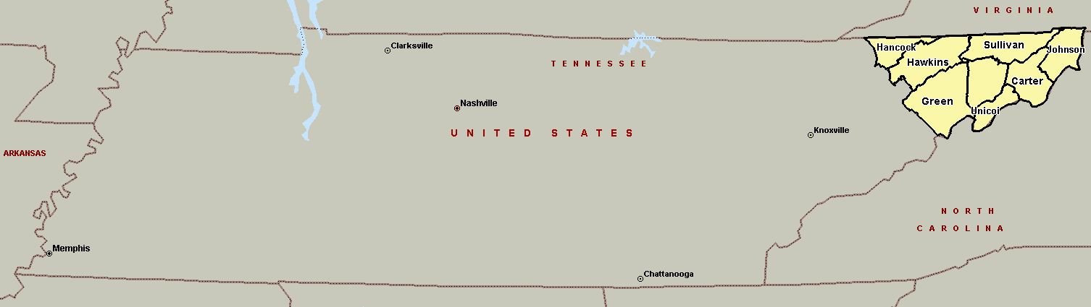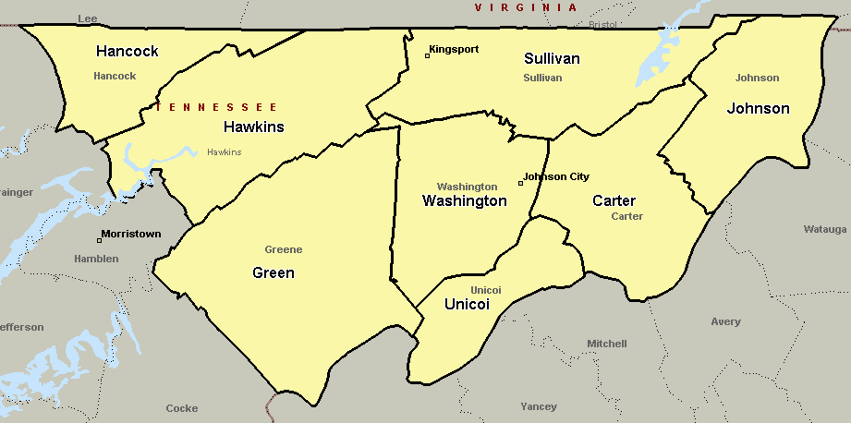

UETHDA Service Area

## Population and Demographic Data

### Population Growth and Change

Based on the 2010 Census, the total population of Tennessee was 6,346,105, up 11.5 percent from 5,689,283 in 2000. Census estimates from 2015 indicate that Tennessee’s population grew by an additional 4.0 percent (similar to the 4.1 percent for the U.S.) from 2010 to 2015, reaching more than 6.6 million residents. The population ***decreased*** in each of the UETHDA service area counties with the exception of Washington County, where a 2.7 percent population increase was seen (Table 2, Fig 4).

|  |  |  |  |
| --- | --- | --- | --- |
|  | Total Population (2010 Census) | Population Estimate 2015 (July 1) | % change |
| United States | 308,745,538 | 321,418,820 | 4.1% |
| Tennessee | 6,346,105 | 6,600,299 | 4.0% |
| Carter County | 57,424 | 56,486 | -1.6% |
| Greene County | 68,831 | 68,580 | -0.4% |
| Hancock County | 6,819 | 6,572 | -3.6% |
| Hawkins County | 56,833 | 56,471 | -0.6% |
| Johnson County | 18,244 | 17,830 | -2.3% |
| Sullivan County | 156,823 | 156,791 | 0.0% |
| Unicoi County | 18,313 | 17,860 | -2.5% |
| Washington County | 122,979 | 126,302 | 2.7% |

Table : Population Change (2010-2015) (US Census)

Figure : Population Change (2010-2015) (US Census)

The four-year population change in the United States was mostly due to a natural increase (births minus deaths), 58 percent. In Tennessee the four-year population change was mostly due to net migration, 61 percent; natural increase accounted for 38 percent of the population change (Fig 5).

*NOTE: The percentage of natural increase and net migration does not add up to 100 for Tennessee due to data reported by the U.S. Census bureau.*

Figure : Natural Increase & Net Migration (2010-2015) (US Census)

As previously stated, only Washington County witnessed a population increase from 2010 to 2015; the overwhelming majority of that population increase was due to net migration (Fig 6, Table 3). Green and Sullivan Counties experienced a positive net migration of 799 and 2,145 individuals each; the majority of migration in each of the counties was due to domestic migration (immigrants coming from a location within the United States) instead of international migration (from any location outside of the United States including Puerto Rico).

In demographics, the rate of **natural increase** is the crude birth rate minus the crude death rate of a population

**Net migration** rate is the difference of [immigrants](https://en.wikipedia.org/wiki/Immigrant) and [emigrants](https://en.wikipedia.org/wiki/Emigrant) of an area in a period of time, divided (usually) per 1,000 inhabitants (considered on midterm population). A positive value represents more people entering the area than leaving it, while a negative value means more people leaving than entering it.

Figure : Natural Increase & Net Migration (2010-2015) (US Census)

|  |  |  |  |  |  |  |  |
| --- | --- | --- | --- | --- | --- | --- | --- |
| Cumulative Estimates of the Components of Population Change (April 1, 2010 to July 1, 2015) | | | | | | | |
|  | Total Population Change | Natural Increase | Vital Events | | Net Migration | | |
| Births | Deaths | Total | International | Domestic |
| United States | 12,660,715 | 7,325,826 | 20,782,904 | 13,457,078 | 5,334,889 | 5,334,889 | (X) |
| Tennessee | 254,024 | 96,386 | 420,465 | 324,079 | 154,490 | 49,546 | 104,944 |
| Carter County | -938 | -679 | 2,774 | 3,453 | -310 | 104 | -414 |
| Greene County | -251 | -1,103 | 3,280 | 4,383 | 799 | 160 | 639 |
| Hancock County | -247 | -169 | 349 | 518 | -61 | 0 | -61 |
| Hawkins County | -365 | -674 | 2,828 | 3,502 | 237 | -22 | 259 |
| Johnson County | -414 | -269 | 806 | 1,075 | -177 | -4 | -173 |
| Sullivan County | -32 | -2,047 | 8,260 | 10,307 | 2,145 | 120 | 2,025 |
| Unicoi County | -453 | -518 | 828 | 1,346 | 71 | 74 | -3 |
| Washington County | 3,323 | 157 | 7,024 | 6,867 | 3,013 | 373 | 2,640 |

Table : Cumulative Estimates of the Components of Population Change (April 1, 2010 to July 1, 2015) (US Census)

Figures 7 to 9 on the following page illustrate the population change from 2010 to 2015 by ethnicity (Hispanic/Latino or non-Hispanic/Latino) and race (white, black/AA, American Indian Alaskan Native (AIAN), Asian, Native Hawaiian Pacific Islander (NHPI), and two or more races). The **Hispanic/Latino population grew** in each of the UETHDA service area counties between 11 and 115.4 percent. The **white population decreased** in all service area counties with the exception of Washington County. The **black/African American population increased** in each of the service area counties.

Figure : Population Change by Ethnicity (2010-2015) (US Census)

**Note**, although this increase is significant, the actual Hispanic/Latino population in Hancock County is still very small (28 in 2015) compared to the other UETHDA service area counties.

Figure : Hancock County, TN Population Change by Ethnicity (2010-2015) (US Census)

Figure : Population Change by Race (2010-2015) (US Census)

### Racial and Ethnic Characteristics

“**White**” refers to a person having origins in any of the original peoples of Europe, the Middle East, or North Africa.

“**Black or African American**” refers to a person having origins in any of the Black racial groups of Africa.

“**American Indian or Alaska Native**” refers to a person having origins in any of the original peoples of North and South America (including Central America) and who maintains tribal affiliation or community attachment.

“**Asian**” refers to a person having origins in any of the original peoples of the Far East, Southeast Asia, or the Indian subcontinent, including, for example, Cambodia, China, India, Japan, Korea, Malaysia, Pakistan, the Philippine Islands, Thailand, and Vietnam.

“**Native Hawaiian or Other Pacific Islander**” refers to a person having origins in any of the original peoples of Hawaii, Guam, Samoa, or other Pacific Islands

“**Some Other Race**” includes all other responses not included in the White, Black or African American, American Indian or Alaska Native, Asian, and Native Hawaiian or Other Pacific Islander race categories described above. Respondents reporting entries such as multiracial, mixed, interracial, or a Hispanic or Latino group (for example, Mexican, Puerto Rican, Cuban, or Spanish) in response to the race question are included in this category.

“**Hispanic or Latino**” refers to a person of Cuban, Mexican, Puerto Rican, South or Central American, or other Spanish culture or origin regardless of race.

In the United States approximately three out of four persons are white (77.1 percent), 13.3 percent are black or African American, 5.6 percent are Asian, 2.6 percent identify as having two or more races, and 17.6 percent are Hispanic/Latino (of any race). Tennessee’s black/African American population is larger, at 17.1 percent, while the Asian and Hispanic/Latino population is approximately one third that of the U.S., 1.8 percent and 5.2 percent, respectively (Table 4, Fig 10-11). The population in the UETHDA service area is predominantly white (95 to 98 percent) and non-Hispanic/Latino (95 to 100 percent).

|  |  |  |  |  |  |  |  |
| --- | --- | --- | --- | --- | --- | --- | --- |
|  | White | Black / AA | AIAN | Asian | NHPI | Two+ | Hispanic / Latino |
| United States | 77.1% | 13.3% | 1.2% | 5.6% | 0.2% | 2.6% | 17.6% |
| Tennessee | 78.8% | 17.1% | 0.4% | 1.8% | 0.1% | 1.8% | 5.2% |
| Carter County | 96.6% | 1.5% | 0.3% | 0.4% | 0.0% | 1.2% | 1.7% |
| Greene County | 95.5% | 2.3% | 0.3% | 0.6% | 0.1% | 1.2% | 2.8% |
| Hancock County | 97.5% | 0.5% | 0.4% | 0.2% | 0.0% | 1.4% | 0.4% |
| Hawkins County | 96.4% | 1.6% | 0.3% | 0.5% | 0.0% | 1.2% | 1.4% |
| Johnson County | 96.0% | 2.4% | 0.3% | 0.2% | 0.0% | 1.1% | 1.8% |
| Sullivan County | 95.1% | 2.4% | 0.4% | 0.7% | 0.0% | 1.4% | 1.8% |
| Unicoi County | 98.0% | 0.5% | 0.3% | 0.2% | 0.0% | 1.0% | 4.4% |
| Washington County | 91.9% | 4.4% | 0.4% | 1.4% | 0.0% | 1.8% | 3.4% |

Table : 2015 Population Estimates by Race/Ethnicity (US Census)

Figure : 2015 Population Estimates by Race (US Census)

Figure : 2015 Population Estimates by Ethnicity (US Census)

### Age and Sex

U.S. Census data indicate that approximately 49 percent of the U.S. population is male, and 51 percent is female; this is not significantly different for Tennessee or the majority of the UETHDA service area. Johnson County’s male and female population distribution is significantly different, however. In the county 54.1 percent are male and 45.9 percent are female (Table 5, Fig 12).

Between 78 and 83 percent of the population in the service area is over the age of 18, and approximately 4.3 to 5.4 percent is below age 5. The median age in each of the service area counties is over 42, with the exception of Washington County, where the median age is 39.7 years.

The "**mean**" is the "average" (when one adds all of the values and then divides by the number of values).

The "**median**" is the "middle" value in a list of numbers (found after the list of numbers is sorted in order).

|  |  |  |  |  |  |
| --- | --- | --- | --- | --- | --- |
|  | Male | Female | 18 years + | < 5 years | Median age |
| United States | 49.2% | 50.8% | 76.5% | 6.4% | 37.4 |
| Tennessee | 48.7% | 51.3% | 76.9% | 6.2% | 38.3 |
| Carter County | 48.8% | 51.2% | 80.7% | 5.0% | 43.2 |
| Greene County | 48.9% | 51.1% | 79.5% | 4.9% | 43.4 |
| Hancock County | 49.5% | 50.5% | 78.8% | 5.4% | 44.2 |
| Hawkins County | 48.6% | 51.4% | 78.4% | 5.2% | 42.8 |
| Johnson County | 54.1% | 45.9% | 82.7% | 4.4% | 43.9 |
| Sullivan County | 48.4% | 51.6% | 79.8% | 5.1% | 44.1 |
| Unicoi County | 49.2% | 50.8% | 80.2% | 4.3% | 45.4 |
| Washington County | 48.6% | 51.4% | 80.1% | 5.3% | 39.7 |

Table : Population – Sex and Age (2014 ACS 5-Year Estimates)

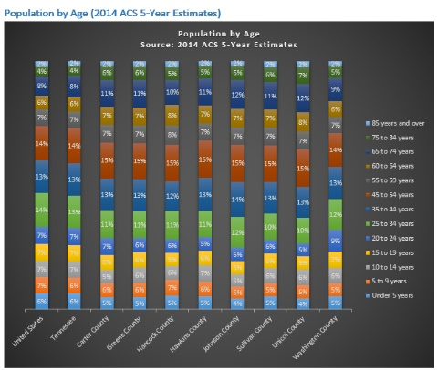KFigure : Population by Gender (2014 ACS 5-Year Estimates)

NOTE: Appendix C illustrates each age group for the U.S., Tennessee and the UETHDA service area counties.

Click on image

### Households

On average, approximately two out of three households in the U.S. and Tennessee are family households. Hawkins County has the highest proportion of family households in the UETHDA service area, 70 percent, while Hancock and Washington Counties have the lowest proportion of family households, 64 percent each. In the U.S. and Tennessee, 29 and 28 percent of households have children under the age of 18. Approximately one in four households in the eight-county service area have children under the age of 18.

Table 6 and Figure 13 list and illustrate the proportion of households with children under age 6 only, those households with children both under age 6 *and* age 6-17, and households with children ages 6-17 only. Hancock County has the highest proportion of households with children under age 6 only, 25.1 percent. Unicoi County has the highest proportion of households with children both under age 6 *and* ages 6-17, 18.5 percent. Johnston County has the highest proportion of households with children ages 6-17 only, 70.1 percent.

|  |  |  |  |  |  |  |  |  |
| --- | --- | --- | --- | --- | --- | --- | --- | --- |
|  | Total households | Total families | | Households with own children < 18 years | | < 6 years only | < 6 years and 6-17 years | 6-17 years only |
| United States | 116,211,092 | 76,958,064 | 66% | 33,917,911 | 29% | 22.1% | 20.1% | 57.8% |
| Tennessee | 2,487,349 | 1,658,171 | 67% | 691,142 | 28% | 22.6% | 19.2% | 58.2% |
| Carter County | 24,090 | 16,334 | 68% | 5,953 | 25% | 23.3% | 20.2% | 56.5% |
| Greene County | 28,489 | 19,348 | 68% | 6,547 | 23% | 16.8% | 18.2% | 65.0% |
| Hancock County | 2,819 | 1,806 | 64% | 653 | 23% | 25.1% | 11.0% | 63.9% |
| Hawkins County | 23,414 | 16,391 | 70% | 6,316 | 27% | 22.0% | 16.4% | 61.6% |
| Johnson County | 7,110 | 4,792 | 67% | 1,747 | 25% | 19.9% | 10.0% | 70.1% |
| Sullivan County | 66,279 | 43,834 | 66% | 16,300 | 25% | 18.8% | 15.1% | 66.0% |
| Unicoi County | 7,579 | 5,013 | 66% | 1,921 | 25% | 15.8% | 18.5% | 65.7% |
| Washington County | 52,330 | 33,463 | 64% | 12,601 | 24% | 24.6% | 16.9% | 58.4% |

Table : Households with Own Children < 18 Years (2014 ACS 5-Year Estimates)

Figure : Households with Own Children < 18 Years (2014 ACS 5-Year Estimates)

In the U.S. more than 8 million families with children below age 18 are led by a single female without a husband present. One in five (20 percent) of those families have children that are under 6 only, 18.7 percent have children, ages 0 to 17, and 61.3 percent have children, ages 6 to 17, only. In Tennessee more than 182,000 families with children below age 18 are led by a single female without a husband present; the distribution of children by age is similar to the U.S. distribution. Sullivan County has the highest number of families with children below age 18 led by a single female without a husband present, 4,060; 18.6 percent are families with children under age 6 only. Hancock County has the highest proportion of families led by single women without a husband present with children under age 6 only, 47.9 percent (Table 7, Fig 14).

| Female householder, no husband present, family household with own children under 18 | | | Under 6 years only | Under 6 years and 6 to 17 years | 6 to 17 years only |
| --- | --- | --- | --- | --- | --- |
| United States | 8,431,335 | 20.0% | | 18.7% | 61.3% |
| Tennessee | 182,629 | 21.8% | | 18.3% | 60.0% |
| Carter County | 1,509 | 31.2% | | 10.9% | 57.9% |
| Greene County | 1,459 | 14.5% | | 17.8% | 67.7% |
| Hancock County | 219 | 47.9% | | 6.8% | 45.2% |
| Hawkins County | 1,410 | 23.3% | | 11.1% | 65.6% |
| Johnson County | 300 | 7.0% | | 6.0% | 87.0% |
| Sullivan County | 4,060 | 18.6% | | 16.4% | 65.0% |
| Unicoi County | 292 | 9.6% | | 15.1% | 75.3% |
| Washington County | 2,850 | 22.6% | | 14.8% | 62.6% |

Table : Female householder, no husband present, with own children under 18 (2014 ACS 5-Year Estimates

Figure : Female householder, no husband present, with own children under 18 (2014 ACS 5-Year Estimates

### Grandparents

*An increasing number of children in the United States live in households headed by a grandparent. This trend is due to: increasing numbers of single parent families, the high rate of divorce, teenage pregnancies, incarcerations of parents, substance abuse by parents, illness, disability or death of parents, parental abuse or neglect. In many of these homes, neither of the child's biological parents is present. In most cases, children taken care of by grandparents move in with them as infants or preschoolers and remain with them for five years or more. These grandparents are a diverse group ranging in age from their thirties to their seventies. Many grandparents are ready to simplify their lives and slow down. Giving that up and taking over the responsibilities of being a primary caregiver again can stir up many feelings including grief, anger, loss, resentment, and possibly guilt. The transition can be very stressful and the emotional and financial burdens can be significant. Culture shock at having to deal with children and adolescents of a different generation can be great. Grandparent-headed households have a significantly higher poverty rate than other kinds of family units.*

***--- American Academy of Child and Adolescent Psychiatry***

In the United States more than 7 million grandparents live with their own grandchildren under age 18, of which 2.7 million (38 percent) are responsible for their grandchildren. In Tennessee more than 155,000 grandparents live with their own grandchildren under age 18, of which more than 75,000 are responsible for their grandchildren (49 percent) (Table 8).

In the UETHDA service area, more than 11,000 grandparents live with their own grandchildren under age 18, of which more than 6,200 are responsible for their grandchildren (55 percent). In Hancock County 68 percent of grandparents living with their own grandchildren are responsible for them, and 38 percent have been responsible for them for one to two years (Fig 15).

|  |  |  |  |  |
| --- | --- | --- | --- | --- |
| Grandparents living with own grandchildren under 18 years | | Responsible for grandchildren | | |
| United States | 7,138,514 | 2,715,879 | 38% |
| Tennessee | 155,190 | 75,316 | 49% |
| Carter County | 1,511 | 895 | 59% |
| Greene County | 1,784 | 1,045 | 59% |
| Hancock County | 149 | 102 | 68% |
| Hawkins County | 1,448 | 895 | 62% |
| Johnson County | 443 | 259 | 58% |
| Sullivan County | 3,705 | 2,043 | 55% |
| Unicoi County | 121 | 74 | 61% |
| Washington County | 2,212 | 943 | 43% |

Table : Grandparents living with own grandchildren < 18 years (2014 ACS 5-Year Estimates)

Figure : Grandparents Years Responsible for Grandchildren (2014 ACS 5-Year Estimates)

### Language

In the United States more than one in five persons over the age of 5 living in poverty speak Spanish as their primary language (21.4 percent). For the state of Tennessee overall, this statistic drops down to 7.5 percent. In Unicoi County the highest percent of persons over the age of 5 living in poverty speak Spanish as their primary language, 12.8, while Hancock reports the lowest at 0 percent (Table 9).

|  |  |  |  |  |  |
| --- | --- | --- | --- | --- | --- |
|  | Speak only English | Speak Spanish | Speak other Indo-European languages | Speak Asian and Pacific Island languages | Speak other languages |
| United States | 70.5% | 21.4% | 3.4% | 3.1% | 1.6% |
| Tennessee | 89.2% | 7.5% | 1.3% | 0.8% | 1.2% |
| Carter County | 98.1% | 1.1% | 0.3% | 0.0% | 0.6% |
| Greene County | 92.9% | 6.3% | 0.5% | 0.2% | 0.1% |
| Hancock County | 99.8% | 0.0% | 0.0% | 0.0% | 0.2% |
| Hawkins County | 97.1% | 2.2% | 0.3% | 0.1% | 0.4% |
| Johnson County | 97.6% | 2.4% | 0.0% | 0.0% | 0.0% |
| Sullivan County | 95.9% | 3.1% | 0.4% | 0.3% | 0.3% |
| Unicoi County | 87.2% | 12.8% | 0.0% | 0.0% | 0.0% |
| Washington County | 94.4% | 4.4% | 0.6% | 0.4% | 0.2% |

Table : Languages Spoken by Population (age 5+) in Poverty (2014 ACS 5-Year Estimates)

#### Linguistically Isolated Households

*Increased linguistic diversity contributes to the United States’ global competitiveness and our ability to integrate culturally and economically. Speaking a parent’s native language other than English at home can have a positive effect on children’s English literacy development, and bilingual language skills can positively affect children’s educational achievement. The Census Bureau’s report, however, highlights a sobering statistic: millions of residents of the United States are not proficient in the English language. In fact,* ***the*** [***Census Bureau***](http://www.census.gov) ***classifies five percent of US households as linguistically-isolated****. A linguistically-isolated household is one where no one in the home above the age of 14 speaks English only or speaks a second language and speaks English well.*

In the U.S. 4.5 percent of all households are linguistically isolated; no one age 14 and over speaks English only or speaks English “very well.” In Tennessee and the UETHDA service area, between 0.3 and 1.5 percent of all households are linguistically isolated. Linguistic isolation for those households who speak Spanish ranges from 0 percent (Hancock County) to 29.6 percent (Greene County) (Table 10).

|  |  |  |  |  |  |
| --- | --- | --- | --- | --- | --- |
| Limited English Speaking Households: No one age 14 and over speaks English only or speaks English "very well" | | | | | |
|  | **All households** | **Households speaking** | | | |
| **Spanish** | **Other Indo-European languages** | **Asian and Pacific Island languages** | **Other languages** |
| United States | 4.5% | 23.5% | 15.8% | 26.7% | 17.1% |
| Tennessee | 1.5% | 26.8% | 9.2% | 22.4% | 24.9% |
| Carter County | 0.3% | 6.7% | 11.4% | 10.5% | 0.0% |
| Greene County | 0.9% | 29.6% | 0.0% | 21.1% | 0.0% |
| Hancock County | 0.4% | 0.0% | 0.0% | 100.0% | 0.0% |
| Hawkins County | 0.3% | 14.5% | 2.0% | 11.3% | 0.0% |
| Johnson County | 0.5% | 20.0% | 36.8% | - | - |
| Sullivan County | 0.3% | 8.8% | 5.5% | 5.0% | 35.7% |
| Unicoi County | 0.4% | 24.6% | 0.0% | - | 0.0% |
| Washington County | 0.5% | 14.1% | 5.6% | 8.9% | 0.0% |

Table : Limited English Speaking Households (2014 ACS 5-Year Estimates)

## Socioeconomic Status

### Education

#### Educational Attainment

Almost one-quarter of adults in Tennessee have obtained a bachelor’s degree or higher (24.4 percent). Education levels in most of the UETHDA service area counties is significantly lower. In Johnson County less than one in 10 adults over the age of 25 have a bachelor’s degree or higher, 9.3 percent. Sullivan and Washington Counties have the highest educational attainment levels; 21.2 and 30.8 percent of adults, respectively, have a bachelor’s degree or higher (Table 11).

Figure 16 illustrates the educational attainment of adults in more detail; Hancock County’s proportion of the population with less than a ninth grade education is more than double that of Tennessee (14 vs. 6 percent). In a globally competing market, regions and cities with high concentrations of well-educated people are far better equipped to attract both local and foreign businesses. These businesses assist in lowering unemployment rates, increase median household incomes, and reduce the number of families living in poverty.

|  |  |  |
| --- | --- | --- |
|  | Percent high school graduate or higher | Percent bachelor's degree or higher |
| United States | 86.3% | 29.3% |
| Tennessee | 84.9% | 24.4% |
| Carter County | 80.2% | 16.1% |
| Greene County | 80.4% | 15.5% |
| Hancock County | 76.3% | 10.1% |
| Hawkins County | 81.3% | 13.0% |
| Johnson County | 74.2% | 9.3% |
| Sullivan County | 84.7% | 21.2% |
| Unicoi County | 77.2% | 13.4% |
| Washington County | 87.1% | 30.8% |

Table : Educational Attainment Population 25 years + (2014 ACS 5-Year Estimates)

Figure : Educational Attainment Population 25 years + (2014 ACS 5-Year Estimates)

#### Tennessee Department of Education

During the 2014-2015 school year there were 1,813 public schools in Tennessee, of which 105 are in the UETHDA service area counties. Two out of three students in Tennessee schools are white (64.9 percent), approximately one-quarter are black/African American (24.1 percent), and 8.5 percent are Hispanic/Latino. The majority of students in the eight UETHDA county schools is white, ranging from 87.5 to 98.3 percent. Unicoi County schools reported a Hispanic/Latino population of 11.4 percent, significantly higher than any of the other county schools (Fig 17).[3]

Figure : TN Schools: Student Membership (Race/Ethnicity)

#### Graduation Rates

At the end of the 2014-15 school year in Tennessee 87.8 percent of students graduated from high school; graduation rates for the same cohort in the UETHDA service area counties were higher than 90 percent in five counties; the lowest graduation rates were in Hancock County, 83.6 percent (Fig 18).[4]

Figure : TN Schools: Graduation Rates (2015)

### Employment Status and Income

|  |  |  |
| --- | --- | --- |
| Unemployment Rate (May 2016) | | |
| Tennessee | 4.1 |
| Carter County | 4.4 |
| Greene County | 4.1 |
| Hancock County | 5.8 |
| Hawkins County | 4.3 |
| Johnson County | 3.6 |
| Sullivan County | 4.2 |
| Unicoi County | 5.8 |
| Washington County | 3.9 |

According to the [U.S. Department of Labor, Bureau of Labor Statistics](http://data.bls.gov/), the unemployment rate in Tennessee (not seasonally adjusted) in May 2016 was 4.1 percent. The county with the highest unemployment rate was Houston County, 6.6 percent, while the county with the lowest unemployment rate was Williamson County, 2.7 percent.[5]

Table : Unemployment Rates by County, not seasonally adjusted (May 2016)

The unemployment rates for the UETHDA service area counties rage from 3.6 percent (Johnson County) to 5.8 percent (Hancock and Unicoi Counties) (Table 12).

In Tennessee the mean (average) household income is just over $44,600, while the mean family income is almost $74,000, both lower than the mean household and mean family income in the United States. The state’s per capita income is $24,811, while the per capita income in the U.S. is $28,555 (Table 13, Fig 19). Washington County has the highest per capita income in the UETHDA service area, $26,083, higher than the state per capita income. Hancock County has the lowest per capita income, $15,464.

**Per capita income** measures the average income earned per person in a given area (city, region, country, etc.) in a specified year. It is calculated by dividing the area's total income by its total population.

|  |  |  |  |  |  |
| --- | --- | --- | --- | --- | --- |
|  | **Median household income** | **Mean household income** | **Median family income** | **Mean family income** | **Per capita income** |
| **United States** | $53,482 | $74,596 | $65,443 | $86,963 | $28,555 |
| **Tennessee** | $44,621 | $62,344 | $55,459 | $73,630 | $24,811 |
| **Carter County** | $32,754 | $44,972 | $41,840 | $52,384 | $19,385 |
| **Greene County** | $35,860 | $47,295 | $44,581 | $54,951 | $19,998 |
| **Hancock County** | $26,528 | $35,875 | $34,494 | $44,395 | $15,464 |
| **Hawkins County** | $37,432 | $50,938 | $46,969 | $58,030 | $21,259 |
| **Johnson County** | $31,711 | $41,297 | $41,018 | $48,989 | $17,273 |
| **Sullivan County** | $39,577 | $56,070 | $52,524 | $68,006 | $24,085 |
| **Unicoi County** | $34,346 | $49,206 | $48,921 | $61,607 | $21,162 |
| **Washington County** | $42,935 | $61,094 | $53,715 | $74,510 | $26,083 |

Table : Income in 2014 Inflation-Adjusted Dollars (2014 ACS 5-Year Estimates)

Figure : Per Capita Income in 2014 Inflation-Adjusted Dollars (2014 ACS 5-Year Estimates)

### Occupation and Industries

In the United States and Tennessee more than one in three civilian employed persons over the age of 16 are employed in management, business, science and arts occupations, and approximately 24 to 25 percent are in sales and office occupations. In the UETDHA service area Washington County has the highest percent of its civilian employed population employed in management, business, science and arts occupations, 38 percent, while Hancock County yields the lowest proportion, 23 percent. Five out of eight UETHDA service area counties report having one in five persons employed in production, transportation and material moving occupations: Greene, Hancock, Hawkins, Johnson, and Unicoi Counties (Fig 20).

Figure : Occupation of Civilian Employed Population Age 16+ (2014 ACS 5-Year Estimates)

Figure 21 on the following page illustrates the industry of the civilian employed population over the age of 16. Although educational services, health care and social assistance are the largest industries overall, six of the eight UETHDA service area counties have a higher proportion of individuals employed in manufacturing (Greene, Hancock, Hawkins, Johnson, Sullivan, and Unicoi Counties). In Hancock County 7 percent are employed in agriculture, forestry, fishing and hunting and mining industries, compared with 1 percent in Tennessee.

Figure : Industry of Civilian Employed Population Age 16+ (2014 ACS 5-Year Estimates)

### Poverty

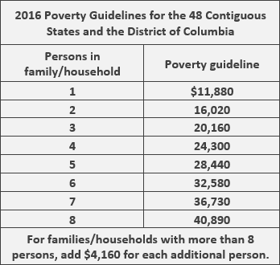The [U.S. Department of Health and Human Services](http://www.hhs.gov/) issues the Federal Poverty Guidelines in the [Federal Register](https://www.federalregister.gov/articles/2015/01/22/2015-01120/annual-update-of-the-hhs-poverty-guidelines) annually. The Poverty Guideline for a family of four in 2016 is $24,300. Research suggests that a family of four requires at least double that amount to make ends meet.[6]

The guideline measurement only accounts for the family’s gross annual income; it does not include other aspects of economic status such as housing, debt, assets, or property. The calculation used today was originally developed in the 1960s based on the amount of money spent by families on food. The poverty level was reached by multiplying that dollar amount (money spent by families on food) times three. Today families not only spend approximately one-seventh of their annual income on food, but the cost of childcare, transportation, and health care have increased drastically over the past 50 years.[7]

**Poverty in Tennessee.** Per the 2014 [Small Area Income and Poverty Estimates (SAIPE),](http://www.census.gov/did/www/saipe/) 18.2 percent of the population in Tennessee lives in poverty (more than 1.1 million individuals), and 25.9 percent of children, ages 0-17, live in poverty (more than 380,000 children). The UETHDA service area county with the highest poverty rate is Hancock County, where 29.5 percent of the population lives in poverty and 42.8 percent of children age 0-17 live in poverty. Almost 114,000 Head Start and Early Head Start eligible children, ages 0 to 4, live in poverty in Tennessee (Table 14).

|  |  |  |  |  |  |  |
| --- | --- | --- | --- | --- | --- | --- |
| Counties | Poverty Estimate All Ages | Poverty Percent All Ages | Poverty Estimate Ages 0-17 | Poverty Percent Ages 0-17 | Poverty Estimate Ages 0-4 | Poverty Percent Ages 0-4 |
| United States | 48,208,387 | 15.5 | 15,686,012 | 21.7 | 4,658,187 | 23.9 |
| Tennessee | 1,165,245 | 18.2 | 380,159 | 25.9 | 113,943 | 29.2 |
| Carter County | 13,567 | 24.6 | 3,535 | 33.2 | ***Note****: The SAIPE does not estimate the number of children ages 0-4 in poverty by county; 2014 ACS 5-year estimates from the U.S. Census Bureau are used in subsequent sections of this report.* | |
| Greene County | 11,768 | 17.7 | 3,328 | 24.9 |
| Hancock County | 1,915 | 29.5 | 597 | 42.8 |
| Hawkins County | 10,987 | 19.6 | 3,239 | 27.6 |
| Johnson County | 4,231 | 26.4 | 1,065 | 35.3 |
| Sullivan County | 28,608 | 18.5 | 8,673 | 28.2 |
| Union County | 4,266 | 22.6 | 1,451 | 33.3 |
| Washington County | 20,388 | 16.7 | 5,408 | 22.0 |
|  | | | | | | |

Table : 2014 Small Area Income and Poverty Estimates

#### Gender

In the U.S. Tennessee, and the UETHDA service area, women live in poverty at greater rates than men. The highest discrepancy is seen in Hancock County, where 23 percent of males live in poverty, yet 33 percent of females live in poverty (Fig 22).

Figure : Poverty Rates by Gender (2014 ACS 5-Year Estimates)

#### Race/Ethnicity

In Tennessee 29 percent of black or African Americans live in poverty, though the highest poverty rates are reported for those who report their race as ‘other’ (36 percent), and Hispanic/Latino residents (34 percent) (Fig 23). In Hancock County 100 percent of black/African American residents reportedly live in poverty. Poverty rates for Hispanic/Latino residents are highest in Greene County (64 percent), and Unicoi County (61 percent) (Table 15).

Figure : Poverty Rates by Race/Ethnicity (2014 ACS 5-Year Estimates)

|  |  |  |  |  |  |  |  |  |
| --- | --- | --- | --- | --- | --- | --- | --- | --- |
|  | White | Black/AA | AIAN | Asian | NHPI | Other | Two | Hispanic / Latino |
| Carter County | 23% | 51% | 29% | 9% | - | 35% | 24% | 24% |
| Greene County | 21% | 35% | 6% | 17% | 0% | 69% | 66% | 64% |
| Hancock County | 28% | 100% | 61% | 0% | - | 0% | 36% | - |
| Hawkins County | 17% | 18% | 43% | 4% | - | 34% | 27% | 30% |
| Johnson County | 23% | 48% | 0% | 0% | - | 97% | 40% | 58% |
| Sullivan County | 17% | 29% | 41% | 10% | 20% | 32% | 46% | 42% |
| Unicoi County | 21% | 5% | 100% | 0% | - | 22% | 48% | 61% |
| Washington County | 17% | 38% | 3% | 12% | 0% | 34% | 38% | 35% |

Table : Poverty Rates by Race/Ethnicity (2014 ACS 5-Year Estimates)

#### Educational Attainment

In the U.S. more than one in four adults over age 25 without a high school degree live in poverty; in Tennessee the rate is slightly higher, at 30 percent. In the UETHDA service area between 25 percent (Hawkins and Washington Counties) and 43 percent (Hancock County) of adults over age 25 without a high school degree live in poverty (Fig 24). Obtaining a higher education degree greatly reduces the poverty rate. However, it does not eliminate it completely. Between 3 and 7 percent of adults with a bachelor’s degree or higher live in poverty in the U.S., Tennessee, and the UETHDA service area.

Figure : Poverty Rates by Educational Attainment (2014 ACS 5-Year Estimates)

#### Employment

The greatest discrepancy in poverty rates is seen between the employed and unemployed labor force. In the U.S. 6 percent of employed males and 8 percent of employed females live in poverty; however, 30 percent of unemployed males and 36 percent of unemployed females live in poverty. Fig 25 illustrates the poverty rates by employment and gender. The highest poverty rate listed is for unemployed females in Hancock County, 57 percent.

Figure : Poverty Rates by Employement (2014 ACS 5-Year Estimates)

#### Children in Poverty

According to 2014 Small Area Income and Poverty Estimates (SAIPE) from the U.S. Census Bureau, Tennessee is home to approximately 113,943 children, ages 0-4, in poverty. SAIPE estimates for children, ages 0-4, in poverty, are not provided for individual counties, townships, or census tracts. In order to estimate children in poverty in the UETHDA service area, poverty data from the 2014 ACS 5-year estimate will be used. These estimates use data from 2010 to 2014, and reflect a 4 percent greater number of children in poverty: 118,580 vs. 113,943 (Table 16). The economy, job market, unemployment, cost of housing and health care all contribute to the increase in poverty statistics, causing an aggregate estimate of five years (2010-14) to be higher than the estimates for 2014 alone.

Based on 2014 ACS 5-year estimates, 55 percent of children, ages 0-4, in poverty in Tennessee are white, 32 percent are black or African American, 6 percent identify as having an “other” race and 6 percent identify as having two or more races. The majority of children, ages 0-4, in poverty in the UETHDA service area are white; in Washington County 21 percent of children, ages 0-4, in poverty are black/African American, a significantly larger proportion than in any of the other counties (Fig 26). In Tennessee 17 percent of children in poverty, ages 0-4, are Hispanic/Latino. In the UETHDA service area Hispanic/Latino children, ages 0-4, make up between 0 and 15 percent of all children, ages 0-4, in poverty.

|  |  |  |  |  |  |  |  |  |
| --- | --- | --- | --- | --- | --- | --- | --- | --- |
|  | **Under 5 years** | **White** | **Black** | **AIAN** | **Asian** | **NHPI** | **Other** | **Two+** |
| **United States** | 4,892,716 | 2,609,515 | 1,225,144 | 76,678 | 110,546 | 11,931 | 503,499 | 355,403 |
| **Tennessee** | 118,580 | 64,645 | 38,236 | 381 | 803 | 118 | 7,098 | 7,299 |
| **Carter County** | 1,316 | 1,193 | 39 | - | - | - | 31 | 53 |
| **Greene County** | 1,271 | 1,055 | 30 | - | - | - | 47 | 139 |
| **Hancock County** | 181 | 172 | - | - | - | - | - | 9 |
| **Hawkins County** | 791 | 677 | 11 | - | - | - | 45 | 58 |
| **Johnson County** | 216 | 194 | - | - | - | - | 20 | 2 |
| **Sullivan County** | 2,565 | 2,340 | 53 | - | - | - | 71 | 101 |
| **Unicoi County** | 201 | 201 | - | - | - | - | - | - |
| **Washington County** | 1,369 | 1,058 | 293 | - | - | - | - | 18 |

Table : Children Ages 0-4 in Poverty (2014 ACS 5-Year Estimates)

Figure : Children Ages 0-4 in Poverty by Race/Ethnicity (2014 ACS 5-Year Estimates)

### Federal Assistance Benefits

#### TANF

[Temporary Assistance for Needy Families (TANF)](http://www.acf.hhs.gov/programs/ofa/programs/tanf) provides temporary cash assistance and employment-related services to enable families with children to become self-supporting. Tennessee provides TANF through a program called Families First. The program’s benefits are time-limited to 60 months in a participant’s lifetime. To be eligible for the program, participants must agree to follow a Personal Responsibility Plan (PRP). As part of the PRP, the participant agrees to keep immunizations and health checks up to date for their children, keep their children in school, co-operate with Child Support Services to establish paternity, and participate in a work/training program for at least 30 hours per week.[8]

Based on data collected from the Annie E. Casey Kids Count Data Center, 86,595 children under the age of 18 received TANF benefits in Tennessee during the 2014 fiscal year, down from 94,648 the previous year (Table 17). The number of families receiving TANF benefits decreased in each UETHDA service area county from 2013 to 2014 with the exception of Hancock and Hawkins Counties, where a small increase was seen.

|  |  |  |  |  |  |
| --- | --- | --- | --- | --- | --- |
|  | FY2010 | FY2011 | FY2012 | FY2013 | FY2014 |
| Tennessee | 119,929 | 116,024 | 108,253 | 94,648 | 86,595 |
| Carter | 519 | 498 | 481 | 473 | 443 |
| Greene | 834 | 804 | 850 | 772 | 730 |
| Hancock | 154 | 144 | 134 | 134 | 148 |
| Hawkins | 795 | 735 | 684 | 698 | 710 |
| Johnson | 264 | 269 | 299 | 252 | 242 |
| Sullivan | 2,196 | 2,157 | 1,976 | 1,785 | 1,709 |
| Unicoi | 264 | 240 | 217 | 188 | 175 |
| Washington | 1,206 | 1,106 | 1,084 | 1,068 | 1,006 |

Table : Children Receiving Families First Grants (TANF) (2010-14)

#### SSI

[Supplemental Security Income, or SSI](http://www.ssa.gov/disabilityssi/ssi.html), are monthly financial payments made to low-income adults who are blind, disabled, or age 65 and older. Disabled or blind children are also eligible to receive SSI benefits. Families receiving SSI are categorically eligible for Head Start and Early Head Start services, providing the family an additional benefit and supportive resource. In 2014, 183,890 individuals received SSI benefits in Tennessee, of which 14 percent where children under age 18 (Table 18).[9] Hancock County has the lowest percent of SSI recipients who are children under age 18, 4 percent, while in Washington County 10 percent of SSI recipients are children under age 18.

|  |  |  |
| --- | --- | --- |
| Number of SSI Recipients by Age - 2014 (released October 2015) | | |
|  | Total |  |
| Tennessee | 183,890 |
| Carter | 2,189 |
| Greene | 2,541 |
| Hancock | 504 |
| Hawkins | 2,097 |
| Johnson | 768 |
| Sullivan | 4,841 |
| Unicoi | 633 |
| Washington | 3,334 |

Table : Number of SSI Recipients by Age - 2014 (released October 2015)

## Economic Features and Trends

**State of Tennessee’s Economy.** According to the Center for Business and Economic Research (CBER) at The University of Tennessee, the State of Tennessee’s economy continued to expand in 2015. Inflation-adjusted gross domestic product (GDP) grew by 2.4 percent for the year, representing an addition of 54,600 new jobs. Job growth in Tennessee was slightly slower than national job gains of 2.1 percent for 2015.

The state unemployment rate fell from 6.6 percent in 2014 to 5.9 percent in 2015, but it still rests above the U.S. rate. CBER economists predict that the state’s unemployment rate will fall to 5.5 percent in 2016 and 5.4 percent in 2017. This would be the first time that Tennessee’s unemployment rate fell below 6 percent since 2007. However, researchers with the University of Tennessee also forecast that during that period of 2016-17, Tennessee’s unemployment rate will remain above the national unemployment rate.

In Tennessee the nominal personal income (unadjusted for inflation or deflation) grew by 4.7 percent in 2015, outpacing the national growth rate of 4.5 percent. Nominal personal income will grow by 4.8 percent in 2016 and 4.7 percent in 2017. It is estimated that all components of personal income in Tennessee will enjoy healthy growth over the next two years. The number of unemployed people in Tennessee is projected to fall by 6.2 percent in 2016 and an additional 1.7 percent in 2017.

According the CBER, the State of Tennessee is projected to see slightly slower growth in 2016 and 2017. The state’s leisure and hospitality, professional and business services, and natural resources, mining, and construction will experience the largest job gains in both 2016 and 2017. Manufacturing employment will continue to increase but at a slow rate of 0.7 percent in 2016 and 2017. Manufacturing employment growth will occur in the durable goods sector, expanding by 1.5 percent in 2016 and 2017. These gains will offset the losses in the nondurable goods manufacturing sector, where employment is projected to shrink by 0.7 percent in 2016 and 0.8 percent in 2017.

**Upper East Tennessee’s Economy.** There are two economically vital Metropolitan Statistical Areas in Upper East Tennessee. The Office of Management and Budget (OMB) defines a Metropolitan Statistical Area as one or more adjacent counties or county equivalents that have at least one urban core area of at least 50,000 residents, plus the adjacent territory that has a high degree of social and economic integration with the core as measured by commuting ties.

The MSAs in upper East Tennessee include: The Johnson City Metropolitan Statistical Area and Kingsport–Bristol–Bristol, Tennessee-Virginia Metropolitan Statistical Area. These MSA are also a component of the Johnson City–Kingsport–Bristol, TN-VA Combined Statistical Area – commonly known as the "Tri-Cities" region. This CSA is the fifth largest in Tennessee, with an estimated 500,538 people in residence.

**The Johnson City TN Metropolitan Statistical Area**, as defined by the United States Census Bureau, is the 219th largest in the nation, with a combined population of 200,271. The largest counties by population are Washington County, Carter County, and Unicoi Counties. The largest places in the Johnson City, Tennessee Metro Area by population are Johnson City, Elizabethton, and Erwin.

Johnson City is an economic hub largely fueled by East Tennessee State University and the medical "Med-Tech" corridor. The Medical corridor components include the Johnson City Medical Center, Franklin Woods Community Hospital, ETSU's Gatton College of Pharmacy, and ETSU's Quillen College of Medicine.

There are a number of major companies headquartered in Johnson City, and the top employers are:

|  |  |
| --- | --- |
| EMPLOYER | No. Employees |
| Mountain States Health Alliance | 3,541 |
| East Tennessee State University | 1,990 |
| Citi Commerce Solutions | 1,700 |
| Washington County School System | 1,275 |
| James H. Quillen VA Medical Center | 1,259 |
| American Water Heater Company | 1,194 |
| AT&T Mobility (formerly Cingular) | 1,000 |

Table : Top Employers in Johnson City

Carter County is also part of the Johnson City, Tennessee Metropolitan Statistical Area. Carter County and its major cities, Elizabethton and Watauga, are located very close to a major I-26 corridor, making interstate commerce accessible to important markets, thriving cities, and small tourist attractions.

**The Kingsport–Bristol–Bristol, Tennessee-Virginia Metropolitan Statistical Area** is the 164th largest in the nation with a combined population of 308,590. The largest counties by population are Sullivan County, Hawkins County, and Washington County, VA. The largest places in Kingsport-Bristol-Bristol, TN-VA Metro Area by population are Johnson City, Kingsport, and Bristol. It was formed in December 2003 by the merger of the Bristol, VA MSA and the Kingsport-Bristol, TN-VA MSA.

Eastman Chemical Company is headquartered in Kingsport. Domtar operates the Kingsport Mill, at which the company produces uncoated freesheet.Holston Army Ammunition Plant, operated by BAE Systems' Ordnance Systems, Inc., manufactures a wide range of secondary detonating explosives for the Department of Defense.

**Bristol** is a city in Sullivan County, Tennessee. It is the twin city of Bristol, Virginia, which lies directly across the state line between Tennessee and Virginia. The boundary between the two cities is also the state line, which runs along State Street in their common downtown district. Top industries in Sullivan County include:

|  |  |
| --- | --- |
| Employer | Employees |
| 1. Eastman | 6,800 |
| 2. Wellmont Health Systems | 6,225 |
| 3. Holston Medical Group | 5,300 |
| 4. Sullivan County Department of Education | 1,650 |
| 5. Kingsport City Schools | 1,100 |
| 6. Pal's Fast Food | 950 |
| 7. CenturyLink Telecommunications | 950 |
| 8. BAE Systems | 525 |
| 9. Domtar Paper | 330 |
| 10.Robinette Company | 325 |

Table : Top Employers in Sullivan County

**Greene County** is located 30 miles southwest of the Tri-Cities region of Johnson City/Kingsport/Bristol, and 54 miles northwest of Asheville, North Carolina. Greene County's diverse industrial base consists of more than 90 industries. Since the formation of the Greene County Partnership in 1993, an organization to promote economic and tourism development, education, chamber of commerce, and beautification and leadership programs in the county, more than 20 manufacturing/distribution companies have located to Greene County. Greene County, Tennessee’s Top Manufacturing Employers include:

|  |  |
| --- | --- |
| ****Employer**** | Employees |
| ****Wal-Mart Logistics**** (Distribution of General & Hardline Goods) | 776 |
| ****DTR Tennessee, Inc.**** (Automotive Anti-Vibration/Hose Products) | 700 |
| ****American Greetings**** (Gift Wrap, Ribbons and Bows, Cards) | 461 |
| ****Worthington Industries**** (Rollover Protective Systems and Cabs) | 410 |
| ****Huf North America**** (Automotive Lock Sets) | 400 |
| ****Parker Hannifin**** (Hydrostatic Motors/Manual Steering Gears) | 400 |
| ****TI Group Automotive Systems**** (Automotive OEM Parts Supplier) | 252 |
| ****Jarden Zinc Products**** (Zinc Casting, Rolling, Slitting, and Fab.) | 252 |
| ****OldcastleBuildingEnvelope**** (Arch Alum Extrusion Roof, Window and Wall Systems) | 250 |
| ****Crown Tonka**** (Walk-In Coolers, Freezers) | 220 |
| ****Donaldson Company**** (Air Filtration Systems) | 155 |
| ****Packaging Services, Inc.**** (Corrugated Boxes, Color Printing, Displays) | 146 |
| ****LMR Plastics**** (Plastic Injection Molding) | 128 |
| ****Ceradyne Inc. - a 3M Company**** (Fused Silica & Fused Magnesia) | 115 |

Table : Top Employers in Green County

**Hawkins County** is located in northeast Tennessee, extending down from the Virginia state line. The county is divided into two almost equal sections by the Holston River, which crosses the county's entire length. It is one of the largest counties in the state. According to Hawkins County Industrial Development Board, the county has an excellent labor force trained in all types of industrial skills. Hawkins County and Phipps Bend Industrial Park are located within minutes of Interstates 81, 40, and 75.  The Tri City airport is within 30 miles and is serviced by 5 carriers. The county is served by Norfolk-Southern and CSX Rail Systems. Hawkins County has a diversified industrial base with no dominant industry. Major local industries employ more than 6,000 people and produce goods ranging from paper labels and reclining chairs to power rack-and-pinion steering. The highest paid jobs in Hawkins County, by median earnings, are Architects, Surveyors, and Cartographers; Physicians and Surgeons; and Human Resources professionals.

The most common industries in Hancock County, Tennessee, by number of employees, are Manufacturing, Healthcare & Social Assistance, and Retail trade. Compared to other counties, Hancock County, Tennessee, has an unusually high number of Agriculture, Forestry, Fishing, Hunting; Mining, Quarrying, Oil, Gas Extraction; and Utilities employers. The highest paying industries in Hancock County, Tennessee, by median earnings, are Finance & Insurance, Utilities, and Transportation & Warehousing.

## Housing and Homelessness

### Housing Characteristics

Based on U.S. Census data, in the United States there are more than 132 million housing units, of which more than 116 million (or 87.5 percent) are occupied housing units. The homeowner vacancy rate in the U.S. is estimated to be 2.1 percent, while the rental vacancy rate is estimated to be 6.9 percent. In Tennessee and the UETHDA service area the percent of occupied housing units ranges from 79.5 percent (Johnson County) to 90.2 percent (Washington County). Homeowner vacancy rates are greatest in Hancock and Hawkins Counties (5.7 and 3.7 percent, respectively), while the rental vacancy rates are greatest in Washington County (6.0 percent) (Table 22).

|  |  |  |  |  |  |  |  |
| --- | --- | --- | --- | --- | --- | --- | --- |
| Subject | Total housing units | Occupied housing units | | Vacant housing units | | Homeowner vacancy rate | Rental vacancy rate |
| United States | 132,741,033 | 116,211,092 | 87.5% | 16,529,941 | 12.5% | 2.1 | 6.9 |
| Tennessee | 2,839,142 | 2,487,349 | 87.6% | 351,793 | 12.4% | 2.2 | 8.2 |
| Carter County | 27,820 | 24,090 | 86.6% | 3,730 | 13.4% | 1.7 | 5.4 |
| Greene County | 32,076 | 28,489 | 88.8% | 3,587 | 11.2% | 1.5 | 5.3 |
| Hancock County | 3,616 | 2,819 | 78.0% | 797 | 22.0% | 5.7 | 4.7 |
| Hawkins County | 26,819 | 23,414 | 87.3% | 3,405 | 12.7% | 3.7 | 5.3 |
| Johnson County | 8,940 | 7,110 | 79.5% | 1,830 | 20.5% | 2.8 | 1.1 |
| Sullivan County | 73,952 | 66,279 | 89.6% | 7,673 | 10.4% | 1.9 | 5.9 |
| Unicoi County | 8,834 | 7,579 | 85.8% | 1,255 | 14.2% | 2.0 | 4.4 |
| Washington County | 58,045 | 52,330 | 90.2% | 5,715 | 9.8% | 2.4 | 6.0 |

Table : Housing Units and Occupancy (2014 ACS 5-Year Estimates)

Approximately one-half percent of occupied housing units in the U.S. lack complete plumbing facilities, and 0.9 percent lack complete kitchen facilities. In Tennessee a lower percentage of occupied housing units lack complete plumbing facilities (0.4 percent) and kitchen facilities (0.8 percent). In the UETHDA service area 2.8 and 1.7 percent of occupied housing units in Hancock and Johnson Counties lack complete plumbing facilities, respectively. Hancock County also leads in terms of occupied housing units lacking complete kitchen facilities, 1.6 percent (Fig 27).

Figure : Selected Characteristics of Occupied Housing Units (2013 ACS 5-Year Estimates)

In the U.S. almost half of all occupied housing units are heated by utility gas (48.8 percent). In Tennessee only one-third of occupied housing units are heated by utility gas, and almost 60 percent are heated by electricity. In the UETHDA service area the majority of homes are heated by electricity, between 53.2 percent (Unicoi County), and 84.0 percent (Sullivan County). In Hancock and Johnson Counties a larger proportion of homes are heated using bottled, tank, or LP gas when compared with the state average (6.9 and 13.2 percent, compared with 4.3 percent). Almost one in five homes (19.3 ad 18.8 percent) in Hancock and Johnson Counties, respectively, are heated by using wood (Fig 28).

Figure : House Heating Fuel of Occupied Housing Units (2014 ACS 5-Year Estimates)

### National Low Income Housing CoalitionFair Market Rent

According to the [National Low Income Housing Coalition (NLIHC)](http://nlihc.org/) in 2015, 33 percent of Tennessee’s households are renters; the Fair Market Rent (FMR) for a two-bedroom home is $779/month. In order to be able to rent a two-bedroom home, without exceeding 30 percent of one’s income, a renter must earn $31,175/year, yet the estimated median household income for a renter in Tennessee is $27,390.[10] With a median income of $27,390, a renter is able to afford $685 for a home, which is less than the fair market rental of a two-bedroom home.

The NLIHC considers those who earn 30 percent of the average mean income to have “extremely low income.” For Tennessee this amount is $17,280, which is almost $2,900 less than the poverty guideline level for a family of three. The rent that someone with “extremely low income” can afford is only $432 per month, $347 *less* than the fair market value of a two-bedroom home (Table 23, Fig 29).

|  |  |  |  |  |  |  |  |  |
| --- | --- | --- | --- | --- | --- | --- | --- | --- |
|  | % of total households that are renters | Two bedroom FMR | Income needed to afford 2 bedroom FMR | Estimated renter median income | Rent affordable at renter median income | 30% of AMI (Extremely Low Income) | Rent affordable at 30% of AMI | Work hrs/wk at minimum wage needed to afford 2 bdrm FMR |
| Tennessee | 33% | $779 | $31,175 | $27,390 | $685 | $17,280 | $432 | 83 |
| Carter | 29% | $658 | $26,320 | $19,670 | $492 | $14,940 | $374 | 70 |
| Greene | 29% | $586 | $23,440 | $22,833 | $571 | $13,890 | $347 | 62 |
| Hancock | 25% | $586 | $23,440 | $14,513 | $363 | $9,480 | $237 | 62 |
| Hawkins | 24% | $660 | $26,400 | $24,217 | $605 | $15,210 | $380 | 70 |
| Johnson | 22% | $586 | $23,440 | $18,559 | $464 | $11,340 | $284 | 62 |
| Sullivan | 26% | $660 | $26,400 | $21,962 | $549 | $15,210 | $380 | 70 |
| Unicoi | 26% | $658 | $26,320 | $19,479 | $487 | $14,940 | $374 | 70 |
| Washington | 33% | $658 | $26,320 | $22,992 | $575 | $14,940 | $374 | 70 |

Table : 2016 Out of Reach

Greene and Hancock Counties are the extremes in terms of affordable rent. In Greene County the rent that is affordable at the renter median income is $15 per month less than the local two-bedroom FMR. In Hancock County, the rent that is affordable at renter median income is $223 per month less than the local two-bedroom FMR. While renters at the median income in Greene County can almost afford their local two-bedroom FMR, similar renters in Hancock County cannot even afford half of the local FMR of a two-bedroom home (Fig 29).

Figure : 2016 Out of Reach - Fair Market Rental Values vs. Income

For those earning minimum wage in Tennessee, one would have to work more than two full-time jobs (83 hours) in order to afford the fair market rental value of a two-bedroom home. In the UETDHA service area those earning minimum wage need to work between 62 and 70 hours per week to afford the fair market rental value of a two-bedroom home (Fig 30).

Figure : Work Hours/Week

***Housing expenditures that exceed 30 percent*** *of household income have historically been viewed as an indicator of a housing affordability problem. The conventional 30 percent of household income that a household can devote to housing costs before the household is said to be “burdened” evolved from the United States National Housing Act of 1937. The thirty percent rule was considered a rule of thumb for the amount of income that a family could spend and still have enough left over for other non-discretionary spending, it made its way to owner-occupied housing too. -* [*http://www.census.gov/housing/census/publications/who-can-afford.pdf*](http://www.census.gov/housing/census/publications/who-can-afford.pdf)

### Public Housing

According to the June 2016 Resident Characteristic Report, issued by the [U.S. Department of Housing and Urban Development (HUD)](http://portal.hud.gov/hudportal/HUD), between March 1, 2015, and June 30, 2016, there were more than 32,000 households (with over 67,000 household members) in Tennessee residing in public housing, of which almost 2,500 households (with more than 5,000 household members) are in the UETHDA service area (Table 24).

The average annual income of households living in public housing in the UETHDA service area is between $6,658 (Hancock County) and $12,595 (Greene County). Approximately half of the households living in public housing in Tennessee are white, half are black/African American, and 2 percent of households are Hispanic/Latino. Sixteen percent of household members in public housing in Tennessee are children under the age of 5. In Hancock County 100 percent of households living in public housing are reportedly white. Washington County has the highest percentage of black/African American households (18 percent), as well as Hispanic/Latino households (6 percent). In both Hancock and Washington Counties one in five (20 percent) household members are children under the age of 5.[11]

*NOTE: Data not available for Johnson County*

|  |  |  |  |  |  |  |  |
| --- | --- | --- | --- | --- | --- | --- | --- |
| Public Housing - Resident Characteristics Report (RCR) | | | | | | | |
|  | Total Number of Households | Household Members | Ave. Annual Income | % White | % Black / African American | % Hispanic or Latino | % Age 0-5 |
| Tennessee | 32,700 | 67,376 | $ 11,317 | 49 | 50 | 2 | 16 |
| Carter County | 414 | 794 | $ 9,037 | 96 | 4 | 1 | 13 |
| Greene County | 319 | 529 | $ 12,595 | 91 | 9 | 3 | 9 |
| Hancock County | 25 | 44 | $ 6,658 | 100 | 0 | 0 | 20 |
| Hawkins County | 260 | 602 | $ 12,619 | 94 | 6 | 1 | 16 |
| Sullivan County | 760 | 1,579 | $ 10,330 | 88 | 12 | 1 | 16 |
| Unicoi County | 73 | 132 | $ 11,723 | 97 | 1 | 4 | 6 |
| Washington County | 617 | 1,333 | $ 9,054 | 81 | 18 | 6 | 20 |

Table : Public Housing

***Public housing*** *was established to provide decent and safe rental housing for eligible low-income families, the elderly, and persons with disabilities. Public housing comes in all sizes and types, from scattered single family houses to high-rise apartments for elderly families. There are approximately 1.2 million households living in public housing units, managed by some 3,300 HAs. The U.S. Department of Housing and Urban Development (HUD) administers Federal aid to local housing agencies (HAs) that manage the housing for low-income residents at rents they can afford. HUD furnishes technical and professional assistance in planning, developing and managing these developments.*

[*http://portal.hud.gov/hudportal/HUD?src=/topics/rental_assistance/phprog*](http://portal.hud.gov/hudportal/HUD?src=/topics/rental_assistance/phprog)

***Resident Characteristics Report (RCR)***

*The Resident Characteristics Report summarizes general information about households who reside in Public Housing, or who receive Section 8 assistance. The report provides aggregate demographic and income information that allows for an analysis of the scope and effectiveness of housing agency operations. The data used to create the report is updated once a month from IMS/PIC.*

### Homelessness

#### Point-in-Time Count

The point-in-time count, required each year by the U.S. Department of Housing and Urban Development, is done to assist federal and state governments in determining how to allocate funding for housing, substance abuse, and mental health programs. The 2015 count reflected that on January 29, 2015, there were 9,123 homeless persons in Tennessee, of which 3,540 were in an emergency shelter, 2,339 were in transitional housing, and 3,244 were unsheltered.[12]

*The* [*Point-in-Time (PIT)*](https://www.hudexchange.info/hdx/guides/pit-hic/) *count is a count of sheltered and unsheltered homeless persons on a single night in January. HUD requires that* [*Continuums of Care*](http://www.endhomelessness.org/library/entry/fact-sheet-what-is-a-continuum-of-care) *conduct an annual count of homeless persons who are sheltered in emergency shelter, transitional housing, and Safe Havens on a single night. Continuums of Care also must conduct a count of unsheltered homeless persons every other year (odd-numbered years). Each count is planned, coordinated, and carried out locally. The Housing Inventory Count (HIC) is a point-in-time inventory of provider programs within a Continuum of Care that provide beds and units dedicated to serve persons who are homeless, categorized by five Program Types: Emergency Shelter; Transitional Housing; Rapid Re-housing; Safe Haven; and Permanent Supportive Housing.*

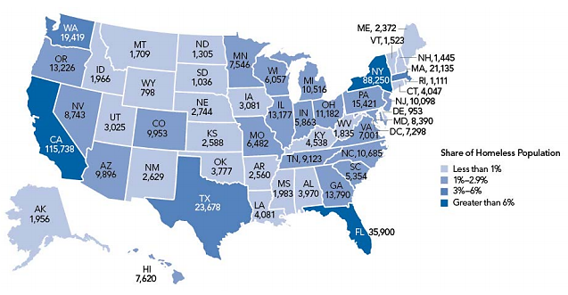

Figure : Estimates of Homeless People by State (2015 Point in Time Count)

**Homeless Children.** In Tennessee 1,625 children under the age of 18 were counted in homeless family households. Thirty-one (31) children under the age of 18 were documented as persons in child-only households in Tennessee, 3 of which were unsheltered at the time of the count.

*The* ***HUD definition of homelessness*** *is narrower than those used by the Departments of Education (ED), Health and Human Services (HHS), Labor, Justice, and Agriculture. HUD focuses primarily on homeless people on the streets, in shelters, in vehicles, or in other places not meant for human habitation. The PIT count offers an important snapshot of homelessness on a given night at one point in the year, with a particular focus on individuals. However, it does not adequately estimate the number of individuals and family members who experience homelessness through the course of a year— especially children. -* [*http://www.homelesschildrenamerica.org/*](http://www.homelesschildrenamerica.org/)

S

Of the 9,123 homeless persons counted in Tennessee in January of 2015, 577 (6.3 percent) were in the Appalachian Regional Continuum of Care (CoC), which covers the eight-county UETHDA service area. The Appalachian Regional CoC reportedly has a higher proportion of chronically homeless individuals (8.7 percent of the Tennessee total) and homeless veterans (13.4 percent of the state total) (Table 25).

|  |  |  |  |
| --- | --- | --- | --- |
|  | Tennessee | Appalachian Regional CoC (TN-509) | |
| Total Homeless | 9,123 | 577 | 6.3% |
| Homeless Individuals | 6,516 | 438 | 6.7% |
| Homeless People in Families | 2,607 | 139 | 5.3% |
| Chronically Homeless | 1,650 | 130 | 7.9% |
| Chronically Homeless Individuals | 1,492 | 130 | 8.7% |
| Chronically Homeless People in Families | 158 | 0 | 0.0% |
| Homeless Veterans | 945 | 127 | 13.4% |
| Homeless Unaccompanied Youth (Under 25) | 673 | 0 | 0.0% |
| Homeless Unaccompanied Children (Under 18) | 14 | 0 | 0.0% |
| Homeless Unaccompanied Young Adults (Age 18-24) | 659 | 0 | 0.0% |
| Parenting Youth (Under 25) | 65 | 4 | 6.2% |
| Parenting Youth Age 18-24 | 65 | 4 | 6.2% |
| Children of Parenting Youth | 94 | 4 | 4.3% |

Table : Point in Time Count (2015)

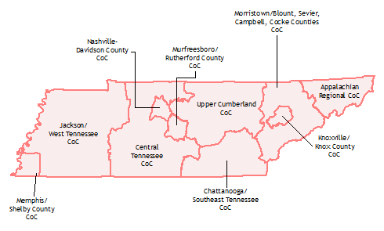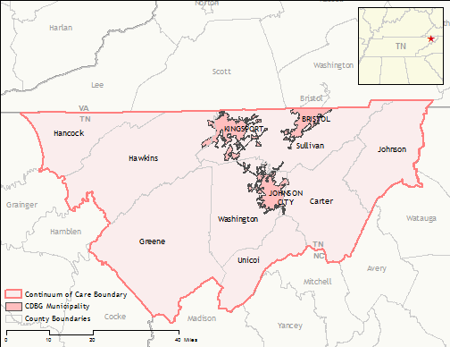

Figure : Appalachian Regional Continuum of Care (TN-509)

#### McKinney-Vento Act

[McKinney-Vento](http://www2.ed.gov/policy/elsec/leg/esea02/pg116.html) is the primary piece of federal legislation dealing with the education of children and youth experiencing homelessness in U.S. public schools. It was reauthorized as Title X, Part C, of the No Child Left Behind Act in January 2002.

The McKinney-Vento program is designed to address the problems that homeless children and youth face in enrolling, attending, and succeeding in school. Under this program, state educational agencies (SEAs) must ensure that each homeless child and youth has equal access to the same free, appropriate public education, including a public preschool education, as other children and youth. In addition, homeless students may not be separated from the mainstream school environment.[13]

The McKinney-Vento Act defines “homeless children and youth” as individuals who lack a fixed, regular, and adequate nighttime residence. The term includes:

* Children and youth who are:
  + Sharing the housing of other persons due to loss of housing, economic hardship, or a similar reason (sometimes referred to as *doubled-up*);
  + Living in motels, hotels, trailer parks, or camping grounds due to lack of alternative adequate accommodations;
  + Living in emergency or transitional shelters;
  + Abandoned in hospitals; or
  + Awaiting foster care placement;
* Children and youth who have a primary nighttime residence that is a public or private place not designed for, or ordinarily used as, a regular sleeping accommodation for human beings;
* Children and youth who are living in cars, parks, public spaces, abandoned buildings, substandard housing, bus or train stations, or similar settings; and
* Migratory children who qualify as homeless because they are living in circumstances described above.

#### Tennessee Homeless Education Program

During the 2013-14 school year Tennessee Local Education Agencies (LEAs) enrolled 17,272 homeless students, a significant increase in number compared with the previous school year when 14,319 homeless students were enrolled (Fig 33).[14] The majority of homeless students enrolled in LEAs were in kindergarten through 3rd grade, 42 percent; approximately 1 percent (222 students), ages 3 to 5, were enrolled in preschool classrooms. Most homeless students served were considered homeless, as they shared housing with other persons commonly referenced as “doubled-up” (77 percent); 2 percent were unsheltered, 12 percent resided in hotels or motels, and 9 percent were in shelters (Fig 34).

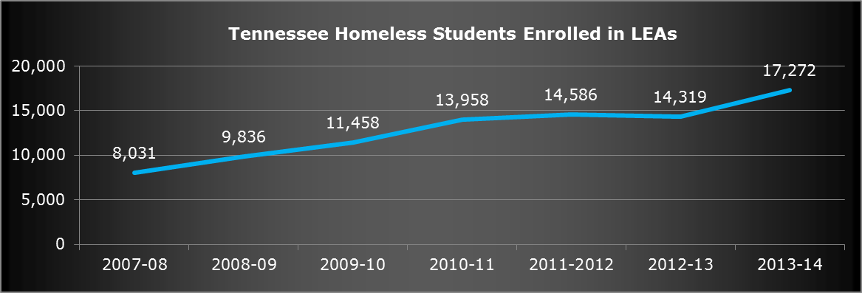

Figure : Tennessee Homeless Students Enrolled in LEAs (Total)

Figure : Tennessee Homeless Students Enrolled in LEAs (Total)

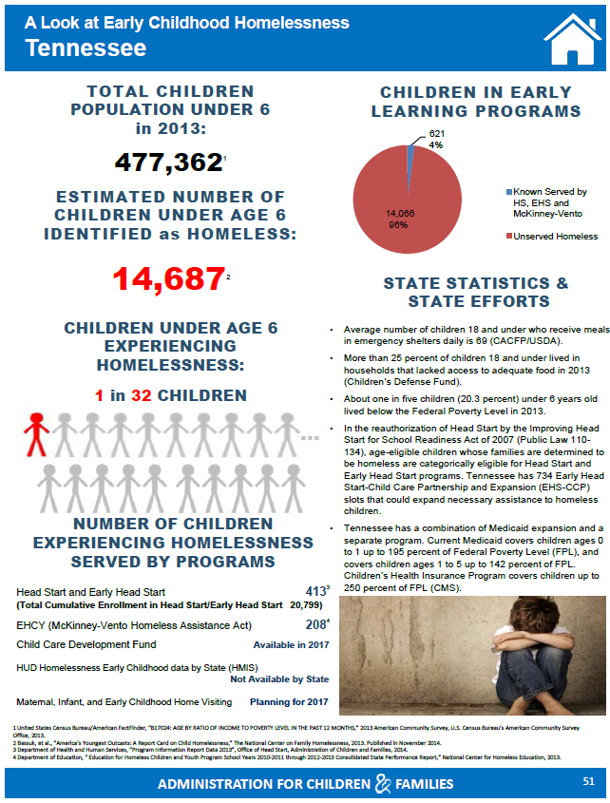The figure below offers an infographic from the [Early Childhood Homelessness in the United States: 50-State Profile](https://www.acf.hhs.gov/sites/default/files/ecd/homelessness_profile_package_with_blanks_for_printing_508.pdf)report issued by the Administration of Children and Families. The report indicates that in Tennessee more than 14,687 children under the age of 6 have been identified as homeless.

## Communication and Transportation

### Access to Phones and Internet

Based on U.S. Census data, more than 2.8 million households, 2.5 percent of total occupied housing units, do not have access to telephone service. In Tennessee almost 66,621 housing units lack telephone service, of which more than 6,070 are located in Carter, Greene, Hancock, Hawkins, Johnson, Sullivan, Unicoi, and Washington Counties (Table 26). Carter County has the highest proportion of households without available telephone service, 6.1 percent, while Sullivan County has the lowest proportion of households without available telephone service, 1.7 percent.

|  |  |  |
| --- | --- | --- |
|  | **Households without telephone service available** | |
| **United States** | 2,875,544 | 2.5% |
| **Tennessee** | 66,621 | 2.7% |
| **Carter County** | 1,471 | 6.1% |
| **Greene County** | 1,216 | 4.3% |
| **Hancock County** | 123 | 4.4% |
| **Hawkins County** | 547 | 2.3% |
| **Johnson County** | 278 | 3.9% |
| **Sullivan County** | 1,148 | 1.7% |
| **Unicoi County** | 226 | 3.0% |
| **Washington County** | 1,061 | 2.0% |

Table : Households Without Telephone Service (2014 ACS 5-Year Estimates)

Based on data collected from [Broadband Now](http://broadbandnow.com/), an organization created to help consumers find broadband in rural areas, there are 144 broadband providers in Tennessee. Although the state is the 29th most connected in the country, there are 993,000 people in the state without access to a wired connection capable of 25mbps download speeds, and 808,000 people with access to only one wired provider, leaving them no options to switch. Additionally, 215,000 people in the state do not have a wired internet provider available where they live.[15]

**BROADBAND SPEEDS**

85.0% of Tennesseans have access to wired broadband 25mbps or faster.

83.0% of Tennesseans have access too broadband 100mbps or faster.

17.8% of Tennesseans have access to 1 gigabit broadband.

**WIRED COVERAGE**

96.0% of Tennesseans have access to wireline service.

24.8% of Tennesseans have access to fiber-optic service.

86.6% of Tennesseans have access to cable service.

90.4% of Tennesseans have access to DSL service.

**WIRELESS COVERAGE**

99.3% of Tennesseans have access to mobile broadband service.

18.6% of Tennesseans have access to fixed wireless service.

In Sullivan County 99.6 percent of people have access to 25 mbps download speeds, and 50.4 percent have access to 1 gigabit download speeds. Johnson City reportedly has 17 internet providers. In Hancock County, only 17.4 percent of people have access to 25 mbps download speeds, and 0.0 percent have access to 1 gigabit download speeds. Sneedville, in Hancock County, reportedly has 4 internet providers.

*NOTE:* [Broadband Now](http://broadbandnow.com/) *has a zip code search function to search for internet providers along with their pricing, download speed, and rating.*

### Transportation

Almost one in 10 households (9.1 percent) in the U.S. do not have access to a vehicle. In Tennessee the proportion of households without access to a vehicle is lower, 6.4 percent, while more than one in five households has access to three or more vehicles, 22.5 percent. In Hancock County, 9 percent of households do not have access to a vehicle, while in Hawkins County this figure is less than 5 percent (Fig 35).

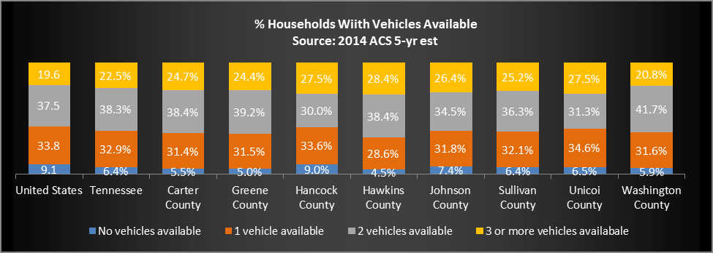

Figure : Households with Vehicle Available (2014 ACS 5-Year Estimates)

### Public Transportation

Public transportation in all of the counties included in this assessment is very limited. Bus and van service in Tennessee is organized by region and by major metropolitan area.[16]

***Johnson City Transit.*** Johnson City, which includes parts of Carter, Sullivan, and Washington Counties, is covered by [Johnson City Transit (JCT)](http://www.johnsoncitytransit.org/).[17] Individual fixed route fares cost $1, and an unlimited monthly pass costs $25. Reduced fares (50 cents) are available to seniors, students, and disabled passengers. ETSU students and staff, and children 5 years-old and younger can ride free. Operating hours for JCT are 6:15 a.m. to 11:00 p.m. Monday through Friday, with more limited hours on Saturday (8:15 a.m. to 5:15 p.m.), and none on Sunday.

***Kingsport Area Transit Service.*** Kingsport, which includes parts of Hawkins, Sullivan, and Washington Counties, is served by [Kingsport Area Transit Services (KATS)](http://kingsporttransit.org/).[18] Fixed route fares cost $1 for adults, ages 18 to 64. Reduced fares (50 cents) are available for Seniors (65+), military veterans, and disabled passengers. An unlimited monthly pass costs $15. Students and children under the age of 18 can ride free. Operating hours for KATS are 7:30 a.m. to 5:30 p.m., Monday through Friday. KATS also offers a Dial-a-Ride ADA van service, which costs $2 each way when eligibility is certified, and is available when the trip is scheduled in advance for 8:00 a.m. to 5:00 p.m., any day except Saturday. Rides for Seniors are available for $3.

***Bristol Tennessee Transit.*** Bristol, in Sullivan County, is covered by [Bristol Tennessee Transit](http://www.bristoltn.org/142/Transit).[19] Individual fares for adults cost 60 cents. Reduced fares (30 cents) are available for seniors (55+) and disabled passengers during off-peak hours. Ten-cent transfers are available between Tennessee and Virginia. Unlimited monthly passes are not available. Operating hours are 6:15 a.m. to 6:00 p.m., Monday through Friday.

***Northeast Tennessee Rural Public Transit.*** The Counties included in this assessment are also covered by Northeast Tennessee Rural Public Transit (NET Trans), which is operated by [First Tennessee Human Resource Agency (FTHRA)](http://www.nettrans.org/).[20] Fares are split into zones based on mileage and region, from a minimum of $2 for a trip up to two miles, to a maximum of $12. for a trip over 50 miles. Operating hours for NET Trans are 6:00 a.m. to 6:00 p.m., Monday through Friday. Additional service to more distant counties and cities is available, as are special requests. For example, a trip to the nearby city of Morristown costs $20 from Carter, Greene, Hancock, or Hawkins Counties, and $75 to $150 from the more distant Counties of Johnston, Sullivan, Unicoi, or Washington. Accompanied children under the age of 8 may ride for 75 cents.

## Disabilities

### U.S. Census

Data from the U.S. Census Bureau indicates that 12.3 percent of the civilian non-institutionalized population in the United Stated has a disability; the rate in Tennessee is higher, at 15.2 percent. In Tennessee less than 1 percent of children under age 5 reportedly have a disability, 6.0 percent of children ages 5 to 17 have a disability, 13.7 percent of adults ages 18 to 64 have a disability, and 40.1 percent of adults over age 65 have a disability (Table 27).

In the United States, the **civilian noninstitutional population** refers to people 16 years of age and older residing in the 50 States and the District of Columbia who are not inmates of institutions (penal, mental facilities, homes for the aged), and who are not on active duty in the Armed Forces.

In the UETHDA service area the percent of the civilian non-institutionalized population with a disability is significantly higher, in some cases 25 percent, or one in four, individuals reportedly have a disability (Hancock and Johnson Counties). Washington County has the lowest disability rate, 16.8 percent, yet it is still higher than the state and national rates (Fig 36).

|  |  |  |  |  |  |  |  |
| --- | --- | --- | --- | --- | --- | --- | --- |
|  | Total | < 5 years | 5 to 17 years | 18 to 64 years | 65 years+ | Male | Female |
| United States | 12.3% | 0.8% | 5.3% | 10.2% | 36.3% | 12.1% | 12.4% |
| Tennessee | 15.2% | 0.9% | 6.0% | 13.7% | 40.1% | 15.0% | 15.5% |
| Carter County | 22.8% | 1.3% | 8.4% | 20.8% | 47.1% | 23.9% | 21.7% |
| Greene County | 22.0% | 0.6% | 8.8% | 19.8% | 46.5% | 22.3% | 21.7% |
| Hancock County | 25.2% | 0.0% | 3.1% | 24.7% | 55.3% | 26.7% | 23.8% |
| Hawkins County | 21.8% | 0.8% | 5.4% | 20.5% | 48.7% | 22.4% | 21.2% |
| Johnson County | 25.2% | 0.0% | 8.2% | 22.5% | 50.1% | 23.6% | 26.8% |
| Sullivan County | 19.6% | 0.7% | 7.2% | 17.1% | 42.3% | 19.2% | 19.9% |
| Unicoi County | 23.9% | 0.0% | 10.6% | 22.8% | 42.9% | 24.9% | 22.9% |
| Washington County | 16.8% | 0.4% | 6.1% | 14.2% | 43.4% | 16.5% | 17.1% |

Table : Disability Characteristics (2014 ACS 5-Year Estimates)

Figure : Civilian Non-Institutionalized Population with a Disability (2014 ACS 5-Year Estimates)

In the U.S., Tennessee, and five of the eight UETHDA service area counties, rates of disabilities for males are higher than for females. In Johnson, Sullivan, and Washington Counties, however, the rate of disabilities for women is higher than for men; Johnson County reports the greatest discrepancy between the rate of disabilities for males (23.6 percent) and females (26.8 percent) (Fig 37).

Figure : Civilian Non-Institutionalized Population with a Disability by Gender (2014 ACS 5-Year Estimates)

Based on averaged U.S. Census data, there are approximately 161,000 children under age 5 with a disability, of which 3,733 are in Tennessee. Based on these estimates, 164 children under age 5 have a disability in the UETHDA service area (Table 28).

|  |  |  |  |  |  |  |  |  |  |  |  |
| --- | --- | --- | --- | --- | --- | --- | --- | --- | --- | --- | --- |
| Subject | United States | Tennessee | Carter County | Greene County | Hancock County | Hawkins County | Johnson County | Sullivan County | Unicoi County | Washington County | UETHDEA Service Area* |
| < 5 years | 161,265 | 3,733 | 38 | 21 | 0 | 23 | 0 | 57 | 0 | 25 | 164 |

Table : Civilian Non-Institutionalized Population Under Age 5 with a Disability (2014 ACS 5-Year Estimates)

**\*NOTE**: Because the American Community Survey of the U.S. Census Bureau uses a narrower definition of disability than other surveys (see below), data should be used to compare regions. The actual number of children with disabilities served by various programs is significantly higher (see school system and IDEA data).

**ACS Definition of Disabilities**

**Hearing difficulty** - deaf or having serious difficulty hearing (DEAR).

**Vision difficulty** - blind or having serious difficulty seeing, even when wearing glasses (DEYE).

**Cognitive difficulty** - Because of a physical, mental, or emotional problem, having difficulty remembering, concentrating, or making decisions (DREM).

**Ambulatory difficulty** - Having serious difficulty walking or climbing stairs (DPHY).

**Self-care difficulty** - Having difficulty bathing or dressing (DDRS).

**Independent living difficulty** - Because of a physical, mental, or emotional problem, having difficulty doing errands alone such as visiting a doctor’s office or shopping (DOUT).

Respondents who report anyone of the six disability types are considered to have a disability.

### TN Department of Education

According to the Tennessee Department of Education, during the 2014-15 school year, the Special Education Program in Tennessee public schools served more than 129,905 children.[21] Almost 7,000 children were served in UETHDA service area county schools. The majority of students receiving special education services had a speech or language impairment, followed by a health impairment, and developmental delay (Table 29).

|  |  |  |  |  |  |  |  |  |  |
| --- | --- | --- | --- | --- | --- | --- | --- | --- | --- |
| NUMBER OF CHILDREN AGES 3 THROUGH 21 WITH IDEA DISABILITIES RECEIVING SPECIAL EDUCATION SERVICES ON DECEMBER 1, 2014 (2014-2015 SCHOOL YEAR) ** | | | | | | | | | |
|  | Tennessee | Carter County | Greene County | Hancock County | Hawkins County | Johnson County | Sullivan County | Unicoi County | Washington County | |
| LEARNING DISABILITY | 47,895 | 421 | 458 | 61 | 379 | 188 | 795 | 187 | 384 | |
| INTELLECTUAL DISABILITY | 7,640 | 62 | 61 | 22 | 39 | 20 | 92 | 33 | 60 | |
| SPEECH/LANGUAGE  IMPAIRED | 32,884 | 216 | 345 | 43 | 270 | 121 | 336 | 181 | 437 | |
| EMOTIONALLY DISTURBED | 3,082 | ** | 24 | ** | 18 | ** | 14 | 0 | 6 | |
| AUTISM | 8,639 | 32 | 37 | ** | 62 | 7 | 66 | 17 | 44 | |
| HEALTH IMPAIRED | 15,399 | 86 | 112 | 34 | 151 | 36 | 184 | 17 | 134 | |
| ORTHO-PEDICALLY  IMPAIRED | 646 | ** | 10 | ** | 7 | 0 | 7 | 0 | 10 | |
| HEARING IMPAIRED  OR DEAF | 1,238 | ** | 6 | ** | 12 | 0 | 9 | ** | 7 | |
| VISUALLY IMPAIRED  OR BLIND | 602 | 8 | ** | ** | 6 | ** | 6 | ** | 9 | |
| DEAF-BLIND | 12 | 0 | 0 | 0 | 0 | 0 | ** | 0 | 0 | |
| MULTIPLE DISABILITIES | 2,121 | 17 | 24 | ** | 13 | ** | ** | 6 | ** | |
| DEVELOPMENTALLY  DELAYED | 9,403 | 27 | 82 | 16 | 80 | 7 | 173 | 18 | 52 | |
| TRAUMATIC BRAIN  INJURY | 344 | ** | ** | ** | 0 | 0 | ** | 0 | ** | |
| TOTAL*** | 129,905 | 879 | 1,166 | 192 | 1,037 | 387 | 1,691 | 465 | 1,149 | |
| **To protect student confidentiality, Tennessee suppresses any student count below 6 students when providing information to the general public. Extra cells masked in some columns.  ***Statewide total includes counts in suppressed cells and count of students in state special schools. | | | | | | | | | | |

Table : Special Education Services (2014-15 TN Department of Education)

### Individuals with Disabilities Education Act (IDEA)

The nation’s special education law is called the Individuals with Disabilities Education Act, or IDEA. IDEA defines the term “child with a disability” in order to make special education and related services available to children with disabilities in public schools and Head Start programs. That definition includes specific disability terms, which are also defined by IDEA.[22]

According to the [IDEA Data Center](https://ideadata.org/), in 2014 (most recent available data) almost 13,000 children, ages 3 to 5, received special education assistance in Tennessee. The majority of children received special education for a speech or language impairment (54.4 percent), followed by developmental delay (32.3 percent), and autism (7.7 percent) (Table 30). More than 4,300 infants and toddlers, ages 0 to 3, were served by Early Intervention programs, of which those ages 2 to 3 make up 52.2 percent.[23]

|  |  |  |  |  |  |  |  |  |
| --- | --- | --- | --- | --- | --- | --- | --- | --- |
| IDEA Part B: Assistance for Education of All Children (ages 3-5) with Disabilities in Tennessee | | | | | | IDEA Part C: Early Intervention (ages 0-3) | | |
| All Disabilities | **12,527** | | **Multiple disabilities** | 171 | 1.4% | **Total** | **4,390** | |
| Autism | 967 | 7.7% | **Orthopedic impairment** | 89 | 0.7% |
| Deaf-blindness | 2 | 0.0% | **Other health impairment** | 174 | 1.4% | Birth to 1 | 606 | 13.8% |
| Developmental delay | 4,042 | 32.3% | **Specific learning disability** | 1 | 0.0% |
| Emotional disturbance | 4 | 0.0% | **Speech or language impairment** | 6,810 | 54.4% | 1 to 2 | 1,493 | 34.0% |
| Hearing impairment | 150 | 1.2% | **Traumatic brain injury** | 16 | 0.1% | 2 to 3 | 2,291 | 52.2% |
| Intellectual disability | 65 | 0.5% | **Visual impairment** | 36 | 0.3% |

Table : 2014 IDEA Part B Child Count [Ages 3-5] and Part C Child County [Ages 0-3]

## Health and Wellness

### Health Disparities Profile

According to data gathered by the [Office on Women’s Health](http://womenshealth.gov/about-us/), Tennessee residents have some of the highest rates of death in the United States due to all illnesses presented in the table below. Concordantly, Tennessee ranks among states with the highest percentage of the prevalence of risk factors for these diseases – namely high blood pressure and obesity – among the African American population (Table 31).[24]

|  |  |  |  |  |  |  |  |
| --- | --- | --- | --- | --- | --- | --- | --- |
|  | White | Black | Hispanic | AIAN | Asian/PI | State Total | State Rank |
|
| All causes | 881 | 965 | 329.5 | 328 | 419.1 | 880.6 | 47 |
| Heart disease | 204.1 | 219.6 | 63.6 | * | 102.2 | 203.7 | 45 |
| Coronary heart disease | 155.5 | 162 | 47.7 | * | 70.2 | 154.3 | 51 |
| Total cancer | 185.4 | 224.3 | 74.2 | * | 89.2 | 187.6 | 48 |
| Colorectal cancer | 16.4 | 23 | * | * | * | 16.9 | 47 |
| Lung cancer | 58.7 | 63.8 | * | * | 34.7 | 58.4 | 51 |
| Stroke | 42.8 | 59.9 | * | * | 46.9 | 44.9 | 47 |
| Chronic obstructive pulmonary diseases | 152.8 | 90.9 | * | * | * | 143.9 | 42 |
| Diabetes–related | 79.1 | 126.7 | 34.5 | * | 48.4 | 83.8 | 43 |

Table : Major Causes of Death among Women in Tennessee (Rate per 100,000) (2014 DHHS Office on Women’s Health)

### Health Professional Shortage Areas

A [Health Professional Shortage Area (HPSA)](http://www.hrsa.gov/shortage/) is a geographic region, a population group or health care facility that has received a designation by the Federal government as having a shortage of health professionals. HPSAs may be designated as having a shortage of primary medical care, dental or mental health providers. They may be urban or rural areas, population groups or medical or other public facilities.

There are currently approximately 6,100 designated Primary Care HPSAs, 4,900 Dental HPSAs, and 4,000 Mental Health HPSAs in the United States. A Primary Care HPSA is based on a physician-to-population ratio of 1: 3,500, a Dental HPSA is based on a dentist-to-population ratio of 1: 5,000, and a Mental Health HPSA is based on a psychiatrist-to-population ratio of 1: 30,000.

All counties reviewed for this assessment have at least two Dental and Mental Health HPSAs. Carter, Greene, and Unicoi Counties have no Primary Care HPSAs, whereas the remaining five counties have at least one (Table 32).[25]

| County | HPSA Discipline Class | HPSA Name | Designation Type |
| --- | --- | --- | --- |
| Carter | Dental | Carter | Single county |
| Low income – Carter | HPSA Population |
| Mental | Mental Health Catchment Area #1 | HPSA Geographic |
| Carter | Single county |
| Greene | Dental | Low Income - Greene County | HPSA Population |
| Greene | Single county |
| Mental | Mental Health Catchment Area 4 | HPSA Geographic |
| Greene | Single county |
| Hancock | Primary | Hancock County | HPSA Geographic High Needs |
| Hancock County | Single county |
| Dental | Hancock County | HPSA Geographic |
| Hancock | Single county |
| Mental | Mental Health Catchment Area #4 | HPSA Geographic |
| Hancock | Single county |
| Hawkins | Primary | Rural Health Services Consortium | Comprehensive Health Center |
| Low Income - Hawkins County | HPSA Population |
| Hawkins | Single county |
| Dental | Rural Health Services Consortium | Comprehensive Health Center |
| Low Income - Hawkins County | HPSA Population |
| Hawkins | Single county |
| Mental | Rural Health Services Consortium | Comprehensive Health Center |
| Mental Health Catchment Area 4 | HPSA Geographic |
| Hawkins | Single county |
| Johnson | Primary | Johnson | HPSA Geographic High Needs |
| Johnson | Single county |
| Dental | Low income - Johnson County | HPSA Population |
| Johnson | Single county |
| Mental | Johnson | Single county |
| Mental Health Catchment Area #1 | HPSA Geographic |
| Sullivan | Primary | None | None |
| Dental | Low Income - Sullivan County | HPSA Population |
| Sullivan | Single county |
| Mental | Mental Health Catchment Area #1 | HPSA Geographic |
| Sullivan | Single county |
| Unicoi | Dental | Low Income - Unicoi County | HPSA Population |
| Unicoi | Single county |
| Mental | Mental Health Catchment Area #1 | HPSA Geographic |
| Unicoi | Single county |
| Washington | Primary | East Tennessee State University | Comprehensive Health Center |
| Dental | East Tennessee State University | Comprehensive Health Center |
| Low Income - Washington County | HPSA Population |
| Washington | Single county |
| Mental | East Tennessee State University | Comprehensive Health Center |
| Mental Health Catchment Area #1 | Comprehensive Health Center |
| Washington | Single county |

Table : Health Professional Shortage Areas (Health Resources and Services Administration)

### Medically Underserved Areas

[Medically Underserved Areas/Populations](http://www.hrsa.gov/shortage/mua/) are areas or populations designated by HRSA as having too few primary care providers, high infant mortality, high poverty or a high elderly population. **The IMU scale is from 0 to 100, where 0 represents completely underserved and 100 represents best served or least underserved.** Under the established criteria, each service area found to have an IMU of 62.0 or less qualifies for designation as an MUA.

Furthermore, seven of the eight counties included in this proposal have at least one MUA. Greene County has two MUAs, whereas Sullivan County has none. Hancock County had the lowest index of medical underservice score, while Unicoi County had the highest (Table 33).[26]

|  |  |  |
| --- | --- | --- |
| County Name | Service Area Name | Index of Medical Underservice Score |
| Carter | Carter Service Area | 55.2 |
| Greene | Baileytown Division Service Area | 56.5 |
| Mohawk Division Service Area | 56.6 |
| Hancock | Hancock County | 50.4 |
| Hawkins | Hawkins Service Area | 53.9 |
| Johnson | Johnson County | 54.7 |
| Sullivan | None | None |
| Unicoi | Unicoi County | 61 |
| Washington | Washington County | 42.2 |

Table : Medically Underserved Areas (Health Resources and Services Administration)

### County Health Rankings

The [County Health Rankings](http://www.countyhealthrankings.org/) is a collaboration between the Robert Wood Johnson Foundation and the University of Wisconsin Population Health Institute that measures the health of nearly all counties in the nation and rank them within states. The Rankings are compiled using county-level measures from a variety of national and state data sources. These measures are standardized and combined using scientifically informed weights.

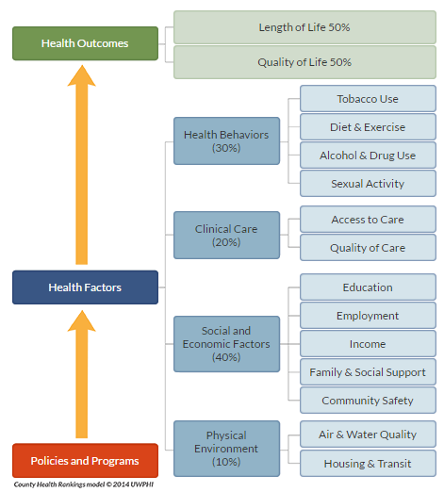The County Health Rankings are based on a model that focuses on the factors, which if improved, can make communities healthier places to live. The health outcomes targeted measure mortality and morbidity, or the length of time people live and the way people feel when they are alive. Health factors, which affect health outcomes, are measured on the following: health behaviors, clinical care, social and environmental factors, and physical environment (Fig 38).[27]

Figure : County Health Rankings Model

Based on 2015 rankings, Tennessee has a premature death rate of 8,600 (the years of potential life lost before age 75 per 100,000 residents).

Of the eight counties in the UETHDA service area, Washington County had the best health outcomes (32 out of 95 counties), with a premature death rate of 8,600. In contrast, Hancock County ranked the lowest, with the worst health outcomes (86 out of 95 counties), with a premature death rate of 10,700. The other counties in the proposal had premature death rates ranging from 8,700 to 11,000. [28]

Table 34 provides information on health outcomes, health factors, and clinical care for Tennessee and the UETHDA service area counties. Each item is hyperlinked to the original source for additional explanation and data source.

|  |  |  |  |  |  |  |  |  |  |
| --- | --- | --- | --- | --- | --- | --- | --- | --- | --- |
|  | Tennessee | Carter | Greene | Hancock | Hawkins | Johnson | Sullivan | Unicoi | Washington |
| Health Outcomes – Rank (of 95) |  | 50 | 54 | 86 | 65 | 45 | 32 | 67 | 19 |
| Length of Life - Rank (of 95) |  | 25 | 47 | 64 | 72 | 29 | 28 | 65 | 22 |
| [Premature death](http://www.countyhealthrankings.org/app/north-carolina/2015/measure/outcomes/1/map) | 8,600 | 8,700 | 9,800 | 10,700 | 11,000 | 9,000 | 8,900 | 10,700 | 8,600 |
| Quality of Life - Rank (of 95) |  | 79 | 60 | 91 | 48 | 73 | 39 | 63 | 21 |
| [Poor or fair health](http://www.countyhealthrankings.org/app/north-carolina/2015/measure/outcomes/2/map) | 23% | 23% | 23% | 27% | 21% | 23% | 22% | 22% | 21% |
| [Poor physical health days](http://www.countyhealthrankings.org/app/north-carolina/2015/measure/outcomes/36/map) | 4.6 | 5 | 4.9 | 5.7 | 4.8 | 4.6 | 4.8 | 4.8 | 4.5 |
| [Poor mental health days](http://www.countyhealthrankings.org/app/north-carolina/2015/measure/outcomes/42/map) | 4.9 | 4.9 | 4.7 | 5.3 | 4.7 | 4.9 | 4.7 | 4.7 | 4.5 |
| [Low birthweight](http://www.countyhealthrankings.org/app/north-carolina/2015/measure/outcomes/37/map) | 9% | 10% | 9% | 10% | 9% | 9% | 9% | 9% | 8% |
| Additional Health Outcomes (not included in overall ranking) | | | | | | | | | |
| [Premature age-adjusted mortality](http://www.countyhealthrankings.org/app/north-carolina/2015/measure/outcomes/127/data) | 430 | 440 | 480 | 630 | 490 | 410 | 440 | 520 | 430 |
| [Child mortality](http://www.countyhealthrankings.org/app/north-carolina/2015/measure/outcomes/128/data) | 60 | 70 | 50 | * | 80 | * | 60 | 400 | 60 |
| [Infant mortality](http://www.countyhealthrankings.org/app/north-carolina/2015/measure/outcomes/129/data) | 8 | 8 | 6 | * | 7 | * | 8 | * | 9 |
| [Diabetes prevalence](http://www.countyhealthrankings.org/app/north-carolina/2015/measure/outcomes/60/data) | 12% | 13% | 12% | 18% | 12% | 15% | 13% | 13% | 11% |
| [HIV prevalence](http://www.countyhealthrankings.org/app/north-carolina/2015/measure/outcomes/61/data) | 295 | 91 | 73 | * | 40 | 101 | 83 | 51 | 154 |
| Health Factors - Rank (of 95) |  | 35 | 40 | 93 | 28 | 27 | 16 | 26 | 6 |
| Health Behaviors - Rank (of 95) |  | 29 | 48 | 90 | 40 | 18 | 55 | 14 | 16 |
| [Adult smoking](http://www.countyhealthrankings.org/app/north-carolina/2015/measure/factors/9/map) | 24% | 24% | 24% | 28% | 23% | 24% | 25% | 23% | 23% |
| [Adult obesity](http://www.countyhealthrankings.org/app/north-carolina/2015/measure/factors/11/map) | 32% | 30% | 33% | 31% | 35% | 30% | 31% | 32% | 32% |
| [Food environment index](http://www.countyhealthrankings.org/app/north-carolina/2015/measure/factors/133/map) | 6.7 | 5.9 | 6.9 | 6.6 | 7.1 | 6.7 | 6.4 | 7.3 | 7 |
| [Physical inactivity](http://www.countyhealthrankings.org/app/north-carolina/2015/measure/factors/70/map) | 32% | 34% | 38% | 39% | 37% | 36% | 36% | 35% | 33% |
| [Access to exercise opportunities](http://www.countyhealthrankings.org/app/north-carolina/2015/measure/factors/132/map) | 69% | 82% | 41% | 1% | 35% | 100% | 77% | 100% | 72% |
| [Excessive drinking](http://www.countyhealthrankings.org/app/north-carolina/2015/measure/factors/49/map) | 12% | 11% | 11% | 10% | 11% | 11% | 12% | 11% | 12% |
| [Alcohol-impaired driving deaths](http://www.countyhealthrankings.org/app/north-carolina/2015/measure/factors/134/map) | 28% | 27% | 24% | 50% | 19% | 6% | 19% | 29% | 31% |
| [Sexually transmitted infections](http://www.countyhealthrankings.org/app/north-carolina/2015/measure/factors/45/map) | 470.4 | 190 | 213.6 | 238.1 | 296.9 | 71.8 | 249.4 | 137.1 | 237.4 |
| [Teen births](http://www.countyhealthrankings.org/app/north-carolina/2015/measure/factors/14/map) | 45 | 46% | 46 | 49% | 49 | 56% | 48 | 44 | 31 |
| Additional Health Behaviors (not included in overall ranking) | | | | | | | | | |
| [Food insecurity](http://www.countyhealthrankings.org/app/north-carolina/2015/measure/factors/139/data) | 17% | 17% | 17% | 20% | 15% | 18% | 15% | 16% | 16% |
| [Limited access to healthy foods](http://www.countyhealthrankings.org/app/north-carolina/2015/measure/factors/83/data) | 8% | 15% | 4% | 1% | 8% | 5% | 14% | 3% | 6% |
| [Drug poisoning deaths](http://www.countyhealthrankings.org/app/north-carolina/2015/measure/factors/138/data) | 18 | 16 | 26 | * | 25 | * | 23 | 15 | 17 |
| [Motor vehicle crash deaths](http://www.countyhealthrankings.org/app/north-carolina/2015/measure/factors/39/data) | 17 | 16 | 21 | 32 | 22 | 22 | 14 | 34 | 12 |
| Clinical Care - Rank (of 95) |  | 59 | 40 | 93 | 28 | 49 | 3 | 56 | 4 |
| [Uninsured](http://www.countyhealthrankings.org/app/north-carolina/2015/measure/factors/85/map) | 16% | 18% | 17% | 17% | 15% | 18% | 15% | 16% | 15% |
| [Primary care physicians](http://www.countyhealthrankings.org/app/north-carolina/2015/measure/factors/4/map) | 1,380 to 1 | 2,610 to 1 | 1,550 to 1 | 6,680 to 1 | 3,550 to 1 | 3,000 to 1 | 710 to 1 | 2,260 to 1 | 620 to 1 |
| [Dentists](http://www.countyhealthrankings.org/app/north-carolina/2015/measure/factors/88/map) | 1,960 to 1 | 3,350 to 1 | 2,530 to 1 | 3,330 to 1 | 5,670 to 1 | 4,460 to 1 | 1,400 to 1 | 3,590 to 1 | 1,860 to 1 |
| [Preventable hospital stays](http://www.countyhealthrankings.org/app/north-carolina/2015/measure/factors/5/map) | 65 | 68 | 74 | 139 | 64 | 57 | 64 | 89 | 64 |
| [Diabetic monitoring](http://www.countyhealthrankings.org/app/north-carolina/2015/measure/factors/7/map) | 87% | 85% | 86% | 79% | 88% | 87% | 91% | 86% | 90% |
| [Mammography screening](http://www.countyhealthrankings.org/app/north-carolina/2015/measure/factors/50/map) | 62% | 57% | 61% | 38% | 61% | 62% | 72% | 59% | 63% |

Table : Health Rankings (2014 University of Wisconsin Population Health Institute)

### Health Insurance

Based on U.S. Census data, more than 14 percent of the U.S. and more than 13 percent of the Tennessee civilian non-institutionalized population lacks health insurance. Within the UETHDA service area, Carter and Hancock Counties had the highest percentages of the civilian non-institutionalized population lacking health insurance, 14.8 and 15.3 percent, respectively (Fig 39). The remaining five counties had lower percentages, ranging from 11.7 percent (Hawkins) to 12.6 percent (Sullivan). Between approximately 33 and 48 percent of individuals in all eight counties have public health insurance coverage, which is higher than the national average (Table 35). [29]

|  |  |  |  |  |
| --- | --- | --- | --- | --- |
|  | With health insurance coverage | With private health insurance | With public coverage | No health insurance coverage |
|
| United States | 85.5% | 65.8% | 31.1% | 14.2% |
| Tennessee | 86.4% | 64.6% | 33.7% | 13.6% |
| Carter County | 85.1% | 58.4% | 42% | 14.9% |
| Greene County | 86.3% | 60.1% | 41.7% | 13.7% |
| Hancock County | 84.7% | 46.8% | 47.2% | 15.3% |
| Hawkins County | 88.3% | 63.4% | 39.8% | 11.7% |
| Johnson County | 87.5% | 57.8% | 47.8% | 12.5% |
| Sullivan County | 87.4% | 64.4% | 39.6% | 12.6% |
| Unicoi County | 88% | 60.8% | 44.7% | 12% |
| Washington County | 87.9% | 68.4% | 33.3% | 12.1% |

Table : Health Insurance Coverage (2014 ACS 5-year estimates)

Figure : Lack of Health Insurance Coverage (2014 ACS 5-year estimates)

The United States has more than 5.2 million children and adolescents under the age of 18 lacking health insurance, of which more than 80,000 are in Tennessee. Four of eight counties in the UETHDA service area have approximately 5 percent or more of their age 0 to 18 population living without health insurance. Unicoi County has the lowest percent of children without health insurance, 1.3 percent. All counties have a percentage of children under age 18 without health insurance lower than the national average of 7.1 percent (Table 36, Fig 41).[30]

|  | Civilian noninstitutionalized population age 0 to 18 | No health insurance coverage age 0 to 18 | |
| --- | --- | --- | --- |
| United States | 73,636,556 | 5,217,055 | 7.1% |
| Tennessee | 1,489,325 | 81,172 | 5.5% |
| Carter County | 11,033 | 643 | 5.8% |
| Greene County | 13,938 | 657 | 4.7% |
| Hancock County | 1,422 | 85 | 6.0% |
| Hawkins County | 12,269 | 344 | 2.8% |
| Johnson County | 3,096 | 104 | 3.4% |
| Sullivan County | 31,656 | 1,943 | 6.1% |
| Unicoi County | 3,600 | 48 | 1.3% |
| Washington County | 24,818 | 1,228 | 4.9% |

Table : Health Insurance Coverage of Individuals Aged 0-18 (2014 ACS 5-year estimates)

Figure : Lack of Health Insurance Coverage (Children ages 0-18) (2014 ACS 5-year estimates)

The [Affordable Care Act (ACA)](http://www.hhs.gov/healthcare/about-the-law/) was enacted with the goal of increasing the quality and affordability of health insurance, lowering the uninsured rate by expanding public and private insurance coverage, and reducing the costs of healthcare for individuals and the government. As part of the ACA, individuals are mandated to purchase health insurance through marketplaces, where families, individuals, or businesses can learn about different health insurance options available and enroll. Insurance premium rate growth in the Affordable Care Act’s Health Insurance Marketplaces has been an area of significant interest, as this is one of the most tangible and measurable indicators of whether the ACA is working to keep health insurance affordable.

The Kaiser Family Institute has calculated the monthly cost of the second lowest cost Silver plan before the tax credit for a 40-year old non-smoker making $30,000 a year in a major city in each state. It is important to note that the cost in Nashville, Tennessee, in 2015 was $203 and in 2016 was $281. The percent change between 2015 and 2016 was 38.4 percent, whereas the average percent change for major metropolitan areas in each state was 10.1 percent. This is noteworthy because it reflects an increased cost to low-income families in the state of Tennessee.[31]

### Birth Rates and Fertility

In Tennessee there were 81,609 total births out of a total population of 6,549,201, a birth rate of 12.5 percent. The UETHDA service area counties have birth rates lower than the state; ranging from 8.2 (Unicoi County) to 10.6 (Johnson County) (Table 37, Fig 41).[32]

|  |  |  |  |  |
| --- | --- | --- | --- | --- |
|  | Total Births | Birth Rate | Rank | Total Population |
| Tennessee | 81,609 | 12.5 | * | 6,549,201 |
| Carter County | 532 | 9.4 | 85 | 56,892 |
| Greene County | 651 | 9.5 | 80 | 68,337 |
| Hancock County | 67 | 10.1 | 69 | 6,633 |
| Hawkins County | 538 | 9.5 | 80 | 56,749 |
| Johnson County | 802 | 10.6 | 51 | 75,520 |
| Sullivan County | 1,575 | 10 | 72 | 157,051 |
| Unicoi County | 147 | 8.2 | 91 | 17,952 |
| Washington County | 152 | 10.3 | 63 | 14,698 |

Table : Total Births and Birth Rates (2014 Tennessee Department of Health)

Figure : Total Births and Birth Rates (2014 Tennessee Department of Health)

Low birth weight is a reliably used indicator of infant health. In the United States birth weight is often categorized as low (less than 2,500 grams) or normal (2,500 grams or more). In Tennessee there were 7,302 babies born with low birth weight (9.1 percent) in 2013. Johnson County had the lowest percentage of low birth weight babies, with 6.9 percent (10 babies). In contrast, Unicoi County had the highest rate of low birth weight babies, with 12.7 percent (21 babies). All other counties included in this assessment had low birth weight percentages lower than the statewide percentage (Table 38).[33]

|  |  |  |  |
| --- | --- | --- | --- |
|  | Live births | Low birth weight number | Low birth weight percent |
| Tennessee | 79,954 | 7,302 | 9.1% |
| Carter County | 501 | 40 | 8.0% |
| Greene County | 643 | 50 | 7.8% |
| Hancock County | 62 | 6 | 9.7% |
| Hawkins County | 523 | 43 | 8.2% |
| Johnson County | 144 | 10 | 6.9% |
| Sullivan County | 1,587 | 124 | 7.8% |
| Unicoi County | 166 | 21 | 12.7% |
| Washington County | 1,327 | 117 | 8.8% |

Table : Total Births and Low Birth Weight (2013 Tennessee Department of Health)

### Obesity

According to [*The State of Obesity: Better Policies for a Healthier America 2015*](http://stateofobesity.org/files/stateofobesity2015.pdf)*,* Tennessee has the 14th highest adult obesity rate in the nation, 31.2 percent, up from 20.9 percent in 2000. Highest rates of obesity were seen for those ages 45-64 (38.7 percent) and black/African American residents (40.6 percent) (Fig 42). The report also found that in 2011, 20.5 percent of Tennessee’s 10-to-17-year-olds were obese, which ranked Tennessee as 5th in the nation, and 14.2 percent of 2-to-4-year-olds from low-income families were obese, ranking the state 18th in the nation.[34]

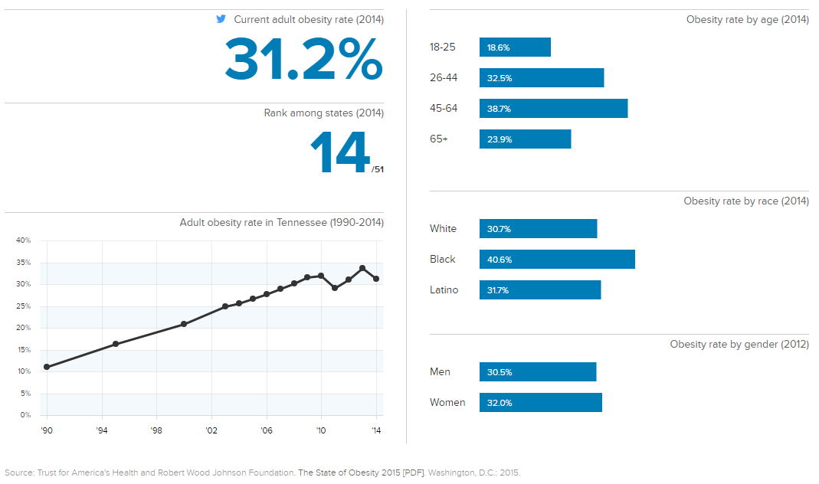

Figure : State of Obesity in Tennessee (2014)

Further examination of health data reveals that in 2012-2013, 42.4 percent of children in Tennessee in the eighth grade were obese. In the UETHDA service area, in seven of eight counties, the obesity rate among eighth graders has decreased from 2012-13 to 2013-14. The percent change has ranged from -0.9 percent to -10.0. Greene County has experienced an increase in the obesity rate, however, between school years, with an increase of half a percent (Table 39, Fig 43).[35]

| Overweight/Obesity (Grade 8) | | | | |
| --- | --- | --- | --- | --- |
|  | 2013-2014 | 2014-2015 | Percent Change |
| Tennessee | 42.4% | 43.2% | 0.8% |
| Carter County | 45.0% | 44.0% | -0.9% |
| Greene County | 46.2% | 46.7% | 0.5% |
| Hancock County | 60.5% | 59.2% | -1.3% |
| Hawkins County | 50.3% | 47.3% | -2.9% |
| Johnson County | 47.3% | 37.3% | -10.0% |
| Sullivan County | 44.9% | 42.1% | -2.8% |
| Unicoi County | 50.3% | 46.1% | -4.2% |
| Washington County | 44.5% | 40.2% | -4.2% |

Table : Childhood Overweight/Obesity (2015 TN Dept. of Economic and Community Development)

Figure : Childhood Overweight/Obesity (2015 Tennessee Department of Economic and Community Development)

Four of the 10 leading causes of death for adults in Tennessee are related to obesity: heart/cardiovascular disease, stroke, chronic kidney disease, and diabetes. The age-adjusted rates of these diseases per 100,000 residents in Carter, Johnson, Hancock, Hawkins, Greene, Sullivan, Washington, and Unicoi Counties for 2015 are listed in the table below. As the data indicates, Hancock County has the highest mortality rates due to heart disease, diabetes, and stroke. In contrast, Johnson County has the lowest mortality rate due to heart disease, Washington County has the lowest mortality rate due to diabetes, and Washington County has the lowest mortality rate due to stroke (Table 40, Fig 44).[36]

|  |  |  |  |  |
| --- | --- | --- | --- | --- |
|  | Heart Disease | Diabetes | Stroke | Chronic Kidney Disease |
| Carter | 156.2 | 28.1 | 47.1 | 14.2 |
| Greene | 207.3 | 24.7 | 16.9 | 54.9 |
| Hancock | 222.8 | 33.3 | 70 | * |
| Hawkins | 164.9 | 26 | 46.9 | 15.1 |
| Johnson | 136.3 | 32.3 | 58.5 | * |
| Sullivan | 151.2 | 27.9 | 47.5 | 14 |
| Unicoi | 223.3 | 26.1 | 45.5 | 13.1 |
| Washington | 178.7 | 20.8 | 44.2 | 11.2 |

Table : Age-adjusted Causes of Death (Rate per 100,000) (2015 US DHHS CDC)

Figure : Age-adjusted Causes of Death (Rate per 100,000) (2015 US DHHS CDC)

### Oral Health

Poor oral health in children and adults can lead to many health problems ranging from tooth loss to gum disease to digestion problems and inflammation of major organs due to infection. Dental disease, decayed teeth, and/or missing teeth also affect self-esteem. Access to affordable dental care is often the number one obstacle for low-income families. Approximately 72 percent of children in Tennessee were rated as having teeth in excellent or very good condition in 2007 and 2011-12, according to the National Survey of Children’s Health (most recent data available).[37] This is similar to the nationwide average of 71 percent. The percent of Tennessee children with no oral health problems in the past six months increased from 76.5 percent from 2007 to 82.6 percent in 2011-12, while the nationwide figures increased from 73.3 percent to 81.3 percent (Table 41).

|  |  |  |  |  |  |  |
| --- | --- | --- | --- | --- | --- | --- |
| Condition of children’s teeth | | | | Children with ≥2 oral health problems in the past 6 months | | |
| United States | **2007** | **2011-12** | **United States** | | **2007** | **2011-12** |
| Excellent/very good condition | 70.7% | 71.3% | No problems | | 73.3% | 81.3% |
| Good condition | 20.9% | 21.1% | 1 or more problems | | 26.7% | 17.4% |
| Fair/poor condition | 8.4% | 7.6% |  | |  |  |
| Tennessee | **2007** | **2011-12** | **Tennessee** | | **2007** | **2011-12** |
| Excellent/very good condition | 72.9% | 71.9% | No problems | | 76.5% | 82.6% |
| Good condition | 21.0% | 20.1% | 1 or more problems | | 23.4% | 17.4% |
| Fair/poor condition | 6.2% | 8.1% |  | |  |  |

Table : Children Oral Health 2007 and 2011-12

## Nutrition

### Supplemental Nutrition Assistance Program (SNAP)

The [*Supplemental Nutrition Assistance Program (SNAP)*](http://www.fns.usda.gov/snap/supplemental-nutrition-assistance-program-snap) (formerly known as the Food Stamp Program) is designed to alleviate hunger and malnutrition by increasing the purchasing power of low-income households. SNAP offers nutrition assistance to millions of eligible, low-income individuals and families and provides economic benefits to communities. SNAP is the largest program in the domestic hunger safety net.  In Tennessee 533,569 households with 1,094,644 individuals received SNAP benefits during the month of June 2016. Of those households, 34,600 received benefits in the UETHDA service area, accounting for a total of 87,028 individuals.*[38]* The state issued more than $137 million in SNAP benefits, of which more than $10 million were issued in the eight-county service area (Table 42).

|  |  |  |  |
| --- | --- | --- | --- |
|  | Individual | Households | Issuance |
| Tennessee | 1,094,644 | 533,569 | $137,036,630 |
| Carter | 10,783 | 5,351 | $1,238,553 |
| Greene | 10,266 | 5,335 | $1,163,086 |
| Hancock | 2,518 | 1,325 | $287,198 |
| Hawkins | 11,135 | 5,406 | $1,281,361 |
| Johnson | 3,859 | 2,113 | $437,215 |
| Sullivan | 26,618 | 13,397 | $3,174,182 |
| Unicoi | 3,183 | 1,663 | $357,564 |
| Washington | 18,666 | 9.785 | $2,293,429 |
| UETHDA Service Area | **87,028** | **34,600** | **$10,232,588** |

Table : SNAP Participation (June, 2016 TN Department of Human Services)

### Women, Infants, and Children (WIC)

The special supplemental nutrition program for [Women, Infants and Children (WIC)](http://www.fns.usda.gov/wic/women-infants-and-children-wic) is a federal program providing support to low-income pregnant, nursing, and non-nursing postpartum women and children, ages 0 to 5. The program is designed to provide supplemental foods, nutrition education, and referrals for health care services. The Tennessee Department of Health provides services in 140 county health department locations and hospital sites throughout the state and serves about 165,000 eligible participants each month. [39]

Based on data collected from the [Kids Count Data Center](http://datacenter.kidscount.org/) in 2014, almost 145,000 infants and children received WIC in 2014, approximately 29.8 percent of the age-eligible population. WIC benefits (both in number and percent) have decreased steadily over the past five years in Tennessee and the UETHDA service area counties (Table 43). Hancock County has, over the past five years, reported the highest percent of WIC recipients; in 2014 almost 59 percent of infants and children received WIC services.

|  | Data Type | 2010 | 2011 | 2012 | 2013 | 2014 |
| --- | --- | --- | --- | --- | --- | --- |
| Tennessee | Number | 178,283 | 169,864 | 167,359 | 163,200 | 143,948 |
| Percent | 36.4% | 34.9% | 34.4% | 33.9% | 29.8% |
| Carter | Number | 1,751 | 1,681 | 1,645 | 1,574 | 1,355 |
| Percent | 47.1% | 46.6% | 45.8% | 44.7% | 40.0% |
| Greene | Number | 2,281 | 2,045 | 1,965 | 1,815 | 1,579 |
| Percent | 51.1% | 46.4% | 45.5% | 45.7% | 40.5% |
| Hancock | Number | 338 | 327 | 316 | 292 | 260 |
| Percent | 73.2% | 71.4% | 71.8% | 69.9% | 58.6% |
| Hawkins | Number | 1,849 | 1,660 | 1,676 | 1,622 | 1,388 |
| Percent | 48.1% | 45.1% | 46.5% | 46.1% | 39.4% |
| Johnson | Number | 654 | 582 | 537 | 501 | 470 |
| Percent | 61.2% | 56.2% | 53.0% | 52.1% | 50.6% |
| Sullivan | Number | 4,326 | 4,005 | 3,951 | 3,877 | 3,417 |
| Percent | 43.7% | 41.3% | 41.1% | 40.7% | 35.7% |
| Unicoi | Number | 599 | 578 | 578 | 541 | 494 |
| Percent | 52.0% | 53.5% | 55.9% | 55.4% | 51.5% |
| Washington | Number | 3,135 | 2,875 | 2,877 | 2,776 | 2,367 |
| Percent | 39.0% | 35.9% | 36.3% | 35.3% | 29.7% |
|  | | | | | | |

Table : Percent of Infants and Children Receiving WIC (2010-14)

### National School Lunch Program

The Tennessee School Nutrition Program provides meals to low-income children attending public and private schools, as well as residential and child care institutions. The School Nutrition Program administers the USDA’s National School Lunch Program, School Breakfast Program, and Afterschool Snack Program across the state.[40] During February 2015, 686,159 children participated in the program. In February 2016, 683,617 children participated in the program. This reflects a change of -0.4 percent from February 2015 to February 2016.[41]

County-level data on eligibility for the national school lunch program is available for the 2014 school year. Almost 60 percent of students in the state of Tennessee were eligible for free or reduced lunch in 2014. Five of the counties in this assessment have percentages of students eligible for free or reduced lunch higher than the state average – Hawkins (67.4 percent), Johnson (70.4 percent), Carter (71.4 percent), Greene (73.2 percent), and Hancock (81.2 percent). Three of the counties had percentages that were lower – Washington (47.4 percent), Sullivan (56 percent), and Unicoi (57.1 percent) (Table 44).[42]

|  |  |  |  |
| --- | --- | --- | --- |
|  | Free eligible (%) | Reduced eligible (%) | Free or reduced eligible (%) |
| Tennessee | 511,586 (51.9%) | 67,650 (6.9%) | 579,236 (58.8%) |
| Carter | 3,445 (62%) | 523 (9.4%) | 3,968 (71.4%) |
| Greene | 4,647 (63.7%) | 687 (9.4%) | 5,334 (73.2%) |
| Hancock | 698 (72.3%) | 86 (8.9%) | 784 (81.2%) |
| Hawkins | 4,204 (57.9%) | 692 (9.5%) | 4,896 (67.4%) |
| Johnson | 1,348 (59.7%) | 241 (10.7%) | 1,589 (70.4%) |
| Sullivan | 5,068 (47.6%) | 905 (8.5%) | 5,973 (56%) |
| Unicoi | 1,256 (48.9%) | 210 (8.2%) | 1,466 (57.1%) |
| Washington | 3,586 (39.9%) | 678 (7.5%) | 4,264 (47.4%) |

Table : Eligibility for the National School Lunch Program

### Food Insecurity

Food deprivation and its measure are often referred to as *Food Insecurity.* The USDA defines food insecurity as “consistent access to adequate food is limited by a lack of money and other resources at times during the year.” In the U.S., more than one in five children live in a household in which they do not always know where they will find their next meal. An estimated 15.8 million children under the age of 18 in the U.S. live in homes that fit the definition of food insecurity.[43]

In Tennessee 24 percent, or more than 350,000 children, live without access to enough and nutritious foods. The average cost of a meal is $2.89; 17 percent of food insecure people live between the 135 and 180 percent poverty brackets. Food insecurity for children is highest in Hancock County, 31 percent. Almost all food insecure children in Hancock County are most likely income eligible for federal nutrition assistance (98 percent). The county with the highest number of food insecure children is Sullivan County, 8,110; approximately 85 percent of those food insecure children are most likely eligible for federal nutrition assistance (Table 45).

|  |  |  |  |  |  |
| --- | --- | --- | --- | --- | --- |
|  | Food insecurity (full population) | Child food insecurity rate | Estimated number of food insecure children (rounded) | Food insecure children likely income-eligible for federal nutrition assistance | Food insecure children NOT likely income-eligible for federal nutrition assistance |
| Tennessee | 16.9% | 24.0% | 357,920 | 72% | 28% |
| Carter | 16.2% | 29.0% | 3,200 | 89% | 11% |
| Greene | 16.0% | 28.1% | 3,960 | 81% | 19% |
| Hancock | 18.0% | 31.0% | 440 | 98% | 2% |
| Hawkins | 14.2% | 24.8% | 3,040 | 83% | 17% |
| Johnson | 15.2% | 26.5% | 830 | 89% | 11% |
| Sullivan | 14.2% | 25.6% | 8,110 | 77% | 23% |
| Unicoi | 15.5% | 27.5% | 990 | 85% | 15% |
| Washington | 14.8% | 23.4% | 5,810 | 71% | 29% |
|  | | | | | |

Table : Food Insecurity (2014 Feeding America)

### Food Deserts

Food deserts are defined as “urban neighborhoods and rural towns without ready access to fresh, healthy, and affordable food. Instead of supermarkets and grocery stores, these communities may have no food access, or are served only by fast food restaurants and convenience stores that offer few healthy, affordable food options.” A 1-mile marker is used in densely populated urban areas, while a 10-mile marker is used in more sparsely populated rural areas. In the United States, it is estimated that 23.5 million people live in food deserts, of which 13.5 million are low-income families.

USDA, Treasury, and HHS have defined a food desert as a census tract with a substantial share of residents who live in low-income areas that have low levels of access to a grocery store or retail outlet selling healthy, affordable food. Census tracts qualify as food deserts if they meet low-income and low-access thresholds[44]:

**1.** They qualify as "***low-income communities,***" based on having: a) a poverty rate of 20 percent or greater, OR b) a median family income at or below 80 percent of the area median family income; AND

**2.** They qualify as "***low-access communities,***" based on the determination that at least 500 persons and/or at least 33 percent of the census tract's population live more than one mile from a supermarket or large grocery store (10 miles, in the case of non-metropolitan census tracts).

Among the counties included in this assessment, all have at least one area that is considered a food desert. Carter and Johnson Counties have the largest tracts of land that are designated food deserts, whereas Hancock and Hawkins Counties have the smallest tracts of land that are designated food deserts.

[**FOOD ACCESS RESEARCH ATLAS**](http://www.ers.usda.gov/data-products/food-access-research-atlas/go-to-the-atlas.aspx) (click title for interactive map)

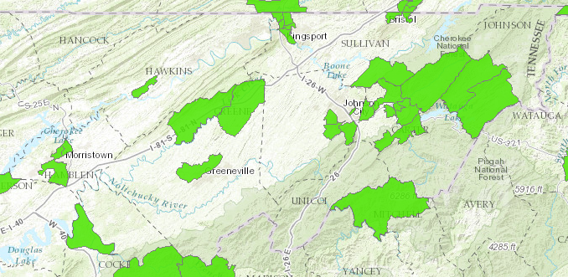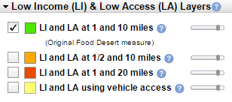

Figure : Food Access Research Atlas – Northeastern Tennessee (2016 USDA ERS Food Desert Atlas)

## Child Welfare

In 2014, there were more than 66,481 children with reported cases of child abuse in Tennessee, 4.4 percent of children, ages 0-18. Population estimates were from the Tennessee Department of Health, Office of Policy Planning and Assessment, Division of Health Statistics. The number of reported child abuse cases in the UETHDA service area in 2014 ranged from 5.0 percent (Green County) to 7.6 percent (Sullivan County) (Table 46). The rate of child abuse cases increased from 2013 to 2014 in the state of Tennessee, as well as Carter, Greene, Sullivan, and Washington Counties. The rate of child abuse cases decreased from 2013 to 2014 in Hancock, Johnson, and Unicoi Counties and stayed the same in Hawkins County (Fig 46).[45]

|  |  |  |  |  |
| --- | --- | --- | --- | --- |
|  | 2013 | | 2014 | |
| **Number** | **Percent** | **Number** | **Percent** |
| Tennessee | 63,512 | 4.3% | 66,481 | 4.5% |
| Carter | 648 | 5.8% | 668 | 6.2% |
| Greene | 633 | 4.6% | 676 | 5.0% |
| Hancock | 79 | 5.8% | 77 | 5.6% |
| Hawkins | 612 | 5.1% | 601 | 5.1% |
| Johnson | 227 | 7.2% | 207 | 6.7% |
| Sullivan | 2,253 | 7.3% | 2,353 | 7.6% |
| Unicoi | 197 | 5.7% | 186 | 5.4% |
| Washington | 1,296 | 5.1% | 1,368 | 5.4% |

Table : Reported Cases of Child Abuse (2014)

Figure : Reported Cases of Child Abuse (2014)

The [Tennessee Department of Children’s Services 2014-2015 Report](https://www.tn.gov/assets/entities/dcs/attachments/Annual+Report+2014-2015.pdf) highlights trends and statistics within the northeast counties in the state. This region includes all counties included in this assessment. Data is not available at the individual county level. The report reveals that in 2014-2015, 216 children, ages 0 to 4, 277 children, ages 5 to 12, and 314 children, ages 13 to 17, were in the custody of Children’s Services. In the northeast 807 children total were in custody, whereas in Tennessee overall, 8,093 children were in custody. The average length of stay in custody was 480 days. Additionally, in the northeast region, there were 1,235 total children in placement and 538 available placements in 2014-2015. The report also showed that in northeast counties, there were 117 children in full guardianship, with pending or without preadoptive placement, and there were 137 children in full guardianship.[46]

## Tennessee Licensed Child Care Programs

In the U.S. more than 15 million children under the age of 6 have the sole parent or both parents in the household in the labor force, 64.8 percent (Table 47). In Tennessee more than 296,000 children under age 6, or 64.0 percent of the total, have all parents in the family in the labor force, of which 18,392 are in the UETHDA service area. Washington County has the highest proportion of children under the age of 6 with all parents in the labor force (67.4 percent), while Hancock County has the lowest proportion of children under the age of 6 with all parents in the labor force (42.8 percent).

|  |  |  |  |  |
| --- | --- | --- | --- | --- |
|  | Own children under 6 years of the population Age 16+ | All parents in family in labor force | | |
| United States | 23,202,576 | 15,035,269 | 64.8% |
| Tennessee | 463,216 | 296,458 | 64.0% |
| Carter County | 3,397 | 2,110 | 62.1% |
| Greene County | 3,920 | 2,509 | 64.0% |
| Hancock County | 428 | 183 | 42.8% |
| Hawkins County | 3,398 | 1,978 | 58.2% |
| Johnson County | 824 | 424 | 51.5% |
| Sullivan County | 8,768 | 5,454 | 62.2% |
| Unicoi County | 816 | 466 | 57.1% |
| Washington County | 7,818 | 5,269 | 67.4% |
| UETHDA Service Area | 29,369 | 18,392 | 62.6% |

Table : Children Under Age 6 With All Parents in Labor Force (2014 ACS 5-Year Estimates)

The average cost of childcare in a child care center in Tennessee for an infant is $5,857 per year; the cost for care of a 4-year old is $4,515 per year, and the cost of care for a school-age child is $1,838 per year (Fig 47). According to [*Child Care Aware America*](http://usa.childcareaware.org/)*,* the price tag of infant care in Tennessee accounts for 29.3 percent of the income of a single parent family and 8.2 percent of the income of a married couple family (Fig 48).[47]



Figure : Average of Cost Child Care in Tennessee (2015 Child Care Aware Report)

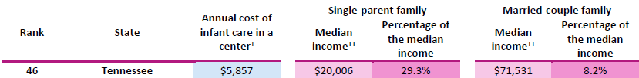

Figure : Average of Cost Child Care in Tennessee as Percent of Income (2015 Child Care Aware Report)

### Regulated Child Care Programs

Based on the [Tennessee Department of Human Services](http://www.tn.gov/accweb/), there are a total of 2,435 child care providers in the state, with a capacity to serve 161,897 children. The majority of providers -- 1,906 Department of Education providers and 1,740 Department of Human Services providers -- offer center care for 13 or more children (Table 48).

|  |  |  |  |  |
| --- | --- | --- | --- | --- |
| Type | Total Providers | | Total Capacity | |
| DOE* | DHS | DOE* | DHS |
| Centers Care for 13 or more children | 1,906 | 1,740 | 159,391 | 154,424 |
| Drop in | 0 | 7 | 0 | 428 |
| Family Homes Care for 7 or fewer children | 0 | 319 | 0 | 2,211 |
| Group Homes Care for 8-12 children | 2 | 369 | 55 | 4,834 |
| TOTAL | 1,908 | 2,435 | 159,446 | 161,897 |
| *Department of Education | | | | |

Table : TN Child Care Providers (2016)

**Child Care Certificate Program**

The Child Care Certificate Program is the Tennessee’s child care assistance program for children of low income participating in the Families First program. Funding for the Child Care Certificate Program is provided by the federal Families First/TANF block grant and the Child Care Development Block Grant (CCDBG). This is often referred to as the subsidized child care program. Families must be determined eligible by DHS staff before participating in the program.

Both licensed(regulated) and unlicensed(unregulated) providers can participate in this program and receive reimbursement from DHS for caring for qualified children.

DHS establishes its state rates using data gathered in a market rate survey of all regulated providers in Tennessee. While this market rate survey is conducted every year, the rates are only changed when funding permits.

The rates are set by three age groups: infants, preschool and school age. The rates are also set by two groups of counties in their standing for average population and incomes over the past three years. Rates for infants and preschool age children are also set by amount of time in care: 1-19 hours per week part-time and 20 or more hours per week for full-time care.

Providers enrolled in the certificate payment program who also earn a 1, 2 or 3 Star Quality rating on their license and participate in that quality care program receive a bonus from the certificate program. Providers who wish to enroll in the certificate program should contact their local Department of Human Services office.

- See more at: <https://www.tn.gov/humanservices/article/child-care-certificate-program#sthash.SNdgfbQ6.dpuf>

#### UETHDA Service Area: Child Care Providers

Based on a July 2016 [Child Care Providers Map](http://www.tn.gov/accweb/faces/stateMapPage.jsp) search, in the UETHDA service area there are 270 regulated child care centers, with a capacity to serve 18,452 children, ages 0 to 18. Of those 270 regulated child care providers, only 82 centers offer child care assistance to Head Start age-eligible children, with a capacity of 5,824 slots.[48] Table 49 lists the names of each center by county, as well as capacity and minimum/maximum ages of children served. Although Hancock County has a total of four child care providers (including the Sneedville Head Start center) there are no centers that offer child care assistance.

|  | Provider Name (Offer Child Care Assistance) | Capacity | Min Age | Max Age |
| --- | --- | --- | --- | --- |
| Carter County   * 8 centers * 636 slots | [CHILDREN'S CTR OF SYCAMORE SHOALS HOSP](http://www.tn.gov/accweb/faces/stateMapPage.jsp) | 78 | 6 WK | 5 YR |
| [Eastside Day care & learning Center](http://www.tn.gov/accweb/faces/stateMapPage.jsp) | 57 | 12 MO | 5 YR |
| [HAROLD MCCORMICK - ESP (-E-)](http://www.tn.gov/accweb/faces/stateMapPage.jsp) | 250 | 4 YR | 12 YR |
| [Heavens Little Miracles](http://www.tn.gov/accweb/faces/stateMapPage.jsp) | 49 | 6 WK | 5 YR |
| [HUNTER FIRST BAPTIST DC & LN CT I](http://www.tn.gov/accweb/faces/stateMapPage.jsp) | 29 | 6 WK | 2 YR |
| [HUNTER FIRST BAPTIST DC & LN CT II](http://www.tn.gov/accweb/faces/stateMapPage.jsp) | 75 | 3 YR | 12 YR |
| [Tennessee Tots Learning Center](http://www.tn.gov/accweb/faces/stateMapPage.jsp) | 60 | 6 WK | 12 YR |
| [TODDLER TIME DAY CARE CENTER](http://www.tn.gov/accweb/faces/stateMapPage.jsp) | 38 | 6 WK | 5 YR |
| Green County   * 11 centers * 665 slots | [ASBURY CHILD ENRICHMENT CENTER](http://www.tn.gov/accweb/faces/stateMapPage.jsp) | 82 | 6 WK | 5 YR |
| [CHILDREN'S CENTER OF HOLSTON HOME](http://www.tn.gov/accweb/faces/stateMapPage.jsp) | 90 | 6 WK | 6 YR |
| [CHUCKEY ELEMENTARY ESP (-E-)](http://www.tn.gov/accweb/faces/stateMapPage.jsp) | 60 | 4 YR | 14 YR |
| [DEBUSK ELEMENTARY - ESP (-E-)](http://www.tn.gov/accweb/faces/stateMapPage.jsp) | 30 | 4 YR | 14 YR |
| [DEBUSK PRE-K (-E-)](http://www.tn.gov/accweb/faces/stateMapPage.jsp) | 20 | 4 YR | 5 YR |
| [It's All About Kids Childcare](http://www.tn.gov/accweb/faces/stateMapPage.jsp) | 50 | 6 WK | 12 YR |
| [NOAH'S ARK DAY CARE & PRE-SCHOOL](http://www.tn.gov/accweb/faces/stateMapPage.jsp) | 91 | 6 WK | 5 YR |
| [Small Miracles](http://www.tn.gov/accweb/faces/stateMapPage.jsp) | 99 | 6 WK | 5 YR |
| [TENDER HEART DAY CARE CENTER](http://www.tn.gov/accweb/faces/stateMapPage.jsp) | 59 | 6 WK | 12 YR |
| [The Learning Tree Children’s Center](http://www.tn.gov/accweb/faces/stateMapPage.jsp) | 50 | 6 WK | 5 YR |
| [THE WOODEN SHOE](http://www.tn.gov/accweb/faces/stateMapPage.jsp) | 54 | 6 WK | 14 YR |
| Hancock County - (N/A) | | | | |
| Hawkins County   * 7 centers * 396 slots | [ALLANDALE EARLY LEARNING CENTER](http://www.tn.gov/accweb/faces/stateMapPage.jsp;jsessionid=D869979621D89A7C71CDC8337987CA78) | 99 | 12 MO | 12 YR |
| [FRIENDS AT PLAY PRESCHOOL](http://www.tn.gov/accweb/faces/stateMapPage.jsp;jsessionid=D869979621D89A7C71CDC8337987CA78) | 45 | 3 YR | 5 YR |
| [MT. CARMEL DAY CARE CENTER](http://www.tn.gov/accweb/faces/stateMapPage.jsp;jsessionid=D869979621D89A7C71CDC8337987CA78) | 37 | 12 MO | 12 YR |
| [PROMISES CHILD CARE CENTER](http://www.tn.gov/accweb/faces/stateMapPage.jsp;jsessionid=D869979621D89A7C71CDC8337987CA78) | 24 | 6 WK | 6 YR |
| [PROMISES TOO! CHILD CARE & PRESCHOOL](http://www.tn.gov/accweb/faces/stateMapPage.jsp;jsessionid=D869979621D89A7C71CDC8337987CA78) | 70 | 6 WK | 12 YR |
| [WEE CARE DAY CARE CENTER](http://www.tn.gov/accweb/faces/stateMapPage.jsp;jsessionid=D869979621D89A7C71CDC8337987CA78) | 49 | 6 WK | 12 YR |
| [WONDERLAND CHILD CARE CENTER](http://www.tn.gov/accweb/faces/stateMapPage.jsp;jsessionid=D869979621D89A7C71CDC8337987CA78) | 72 | 36 MO | 12 YR |
| Johnson County   * 4 centers * 254 slots | [In the Beginning Learning & Care Center](http://www.tn.gov/accweb/faces/stateMapPage.jsp;jsessionid=D869979621D89A7C71CDC8337987CA78) | 24 | 3 MO | 5 YR |
| [KID'S CORRAL SCH-AGE CC PROGRAM@ROAN CRK (-E-)](http://www.tn.gov/accweb/faces/stateMapPage.jsp;jsessionid=D869979621D89A7C71CDC8337987CA78) | 100 | 4 YR | 12 YR |
| [KIDS' COUNTRY CHILDCARE (-E-)](http://www.tn.gov/accweb/faces/stateMapPage.jsp;jsessionid=D869979621D89A7C71CDC8337987CA78) | 100 | 4 YR | 12 YR |
| [PANTHER DEN SACC PROGRAM (-E-)](http://www.tn.gov/accweb/faces/stateMapPage.jsp;jsessionid=D869979621D89A7C71CDC8337987CA78) | 30 | 6 WK | 12 YR |
| Sullivan County   * 26 centers * 1,877slots | [ALL ABOUT KIDS](http://www.tn.gov/accweb/faces/providerZipList.jsp) | 48 | 6 WK | 12 YR |
| [Country Kids Highway 126](http://www.tn.gov/accweb/faces/providerZipList.jsp) | 48 | 6 WK | 12 YR |
| [FIRST BAPTIST KID'S CARE](http://www.tn.gov/accweb/faces/providerZipList.jsp) | 35 | 3 YR | 5 YR |
| [TED E. BEAR ACADEMY](http://www.tn.gov/accweb/faces/providerZipList.jsp) | 29 | 6 WK | 12 YR |
| [WHEELER UNITED METHODIST CHILD CARE C.](http://www.tn.gov/accweb/faces/providerZipList.jsp) | 70 | 6 WK | 13 YR |
| [Piney Bluff Child Care Center](http://www.tn.gov/accweb/faces/providerZipList.jsp) | 99 | 6 WK | 12 YR |
| [BY-PASS DAY CARE CENTER, INC.](http://www.tn.gov/accweb/faces/providerZipList.jsp) | 52 | 6 WK | 5 YR |
| [LITTLE HANDS CHRISTIAN CHILD CARE CENTER](http://www.tn.gov/accweb/faces/providerZipList.jsp) | 99 | 6 WK | 12 YR |
| [LITTLEST ANGEL CHILD CARE CENTER](http://www.tn.gov/accweb/faces/providerZipList.jsp) | 150 | 6 WK | 14 YR |
| [WELLMONT CHILD DEVELOPMENT CENTER](http://www.tn.gov/accweb/faces/providerZipList.jsp) | 120 | 6 WK | 12 YR |
| [YWCA CHILDREN'S CENTER](http://www.tn.gov/accweb/faces/providerZipList.jsp) | 84 | 6 WK | 5 YR |
| [BLOOMINGDALE LEARNING CENTER](http://www.tn.gov/accweb/faces/providerZipList.jsp) | 24 | 6 WK | 5 YR |
| [CHRISTIAN LIFE CHILD LEARNING CENTER](http://www.tn.gov/accweb/faces/providerZipList.jsp) | 69 | 6 WK | 5 YR |
| [CHURCH CIRCLE FIRST PRESBYTERIAN](http://www.tn.gov/accweb/faces/providerZipList.jsp) | 75 | 6 WK | 5 YR |
| [FIRST BROAD STREET CHILD CARE CENTER](http://www.tn.gov/accweb/faces/providerZipList.jsp) | 99 | 6 WK | 5 YR |
| [GEORGE WASHINGTON SCH/EARLY CHILDHOOD (-E-)](http://www.tn.gov/accweb/faces/providerZipList.jsp) | 55 | 6 WK | 5 YR |
| [KINDERCARE LEARNING CENTERS, LLC](http://www.tn.gov/accweb/faces/providerZipList.jsp) | 94 | 6 WK | 12 YR |
| [KINGSPORT CHILD DEVELOPMENT CENTER](http://www.tn.gov/accweb/faces/providerZipList.jsp) | 99 | 6 WK | 5 YR |
| [ST. PAUL'S DAY SCHOOL & KINDERGARTEN (-E-)](http://www.tn.gov/accweb/faces/providerZipList.jsp) | 75 | 2 YR | 5 YR |
| [THE PLAY CENTER NURSERY SCHOOL, INC.](http://www.tn.gov/accweb/faces/providerZipList.jsp) | 150 | 6 WK | 12 YR |
| [MIDWAY PRESCHOOL AND DAY CARE](http://www.tn.gov/accweb/faces/providerZipList.jsp) | 72 | 6 WK | 12 YR |
| [KIDDIE KOLLEGE, INC.](http://www.tn.gov/accweb/faces/providerZipList.jsp) | 20 | 12 MO | 8 YR |
| [Rock Springs Elementary Pre-K Academy (-E-)](http://www.tn.gov/accweb/faces/providerZipList.jsp) | 20 | 2 YR | 5 YR |
| [WAVERLY ROAD CHILD CARE CENTER, INC.](http://www.tn.gov/accweb/faces/providerZipList.jsp) | 60 | 6 WK | 5 YR |
| [JOYCE ALBRIGHT DAY CARE CENTER](http://www.tn.gov/accweb/faces/providerZipList.jsp) | 32 | 12 MO | 6 YR |
| [SMILING SPROUTS ACADEMY, LLC.](http://www.tn.gov/accweb/faces/providerZipList.jsp) | 99 | 6 WK | 12 YR |
| Unicoi County   * 1 center * 65 slots | [UNICOI CHILD CARE CENTER](http://www.tn.gov/accweb/faces/stateMapPage.jsp;jsessionid=D869979621D89A7C71CDC8337987CA78) | 65 | 6 WK | 12 YR |
| Washington County   * 25 centers * 1,914slots | [BOONES CREEK CHILD DEV. CENTER](http://www.tn.gov/accweb/faces/stateMapPage.jsp;jsessionid=D869979621D89A7C71CDC8337987CA78) | 99 | 6 WK | 5 YR |
| [EARLY LEARNING CENTER-FIRST UN. METH.CH.](http://www.tn.gov/accweb/faces/stateMapPage.jsp;jsessionid=D869979621D89A7C71CDC8337987CA78) | 98 | 6 WK | 5 YR |
| [ETSU CHILD STUDY CENTER](http://www.tn.gov/accweb/faces/stateMapPage.jsp;jsessionid=D869979621D89A7C71CDC8337987CA78) | 133 | 3 MO | 5 YR |
| [FAIRMONT ELEMENTARY - EDUCARE (-E-)](http://www.tn.gov/accweb/faces/stateMapPage.jsp;jsessionid=D869979621D89A7C71CDC8337987CA78) | 150 | 4 YR | 11 YR |
| [GRAY UNITED METHODIST CHURCH PRESCHOOL](http://www.tn.gov/accweb/faces/stateMapPage.jsp;jsessionid=D869979621D89A7C71CDC8337987CA78) | 29 | 30 MO | 5 YR |
| [HOSPITOTS CHILD CARE CENTER](http://www.tn.gov/accweb/faces/stateMapPage.jsp;jsessionid=D869979621D89A7C71CDC8337987CA78) | 125 | 6 WK | 5 YR |
| [JOHNSON CITY KIDZ CLUBHOUSE, INC](http://www.tn.gov/accweb/faces/stateMapPage.jsp;jsessionid=D869979621D89A7C71CDC8337987CA78) | 46 | 6 WK | 5 YR |
| [KINDER CARE LEARNING CENTERS, LLC](http://www.tn.gov/accweb/faces/stateMapPage.jsp;jsessionid=D869979621D89A7C71CDC8337987CA78) | 94 | 6 WK | 12 YR |
| [LAKE RIDGE ELEMENTARY - EDUCARE (-E-)](http://www.tn.gov/accweb/faces/stateMapPage.jsp;jsessionid=D869979621D89A7C71CDC8337987CA78) | 125 | 3 YR | 11 YR |
| [LAKE RIDGE ELEMENTARY - PRESCHOOL (-E-)](http://www.tn.gov/accweb/faces/stateMapPage.jsp;jsessionid=D869979621D89A7C71CDC8337987CA78) | 50 | 3 YR | 4 YR |
| [LITTLE BO PEEP LEARNING CENTER](http://www.tn.gov/accweb/faces/stateMapPage.jsp;jsessionid=D869979621D89A7C71CDC8337987CA78) | 32 | 6 WK | 8 YR |
| [LITTLE BUCCANEERS STUDENT CHILD CARE CTR](http://www.tn.gov/accweb/faces/stateMapPage.jsp;jsessionid=D869979621D89A7C71CDC8337987CA78) | 82 | 3 MO | 5 YR |
| [PARKWAY PRESCHOOL](http://www.tn.gov/accweb/faces/stateMapPage.jsp;jsessionid=D869979621D89A7C71CDC8337987CA78) | 50 | 6 WK | 12 YR |
| [PlayStation](http://www.tn.gov/accweb/faces/stateMapPage.jsp;jsessionid=D869979621D89A7C71CDC8337987CA78) | 84 | 6 WK | 12 YR |
| [Princeton Prep Inc.](http://www.tn.gov/accweb/faces/stateMapPage.jsp;jsessionid=D869979621D89A7C71CDC8337987CA78) | 95 | 6 WK | 12 YR |
| [SCIENCE HILL PRESCHOOL (-E-)](http://www.tn.gov/accweb/faces/stateMapPage.jsp;jsessionid=D869979621D89A7C71CDC8337987CA78) | 50 | 6 WK | 4 YR |
| [SHEPHERD'S PASTURE PRESCHOOL](http://www.tn.gov/accweb/faces/stateMapPage.jsp;jsessionid=D869979621D89A7C71CDC8337987CA78) | 24 | 30 MO | 5 YR |
| [Shining Stars Christian Learning Center](http://www.tn.gov/accweb/faces/stateMapPage.jsp;jsessionid=D869979621D89A7C71CDC8337987CA78) | 85 | 6 WK | 5 YR |
| [SMALL STEPS CHILDREN'S ACADEMY](http://www.tn.gov/accweb/faces/stateMapPage.jsp;jsessionid=D869979621D89A7C71CDC8337987CA78) | 42 | 6 WK | 5 YR |
| [Splash Early Learning Center](http://www.tn.gov/accweb/faces/stateMapPage.jsp;jsessionid=D869979621D89A7C71CDC8337987CA78) | 48 | 12 MO | 5 YR |
| [SULPHUR SPRINGS COMMUNITY CHILD CARE](http://www.tn.gov/accweb/faces/stateMapPage.jsp;jsessionid=D869979621D89A7C71CDC8337987CA78) | 50 | 6 WK | 5 YR |
| [Sundale Preschool](http://www.tn.gov/accweb/faces/stateMapPage.jsp;jsessionid=D869979621D89A7C71CDC8337987CA78) | 99 | 6 WK | 5 YR |
| [TINY TOWN, INC.](http://www.tn.gov/accweb/faces/stateMapPage.jsp;jsessionid=D869979621D89A7C71CDC8337987CA78) | 65 | 6 WK | 12 YR |
| [TRI-CITIES CHRISTIAN PRESCHOOL & AC-GRAY (-E-)](http://www.tn.gov/accweb/faces/stateMapPage.jsp;jsessionid=D869979621D89A7C71CDC8337987CA78) | 87 | 2 YR | 10 YR |
| [WESLEY MEMORIAL UMC PRESCHOOL](http://www.tn.gov/accweb/faces/stateMapPage.jsp;jsessionid=D869979621D89A7C71CDC8337987CA78) | 72 | 2 YR | 5 YR |

Table : Child Care Providers [excluding HS\}in UETHDA Service Area (July 2016)

*NOTE: This list does not include any Head Start or Early Head Start centers in the service area.*

*See* *Appendix D* *for a comprehensive list of child care providers including the hours of operation and center addresses.*

# Geographic Location of Eligible Children and Families

According to the 2014 American Community Survey (5-year estimates), there are more than 118,000 children, ages 0-4, living in poverty in Tennessee, of which 7,910 live in the UETHDA service area. Of the 7,910 children in poverty, it can be estimated that 60 percent are EHS age-eligible (4,746), and 40 percent are HS age-eligible (3,164) (Table 50).

Sullivan County is home to the highest number of children, ages 0-4, in poverty, 2,565, of which approximately 1,539 are EHS age-eligible, and 1,026 are HS age-eligible. Carter, Greene, and Washington Counties each have over 1,000 children, ages 0-4, in poverty. The county with the smallest number of children, ages 0-4, in poverty is Hancock County, 181.

|  |  |  |  |
| --- | --- | --- | --- |
|  | Under 5 years | *Estimate Children Ages 0-2* | *Estimate Children Ages 3-4* |
| United States | 4,892,716 | 2,935,630 | 1,957,086 |
| Tennessee | 118,580 | 71,148 | 47,432 |
| Carter County | 1,316 | 790 | 526 |
| Greene County | 1,271 | 763 | 508 |
| Hancock County | 181 | 109 | 72 |
| Hawkins County | 791 | 475 | 316 |
| Johnson County | 216 | 130 | 86 |
| Sullivan County | 2,565 | 1,539 | 1,026 |
| Unicoi County | 201 | 121 | 80 |
| Washington County | 1,369 | 821 | 548 |
| UETHDA Service Area | 7,910 | 4,746 | 3,164 |

Table : Number of Children (0-4) in Poverty (2014 ACS 5-Year Estimates)

The map on the following page illustrates the number of children, ages 0-4, in poverty by zip code tabulation area (ZCTAs). There are three ZCTAs in the UETHDA service area with more than 800 children, ages 0-4, in poverty.

***ZIP Code Tabulation Areas (ZCTAs)*** *are generalized areal representations of United States Postal Service (U.S.PS) ZIP Code service areas. The U.S.PS ZIP Codes identify the individual post office or metropolitan area delivery station associated with mailing addresses. U.S.PS ZIP Codes are not areal features but a collection of mail delivery routes.* [*https://www.census.gov/geo/reference/zctas.html*](https://www.census.gov/geo/reference/zctas.html)

***ZIP Code Tabulation Areas (ZCTAs)*** *are generalized areal representations of United States Postal Service (U.S.PS) ZIP Code service areas. The U.S.PS ZIP Codes identify the individual post office or metropolitan area delivery station associated with mailing addresses. U.S.PS ZIP Codes are not areal features but a collection of mail delivery routes.* [*https://www.census.gov/geo/reference/zctas.html*](https://www.census.gov/geo/reference/zctas.html)

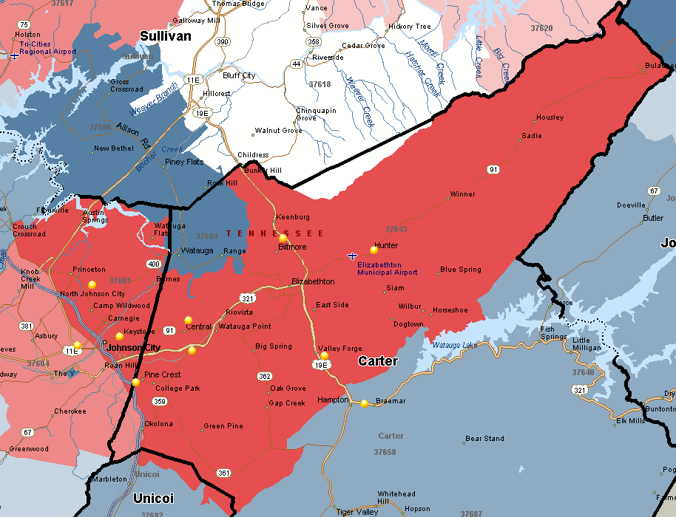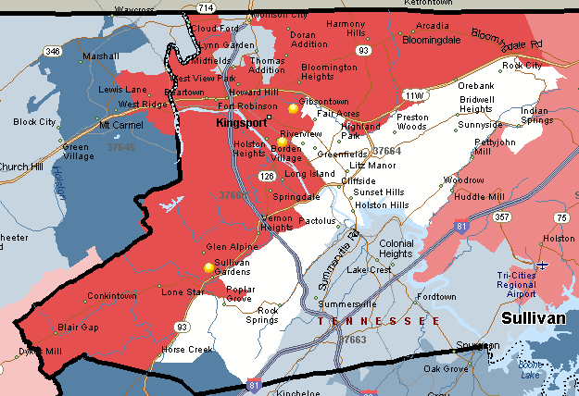ZCTA 37660 in Sullivan County (surrounding the city of Kingsport, and bordering Hawkins County to the west) is home to 948 children, 0-4, in poverty (Fig 49).

Figure : ZCTA 37660

ZCTA 37601 (north east of Johnson City and crossing over Washington and Carter Counties) is home to 929 children, ages 0-4, in poverty. ZCTA 37634 (in northern Carter County, bordering Sullivan County) is home to 806 children, ages 0-4, in poverty (Fig 50).

Figure : ZCTAs 37601, 37634

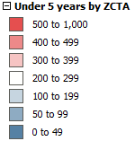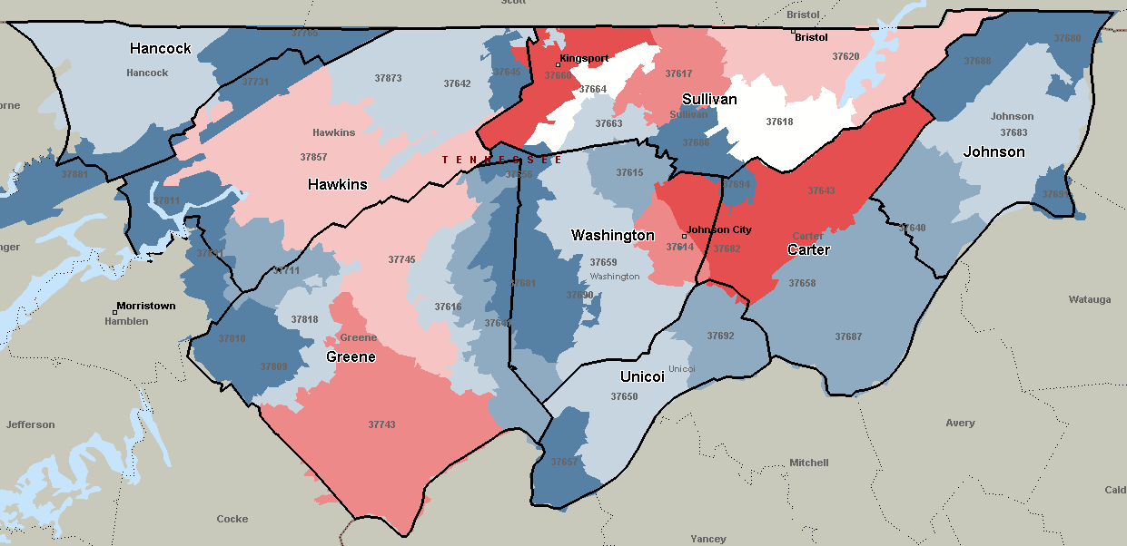

| ZCTA | < 5 years | *Estimate Children Ages 0-2* | *Estimate Children Ages 3-4* |
| --- | --- | --- | --- |
| 37660 | 948 | 569 | 379 |
| 37601 | 929 | 557 | 372 |
| 37643 | 806 | 484 | 322 |
| 37743 | 481 | 289 | 192 |
| 37617 | 423 | 254 | 169 |
| 37604 | 405 | 243 | 162 |
| 37620 | 377 | 226 | 151 |
| 37745 | 371 | 223 | 148 |
| 37857 | 354 | 212 | 142 |
| 37618 | 294 | 176 | 118 |
| 37664 | 213 | 128 | 85 |
| 37659 | 195 | 117 | 78 |
| 37665 | 176 | 106 | 70 |
| 37869 | 165 | 99 | 66 |
| 37663 | 161 | 97 | 64 |
| 37683 | 151 | 91 | 60 |
| 37642 | 145 | 87 | 58 |
| 37873 | 134 | 80 | 54 |
| 37616 | 123 | 74 | 49 |
| 37650 | 115 | 69 | 46 |
| 37818 | 100 | 60 | 40 |
| 37687 | 98 | 59 | 39 |
| 37640 | 94 | 56 | 38 |
| 37692 | 86 | 52 | 34 |
| 37711 | 83 | 50 | 33 |
| 37641 | 74 | 44 | 30 |
| 37615 | 65 | 39 | 26 |
| 37658 | 50 | 30 | 20 |
| 37810 | 47 | 28 | 19 |
| 37881 | 47 | 28 | 19 |
| 37686 | 46 | 28 | 18 |
| 37690 | 44 | 26 | 18 |
| 37645 | 38 | 23 | 15 |
| 37645 | 38 | 23 | 15 |
| 37891 | 36 | 22 | 14 |
| 37694 | 35 | 21 | 14 |
| 37809 | 31 | 19 | 12 |
| 37681 | 14 | 8 | 6 |
| 37688 | 13 | 8 | 5 |
| 37656 | 10 | 6 | 4 |
| 37811 | 6 | 4 | 2 |
| 37811 | 6 | 4 | 2 |
| *37614, 37657, 37680, 37682, 37691, 37731, 37731, 37765 = 0* | | | |

Table : Number of Children (0-4) in Poverty by ZCTA (2014 ACS 5-Year Estimates)

# Characteristics of HS/EHS Families (PIR)

|  |  |  |  |  |
| --- | --- | --- | --- | --- |
|  | UETHDA | Carter County HS | Johnson County HS | TOTAL |
| Funded Enrollment | 817 | 153 | 80 | 1,050 |
| Cumulative Enrollment | 969 | 166 | 87 | 1,222 |

Table : 2014-15 UETHDA Enrollment

During the 2014-15 program year the UETHDA Head Start program was funded to serve 1,050 preschool aged children, ages 3 and 4. The program served a total of 1,222 across its 32 direct service centers and nine partner sites in Carter and Johnson Counties (Table 52).

|  |  |  |  |  |
| --- | --- | --- | --- | --- |
| Center Name | **Center Address** | **City** | **State** | **Zip** |
| UPPER EAST TENNESSEE HUMAN DEVELOPMENT AGENCY | | | | |
| Baileyton | 6536 Horton Hwy | Greeneville | TN | 37745 |
| Bluff City | 284 J Forrest Thomas St | Bluff City | TN | 37618 |
| Boones Creek | 348 Christian Church Rd | Gray | TN | 37615 |
| Camp Creek | 2941 Camp Creek Rd | Greeneville | TN | 37743 |
| Carver | 500 Washington St | Johnson City | TN | 37604 |
| Children First Child Development Center | 837 Pardee St | Johnson City | TN | 37601 |
| Chuckey | 1605 Chuckey Hwy | Chuckey | TN | 37641 |
| Dobbins | 301 Louis St | Kingsport | TN | 37660 |
| East View | 454 E Bernard Ave | Greeneville | TN | 37745 |
| Florida Avenue | 703 Florida Ave | Bristol | TN | 37620 |
| Fugate Hill | 901 Locust St | Rogersville | TN | 37857 |
| George Clem | 310 Floral St | Greeneville | TN | 37743 |
| Girls Inc. Head Start | 1100 Girls Place | Kingsport | TN | 37660 |
| Grandview Head Start | 2891 Highway 11 E | Telford | TN | 37690 |
| Greeneville Technology Center (GTC) | 1121 Hal Henard Rd | Greeneville | TN | 37743 |
| Hal Henard | 425 E Vann Rd | Greeneville | TN | 37743 |
| Harmony | 1019 Painter Rd | Jonesborough | TN | 37659 |
| Highland Head Start/Pre-K | 208 N Highland Ave | Greeneville | TN | 37745 |
| Lake Terrace | 2450 Mint Hill Rd | Johnson City | TN | 37601 |
| McDonald | 8120 McDonald Rd | Mohawk | TN | 37810 |
| Mosheim | 299 W School Street | Greeneville | TN | 37743 |
| Nolachuckey | 565 Nolichuckey Rd | Greeneville | TN | 37743 |
| Ottway | 2705 Ottway Rd | Greeneville | TN | 37745 |
| Persimmon Ridge | 1521 Persimmon Ridge Rd | Jonesborough | TN | 37659 |
| Pinecrest | 500 Angel Pl | Johnson City | TN | 37601 |
| Sneedville | 216 Harrison St | Sneedville | TN | 37869 |
| Sullivan | 209 Rosemont St | Kingsport | TN | 37660 |
| Surgoinsville Head Start | 3327 Highway 11W | Surgoinsville | TN | 37873 |
| Tusculum View | 1725 Lafayette St | Greeneville | TN | 37745 |
| Unicoi/Erwin | 435 N Main Ave | Erwin | TN | 37650 |
| Weaver | 3341 Weaver Pike | Bristol | TN | 37620 |
| West Pines | 3500 W Pines Rd | Greeneville | TN | 37745 |
| Carter County Head Start | | | | |
| Central Head Start | 252 Taylortown Rd | Johnson City | TN | 37601 |
| Cloudland | 8540 Highway 19 E | Roan Mountain | TN | 37687 |
| Hampton 1 | 408 Highway 321 | Hampton | TN | 37658 |
| Happy Valley 1 & 2 | 1840 Milligan Hwy | Johnson City | TN | 37601 |
| Hunter | 145 Hope St | Elizabethton | TN | 37643 |
| Keenburg | 139 Keenburg Rd | Elizabethton | TN | 37643 |
| Valley Forge 2 | 1485 Riverview Dr | Elizabethton | TN | 37643 |
| Johnson County Head Start | | | | |
| Mountain City | 301 Donnelly St | Mountain City | TN | 37683 |
| Roan Creek | 2410 Roan Creek Rd | Mountain City | TN | 37683 |

**Upper East Tennessee Human Development Agency Head Start Centers**

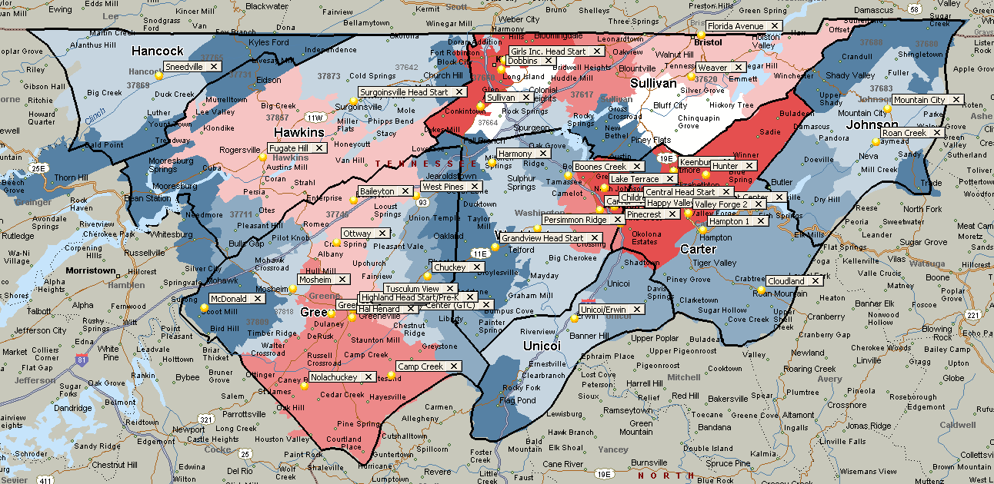

The following pages illustrate the UETHDA Program Information Report (PIR) data for the 2014-15 program year, comparing Head Start statistics for programs in the United States, Region IV, Tennessee, and its partner sites.

### Enrollment Eligibility

### Race of Head Start Families and Children

### Ethnicity of Head Start Families and Children

### Languages Spoken by HS Families and Children

**Note**: other languages spoken by Head Start families in the U.S., Region IV, and Tennessee include: Central/South American and Mexican, Caribbean Languages, Middle Eastern/South Asian Languages, East Asian Languages, Native North American/Alaska Native Languages, Pacific Island Languages, European and Slavic Languages, African Languages, and Other Languages.

### Children with Disabilities

### Head Start Families

#### Employment

#### Educational Attainment

#### In Training/School

#### Federal Benefits

### Child Development Staff

#### Race

#### Ethnicity

#### Languages

#### Education/Degree

# Strengths and Needs of Eligible Children and Families

In order to collect primary data from Head Start parents and guardians, a Parent Community Needs Survey was distributed via mail in English and Spanish to all families enrolled during the 2015-16 program year, 72 surveys were completed and returned. Additional surveys were completed by prospective Head Start parents at various Health Fairs conducted in the service area during the months of July and August; 639 surveys were completed.

The majority of surveys completed and returned by both HS parent and health fair respondents were from Greene County, no surveys were collected in Johnson County.

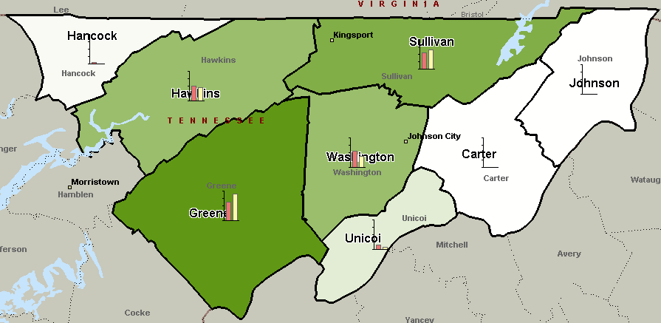

|  |  |  |  |  |
| --- | --- | --- | --- | --- |
| Answer Options | Health Fair Respondents | Response Count | Current HS Parents | Response Count |
| Greene County | 25.3% | 153 | 36.0% | 18 |
| Washington County | 22.7% | 137 | 16.0% | 8 |
| Sullivan County | 22.2% | 134 | 26.0% | 13 |
| Hawkins County | 20.9% | 126 | 18.0% | 9 |
| Unicoi County | 6.3% | 38 | 4.0% | 2 |
| Hancock County | 2.3% | 14 | 0.0% | 0 |
| Carter County | 0.3% | 2 | 0.0% | 0 |
| Johnson County | 0.0% | 0 | 0.0% | 0 |
| *answered question* |  | 604 |  | 50 |
| *skipped question* |  | 35 |  | 22 |

### Parent Survey Results

#### Characteristics

Of those who responded to the survey, the overwhelming majority indicated their race to be white/Caucasian (85 and 87 percent). Of the health fair respondents, 9.3 percent were Hispanic/Latino and 8.1 percent were black/African American. Of the current HS parents, 5.8 percent were Hispanic/Latino and 14.5 percent were black/African American.

More than one third of respondents in both groups were employed full-time, more than one fifth of health fair respondents were unemployed (22.8 percent) and more than one fifth of current HS parents were full time homemakers (22.9 percent). A significantly larger proportion of HS parents were reported having a disability (15.7 percent) when compared to the health fair respondents (8.9 percent).

Although almost 3 out of 4 HS parents (72.9 percent), and 2 out of 3 health fair respondents (66.4 percent), indicated having a checking or savings account, **approximately 1 out of 4 HS parents/guardians and 1 out of 3 health fair respondents do not have a checking or savings account.**

More than one third of respondents indicated *not* having a computer or internet at home. **However, 95.7 percent of HS parents and 87.7 percent of health fair respondents do have a mobile phone with text capability**.

#### Perception of Problems in the Community

Survey takers were given a list of 20 items and asked to rate each on a scale of 1 to 5 to indicate how serious of a problem they found each item to be in their city or town. The scale provided was as follows: (1) Not a Problem (2) Somewhat (3) Problem (4) Serious Problem (5) Very Serious Problem. (Answers on the following charts are sorted by the rate given to each item by health fair respondents, from highest to lowest).

HS parents repeatedly rated all items higher than the health fair respondents (considering each item a more significant problem). Consistent however, were the top three problems as perceived by both groups: **1. Low wages** (rated 3.22 by HS parents and 2.58 by health fair respondents), **2. Availability of jobs** (rated 3.01 by HS parents and 2.48 by health fair respondents), and **3. Incidence of drug and alcohol abuse** (rated 3.03 by HS parents and 2.36 by health fair respondents).

The greatest difference in perception of a problem was the cost of utilities, HS parents gave it a rating of 2.68, 30 percent higher than the health fair respondent rating of 2.06.

**Note**: Low wages was rated a 5 (very serious problem) by 15 percent of health fair respondents and by 35 percent of HS parents. HS parents rated all problems a 5 at greater rates than the health fair respondents, with the exception of affordable child care before and after schools (HS parents rated this item as a “very serious problem” 13 percent, compared to the 14 percent rating by health fair respondents).

| How serious of a problem do you feel each of the following items is in your City/Town?  *Scale:(1) Not a Problem (2) Somewhat (3) Problem (4) Serious Problem (5) Very Serious Problem* | | | | | |
| --- | --- | --- | --- | --- | --- |
| Answer Options | Health Fair Respondents | | | Current HS Parents | |
| Rating Average | Percent Who Rated Item a 5 “Very Serious Problem” | Rating Average | | Percent Who Rated Item a 5 “Very Serious Problem” |
| Low wages | 2.58 | 15% | 3.22 | | 35% |
| Availability of jobs | 2.48 | 12% | 3.01 | | 26% |
| Incidence of drug and alcohol abuse | 2.36 | 16% | 3.03 | | 38% |
| Affordable child care during before and after school hours | 2.35 | 14% | 2.44 | | 13% |
| Availability and access to public transportation | 2.19 | 11% | 2.72 | | 25% |
| Incarceration of parents | 2.12 | 7% | 2.49 | | 18% |
| Child abuse and neglect | 2.12 | 7% | 2.58 | | 19% |
| Availability of affordable housing | 2.10 | 7% | 2.46 | | 13% |
| Public safety/crime | 2.09 | 6% | 2.60 | | 17% |
| Utility costs (heating, electricity, water) | 2.06 | 6% | 2.68 | | 17% |
| Child health issues (obesity, exposure to lead, asthma) | 1.99 | 6% | 2.33 | | 15% |
| Domestic Violence | 1.97 | 4% | 2.40 | | 17% |
| Availability of job training | 1.93 | 5% | 2.14 | | 7% |
| Services for children with disabilities | 1.90 | 6% | 2.29 | | 15% |
| Gang activity | 1.76 | 4% | 2.04 | | 11% |
| Access to public assistance (WIC, Food Stamps - SNAP, TN Care, Families First - TANF) | 1.67 | 4% | 1.79 | | 8% |
| Availability of adult education (GED, ESL, efc) | 1.62 | 2% | 1.89 | | 8% |
| Quality of public education in your city or town | 1.61 | 3% | 1.86 | | 6% |
| Access to health care | 1.60 | 3% | 2.07 | | 11% |
| Availability of recreation for families (parks, church programs, membership organizations) | 1.59 | 4% | 1.69 | | 4% |

**Poverty**. The top three reasons for poverty in the community according to survey respondents were low wages, the opinion that people do not want to work and not enough jobs. Additional reasons for poverty included the high cost of housing, lack of child care, high cost of health care, lack of job skills and education, high cost of utility and lack of transportation.

#### Family Needs

The majority of survey takers (619 out of 639 health fair respondents and 72 of 72 HS parents) responded to the question asking if they or someone in their immediate family experienced a time in the past year where they needed a particular service or experienced particular situations related to inadequate income (see chart below). Approximately 56 to 60 percent indicated that they or someone in their family had at one point within the last year **needed to see a dentist** but could not afford to; 35 to 42 percent **needed to see a doctor** but could not afford to; and 35 to 44 percent **needed to buy medicine** but could not afford to. Additionally, of the HS parents 52 percent **looked for work but could not get a job**; 38 percent lost a job within the last year; and 35 percent **could not pay rent**.

Between 25 and 32 percent stated they **needed to buy food** but could not afford to do so and 12 to 15 percent **went hungry.** The percent of health fair respondents who answered “yes” was greater for only four of the 14 items: had utilities cut off (couldn’t pay), been evicted, had utilities cut off (landlord failed to pay) and had home condemned.

**What are the two or three most important things that you believe will improve your household’s quality of life?** Of the 711 respondents, 316 responded to this question with 585 individual answers. The majority of responses (35 percent) were related to **employment and wages**. Other top answers included a better education, healthier food and living, and child care. The word clouds below illustrate responses given by the health fair respondents and current HS parents.

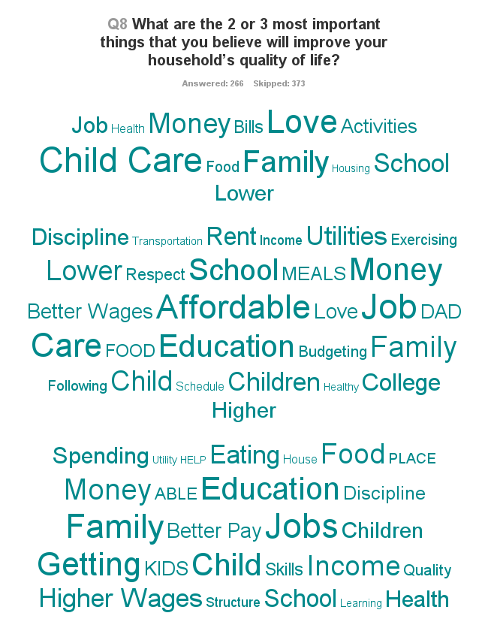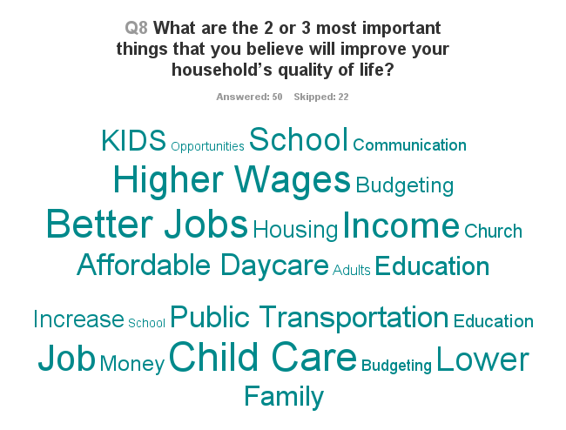

#### Communication

The majority of HS parents who participated in the survey, 94.3 percent, indicated they are satisfied with the communication between themselves and their child’s teacher. Those who were not satisfied with the communication cited reasons such as lack of time, that the child shared things with the parent (instead of the teacher), miscommunication by an estranged husband, and a desire for additional communication regarding the child’s academic progress (in addition to letters sent home).

|  |  |  |
| --- | --- | --- |
| 6. Are you satisfied with the communication between you and your child's teacher? | | |
| Answer Options | Response Percent | Response Count |
| Yes | 94.3% | 66 |
| No, because...My teacher does not speak my preferred language | 1.4% | 1 |
| No, because...I do not have time | 1.4% | 1 |
| No, because...The teacher does not have time | 1.4% | 1 |
| No, because...Other (please specify) | 4.3% | 3 |

#### Kindergarten Registration

Two out of three HS parents indicated they were very knowledgeable with the process of Kindergarten registration (66.7 percent), compared to 40 percent of the health fair respondents. Less than 5 percent of HS parents indicated they were not knowledgeable of the Kindergarten registration process, compared to 17.3 percent of health fair respondents.

#### Parent Training

Prospective HS parents at the health fairs were asked which trainings they were interested in receiving. Two thirds of respondents expressed interest in a training to help their child learn to read. Almost half (46.9 percent) were interested in discipline techniques/child guidance training and one quarter of respondents were interested in information on child development, exercising to good health and cooking healthy meals and snacks.

|  |  |  |  |
| --- | --- | --- | --- |
| 6. Head Start provides training to Parents and Families. Please check the areas of training that would best meet the needs of your family: | | | |
| Answer Options | **Response Percent** | **Response Count** |
| Help my child learn to read | 65.9% | 350 |
| Discipline Techniques/Child Guidance | 46.9% | 249 |
| Information on Child Development | 25.2% | 134 |
| Exercising to good health | 25.0% | 133 |
| Cooking healthy meals and snacks | 24.3% | 129 |
| Information on Brain Development | 18.8% | 100 |
| Cooking with my child at home | 15.4% | 82 |
| Potty Training my child | 12.6% | 67 |
| Grandparents raising children | 10.7% | 57 |
| Child Proofing my home | 6.8% | 36 |
| *answered question* | ***531*** | **531** |
| *skipped question* | ***108*** | **108** |

#### EHS Services and Hours

Prospective HS parents at the health fairs were asked if they were interested in the Early Head Start program, serving infants, toddlers and pregnant mothers. Of the 639 surveys completed, 565 responded to the question. Just over a third (30.8 percent) of respondents indicated they were interested in the EHS program, reporting they had a total of 217 children ages 0-2. The majority, 128 respondents, were interested in center based services, 45 respondents were interested in home based services. The majority, 47.6 percent of respondents, expressed an interested in part day services, 37.4 percent are interested in full day services, 11.9 percent in evening hours and 3.1 percent in weekend hours.

#### Services in the Community

|  |  |  |
| --- | --- | --- |
| Answer Options | Health Fair Respondents Rating Average | HS Parents Rating Average |
| GED/Adult High School services | 1.88 | 1.67 |
| Check cashing services | 1.80 | 1.64 |
| Mental Health services | 1.75 | 1.03 |
| Job training at community colleges | 1.67 | 1.55 |
| English as a Second Language (ESL) services | 1.64 | 1.33 |
| Life skills or tutoring | 1.58 | 1.19 |
| Classes to get a better job | 1.57 | 1.24 |
| Places to help you pick the jobs you want to do | 1.55 | 1.07 |
| Places that teach people how to make a budget and save money | 1.46 | 0.94 |
| Credit counseling and credit repair | 1.45 | 1.24 |
| Places that teach about saving for retirement | 1.42 | 1.00 |

Survey takers were asked to rate community services in their county, and/or to state “don’t know” if they did not use the service or had no knowledge of the service. The top two best rated services by both health fair respondents and HS parents were GED/adult high school services and check cashing services. Graphs below are sorted based on the number of respondents who indicated the services was “good.”

**Besides Early Head Start, list the top two service agencies that you and your neighbors use the most?** Of the 711 total respondents, 318 responded to this question with 526 individual answers. The top three answers included the Department of Health and Human Services, WIC, and the Health Department. The word clouds below illustrate additional responses given by the health fair respondents and current HS parents.

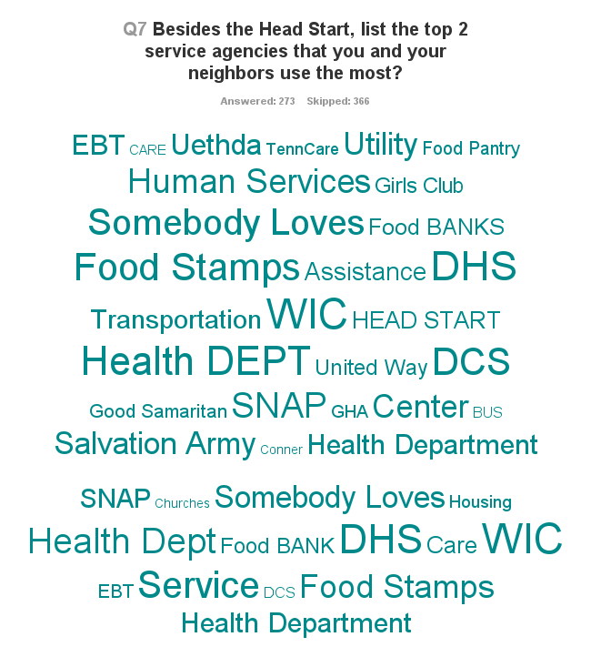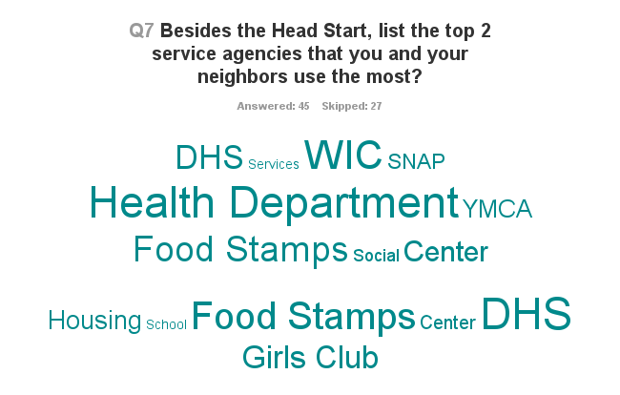

### Key Informant Responses

As a strategic step to supplement secondary data findings, the Upper East Tennessee Human Development Agency, Inc. staff identified a group of key informants and invited them to offer answers to questions that provide additional insight into the communities and families served by the agency in their service area. Key informants, leaders and experts who were invited to respond to the community assessment represented the following partners and area agencies: Northeast Tennessee Regional Health Office, Frontier Health, Sullivan County Health Department, Department of Human Services in Kingsport, Tennessee Nutrition and Consumer Education Program (TNCEP), Community Health Centers College of Nursing at East Tennessee State University, Appalachian Federal Credit Union, First Tennessee Human Resource Agency, Workforce Development, The Appalachian Regional Coalition on Homelessness, Eastern Eight Community Development Corporation (Affordable Housing), Second Harvest Food Bank, School System, Veterans Affairs Administration, Tennessee Early Intervention Program, Private Physician (Pediatrician), the Mountain States Health Alliance, and the Children’s Advocacy Center.

The questions and summary of responses collected follow:

1. **What do you see as the top priority issues affecting economic self-sufficiency during the next four years in your city and/or community?**

The top priority mentioned by informants was the lack of jobs and employment opportunities for residents in the area. Informants also identified the need for education, skills trainings and technical training as important for the next four years. An informant stated this as a priority and a challenge to keep young educated residents from leaving the area. Following these two priority issues, several informants identified drug abuse and addiction as a major priority to address in the service areas. Drug addiction is a “growing culture” for some and it is a way for some to make a living. One informant identified higher rates of addiction and Neonatal Abstinence Syndrome (NAS) babies are driving up health care costs. Two other issues mentioned as priorities are the need for transportation for many in families and housing challenges; need for affordable housing or public housing options for low income residents. Addressing homelessness was also identified as a priority by three informants. Two informants identified inadequate tax base resources in the area to support education and all the necessary services that could meet the needs of the community.

1. **What do you see as the top priority issues affecting education for adults during the next four years in your county and/or state?**

Informants argue that more opportunities and access to education is the best chance for residents to obtain and maintain good paying jobs in the region. Some informants identified these problems and challenges to education for some: lack to transportation in rural areas of the region, less and limited resources and funding supporting adult education, recent cuts in GED funding and basic adult education. The solutions offered by informants which are directly related to education included: providing more locations and times to offer adult education, creating cooperative opportunities so people can receive higher education while they are being employed in the field, increase funding for adult education and providing adults with non-college interest technical work experience for job placement, like plumbing, welding, electrician, cosmetology, mechanical, computers, etc.  Money management and time management are also needed, according to one respondent, to support many students that do not have good knowledge of these important skills.

1. **What do you perceive to be the number one priority issue or concern for the city and/or community leaders during the next four years? (i.e. environmental, economic, health, and social)**

Respondents identified several issues of concern and listed how many of these must be addressed by leaders in the area. Drug addiction and abuse, housing needs, and economic development are the main areas of concern mentioned. The following is a list of exact responses collected:

1. *Drug addiction and rehabilitation services are up and coming. Will have serious consequences in many areas-health care costs, rehab costs, mental health costs, economic costs (due to job loss).*
2. *I think the biggest concern that our community should have is the growing problem of drug addiction (especially opiates) in our area. As a pediatrician, I have seen this problem destroy the family unit and infiltrate into every aspect of our community. I have seen a huge increase in parent's addicted to drugs and become unable to effectively parent because of this. I have seen a huge increase in grandparents having to take over the parenting of their grandchildren because the parents have been incarcerated for drug related crimes. I have seen a huge increase in pregnant women addicted to pain meds and newborns born with neonatal abstinence syndrome not to mention the long-term effects this is having on children.  The amount of child abuse and neglect from the problem is growing all the time. I think we need to increase the education in our community about this problem and how we as individuals can help stop it.*
3. *Family Shelter is needed in the Tri-cities where families can live and remain stable.  Families with children should not have to move from Church to Church in order to have a place to stay while homeless. We need more funding to move homeless individuals into housing, and funding to assist those falling into the homeless prevention category with impending evictions and utility shutoffs.*
4. *Economic issues as the city is placing too much emphasis on the social aspect of the community--The city is focusing on the wrong issues.*
5. *Social sector is seeing drastic increase for services due to limited jobs, baby boomers trying to live off social security.*
6. *Grandparents raising grandchildren due to parents making bad decisions (drug addiction)*
7. *Major health issues - obesity, diabetes, cardiovascular disease, cancer, addiction and mental health issues.*
8. *Communities rising needs for services vs. budgeting; more social services budgets are being cut to provide services to failing infrastructures. Social services are needed in each community to provide housing, career coaching, daycare, assisting with utilities, senior care, etc.*
9. *Homelessness has become a huge problem in the Kingsport and Bristol, and always has been in Johnson City. This creates a ripple effect affecting the economy and environment.  Healthcare, particularly Mental Health Care.*

1. **In your opinion, what are the top two to three strengths of your city and/or community?**

The following six themes were identified as the two strengths in the service area. Under each of the themes the report lists the respondents’ opinions:

1. Good quality of life:

* Low cost of living
* Beautiful green spaces
* The possibility for tourism to explode

1. Strong Community Involvement

* Good community resources
* Especially, the support of the faith based community
* Strong commitment from our community leaders
* Good financial support by many people in our community
* Collective desire for progress within the community
* Development of community partnerships and collaborations
* Community benevolence
* Individual community support
* Concern for health and well-being of individuals within the community
* Regional partnerships between non-profits

1. Education Strengths:

* Education facilities, colleges, universities and technical school
* Kingsport City Schools and Head Start programs

1. Healthcare

* Top Medical services
* Good hospitals
* Great VA hospital for veterans
* Good primary medical care
* Good long term outpatient mental health and addiction providers

1. Job Market

* Potential job development market
* Adequate Training and Employment Opportunities

1. Housing

* Coordinated Entry system of the Appalachian Regional Coalition on Homelessness that connects homeless/imminently homeless to services.

1. **What is the status of employment and training services in your city and/or community? Please explain.**

To understand the level of knowledge or lack of awareness from respondents to this question, it is best to list the answers verbatim.

* *There are programs available and efforts are underway to ensure they meet the needs of business and industry.  An important program is the Career Ready Communities effort that has been adopted by all eight counties in our region*
* *There are some pockets of availability of training and employment services in the area; would like to see them expanded so that adults have the opportunity to go back and get the training they need for today's job market.*
* *Not many employment and training services in the area; Vocational Rehab is active and available, but qualifying for their services are not open to all.*
* *Alliance for Business and Training and Dept. of Labor Workforce and Development are the only two I'm aware.*
* *I know there is a new job center to help those unemployed, but I really don't know much about it*
* *NE state offers excellent training services.*
* *I'm embarrassed to say I don't really know.*
* *I think we need a culinary school in the area. Otherwise, we have adequate employment and training services in our area.*
* *Inaccessible - no transportation from rural areas*
* *Very limited*
* *Education is within reach of all 8 counties if the individual seeks the training opportunities*
* *Companies and business struggle to find skilled and dedicated workers.*

1. Do you have any advice for UETHDA's leadership staff regarding community partnership and involvement? - Open-Ended Response

The following is a list of recommendations and comments from Key Informants about UETHDA:

* *Get as much buy in from community leaders as possible before proceeding with any type of intervention. Also, bring money if you can! Grant funding, etc.*
* *UETHDA leads with excellence and thoroughness.*
* *To encourage the businesses here to invest in the people already living in our community rather than bringing in outside people.*
* *UETHDA members need to become involved in the CoC and enter service data into HMIS so that we can assure no duplication of services in our area.*
* *Keep up the good work and stay engaged*
* *Partner with area agencies to combine funds for a Regional solution to homelessness and accessibility*
* *No, I think UETHDA does a good job reaching out to the community and watching for partnership opportunities.*
* *Job training and early childhood intervention!  UETHDA is already working in these areas*
* *In my experience with UETHDA, they have a tendency to partner with all key agencies and  providers.  Involvement in things like Interagency Councils and Health Councils would be a plus.*
* *Poverty and unemployment have no physical boundaries. Communities working together can provide a stronger region and area in which to live and work.  Unifying social services among the communities will help prevent double dipping of services and the government dollars can and will be able to service more individuals.*
* *To continue our partnership in the 8 counties as the resource hub for low-income, homeless and imminently homeless.  It would be great if we could blend our HMIS (Homeless Management Information System) Software with UETHDA's.*

# Resources, Collaborative/Formal Agreements and Partnerships

## Health and Nutrition

|  |  |  |  |  |  |  |
| --- | --- | --- | --- | --- | --- | --- |
| Name of Program/Partner | Address | City | State | Zip | Phone Number | Services Provided by Partner to Program |
| Northeast TN Regional Health Office | 185 Treasure Lane | Johnson City | TN | 37604 | 423-979-4648 | Provide health services for children with no insurance. |
| Sullivan County Health Department | 1029 Sullivan Street | Kingsport | TN | 37662 | 423-279-2169 | Provide health services for children with no insurance. |
| Mountain States Health Alliance | 2000 Brookside Drive | Kingsport | TN | 37662 | 423-943-6907 | Provides referrals and health services to Head Start children. |
| TNCEP (Jennifer Banks) | 3258 Highway 126, Suite 104 | Blountville | TN | 37617 | 423-279-2723 | Provide training and resources for parents and staff. |
| Second Harvest Food Bank | 1020 Jericho Drive | Kingsport | TN | 37663 | 423-279=0430 | Provide food to parents and community. |

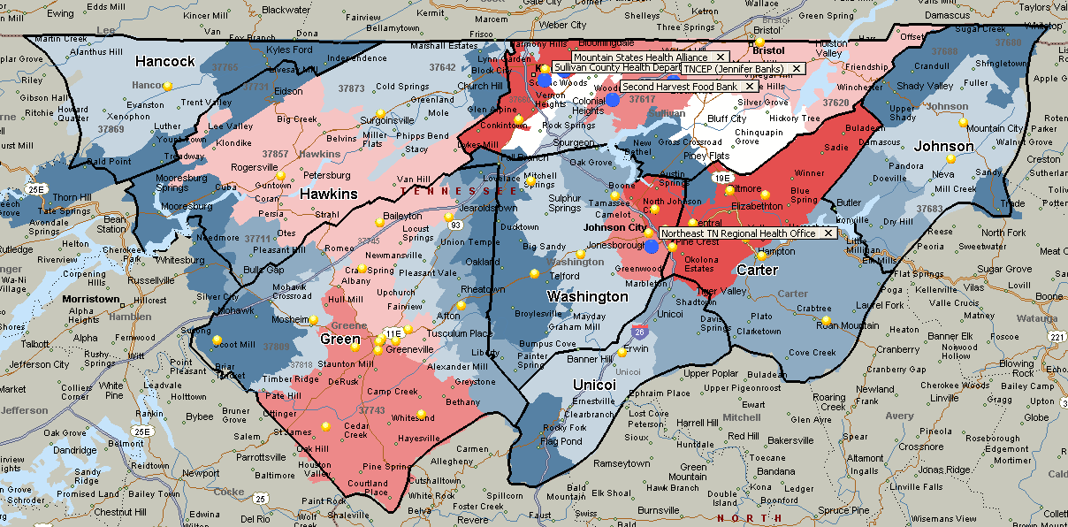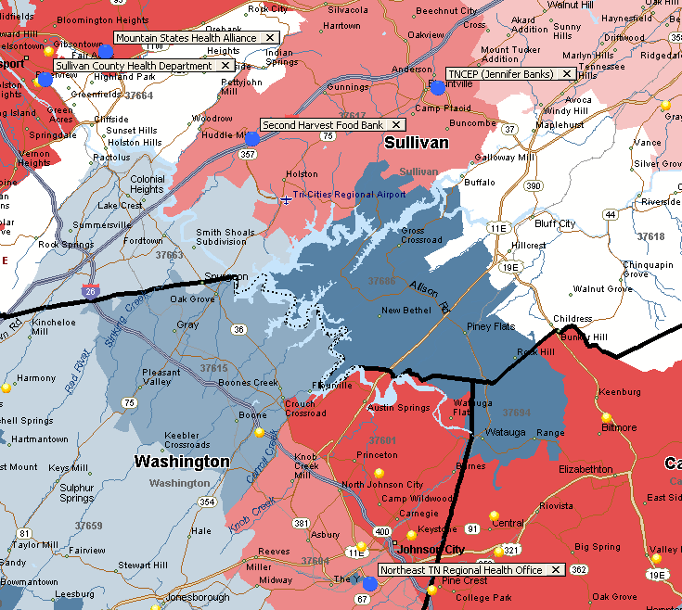

## Dental Health

|  |  |  |  |  |  |  |
| --- | --- | --- | --- | --- | --- | --- |
| Name of Program/Partner | Address | City | State | Zip | Phone Number | Services Provided by Partner to Program |
| ETSU College of Nursing | 2151 Century Lane | Johnson City | TN | 37604 | 423-946-0981 | Provide health services including dental for children with no insurance. |

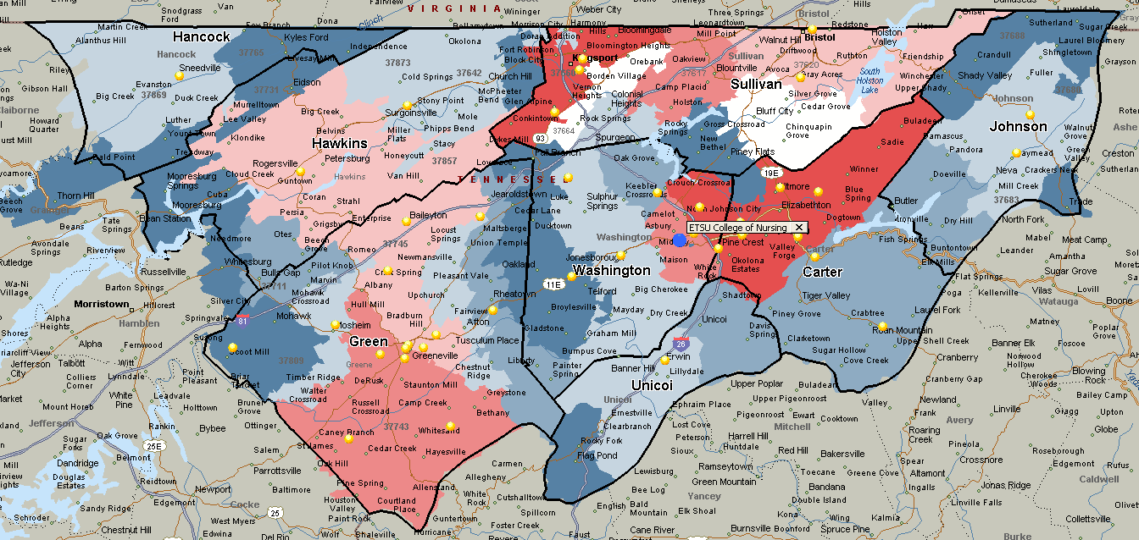

## Mental Health

|  |  |  |  |  |  |  |
| --- | --- | --- | --- | --- | --- | --- |
| Name of Program/Partner | Address | City | State | Zip | Phone Number | Services Provided by Partner to Program |
| Cherokee Health Systems | 2018 Western Avenue | Knoxville | TN | 37921 | 865-934-6734 | Observations, recommendations, follow-up meetings with staff and parents/guardians. |
| Frontier Health | 1167 Spratlin Park Drive | Johnson City | TN | 37615 | 423-467-3702 | Observations, recommendations, follow-up meetings with staff and parents/guardians. |
| Child Find (Coordinator Kathy Parham) | 1609 Ft. Henry Drive | Kingsport | TN | 37660 | 423-378-2172 | Provide services to children with developmental and/or speech delays. |
| Tennessee Early Intervention Program | 1110 Seminole Drive | Johnson City | TN | 37604 | 423-434-4401 | Provide services to children with developmental and/or speech delays. |

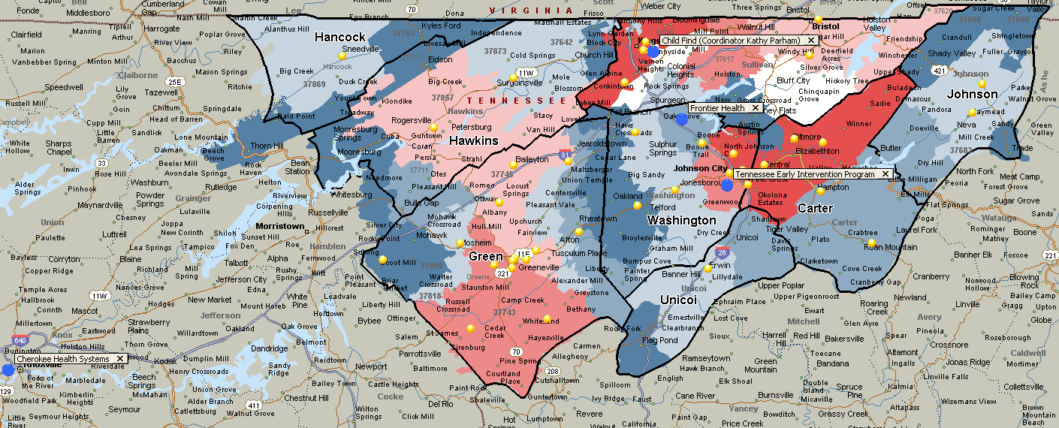

## Disability Services

|  |  |  |  |  |  |  |
| --- | --- | --- | --- | --- | --- | --- |
| Name of Program/Partner | Address | City | State | Zip | Phone Number | Services Provided by Partner to Program |
| Child Find (Coordinator Kathy Parham) | 1609 Ft. Henry Drive | Kingsport | TN | 37660 | 423-378-2172 | Provide services to children with developmental and/or speech delays. |
| Tennessee Early Intervention Program | 1110 Seminole Drive | Johnson City | TN | 37604 | 423-434-4401 | Provide services to children with developmental and/or speech delays. |

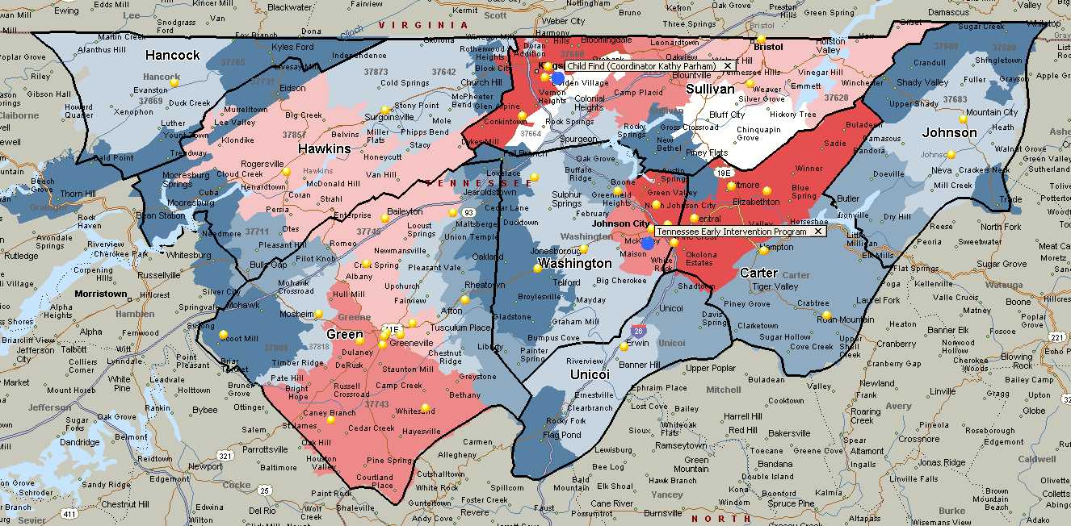

## Education, Employment and Job Training

|  |  |  |  |  |  |  |
| --- | --- | --- | --- | --- | --- | --- |
| Name of Program/Partner | Address | City | State | Zip | Phone Number | Services Provided by Partner to Program |
| Kingsport City Schools (Brian Cinnamon) | 400 Clinchfield Street, Suite 200 | Kingsport | TN | 37660 | 423-378-2100 | Partnership between Kingsport City Schools and Head Start to serve preschool children. |
| Greeneville City Schools (Terry Rymer) | 129 West Depot Street | Greeneville | TN | 37743 | 423-787-8004 | Partnership between Greeneville City Schools and Head Start to serve preschool children. |
| Greene County Schools (Chris Malone) | 910 West Summer Street | Greeneville | TN | 37743 | 423-639-4194 | Partnership between Greene County Schools and Head Start to serve preschool children. |
| Workforce Development | 1104 E. Center Street | Kingsport | TN | 37662 | 423-547-7515 | Provide training and job services to parents and community. |

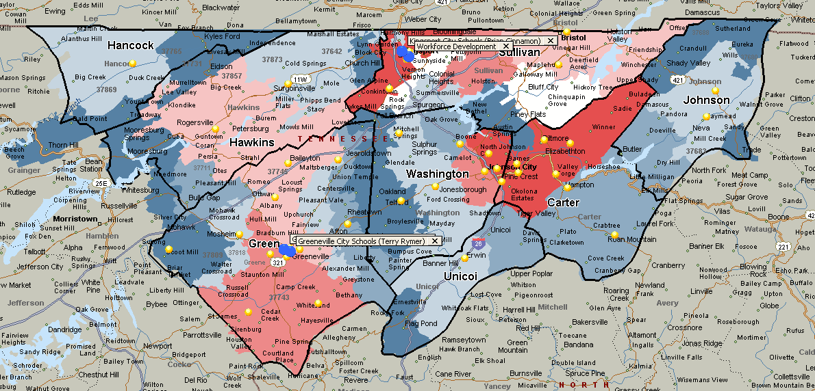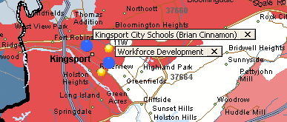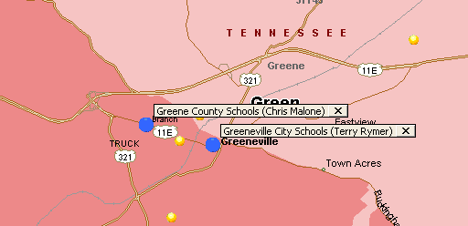

## Social Services / Family Support Services

|  |  |  |  |  |  |  |
| --- | --- | --- | --- | --- | --- | --- |
| Name of Program/Partner | Address | City | State | Zip | Phone Number | Services Provided by Partner to Program |
| Appalachian Federal Credit Union | 1500 E. Stone Drive | Kingsport | TN | 37660 | 423-378-2819 | Provide financial literacy for staff and families. |
| NET TRANS | 2203 McKinley Road | Johnson City | TN | 37604 | 423-461-8206 | Provide transportation for parents and community. |
| ARCH | 321 E. Walnut St. | Johnson City | TN | 37601 | 423-218-4090 | Provide resources and assistance to homeless in the community. |
| Eastern Eight | 214 E. Watauga Ave. | Johnson City | TN | 37601 | 423-232-2055 | Provide housing assistance to parents and community. |
| 1st TN Developmental District | 3211 N. Roan Street | Johnson City | TN | 37601 | 423-928-0224 | Regional association of local governments that provides statistics and resources for community. |
| Children's Advocacy Center | 150 Blountville Bypass | Blountville | TN | 37617 | 423-279-1222 | Provide counseling and crisis intervention services to Head Start children, families, and community. |

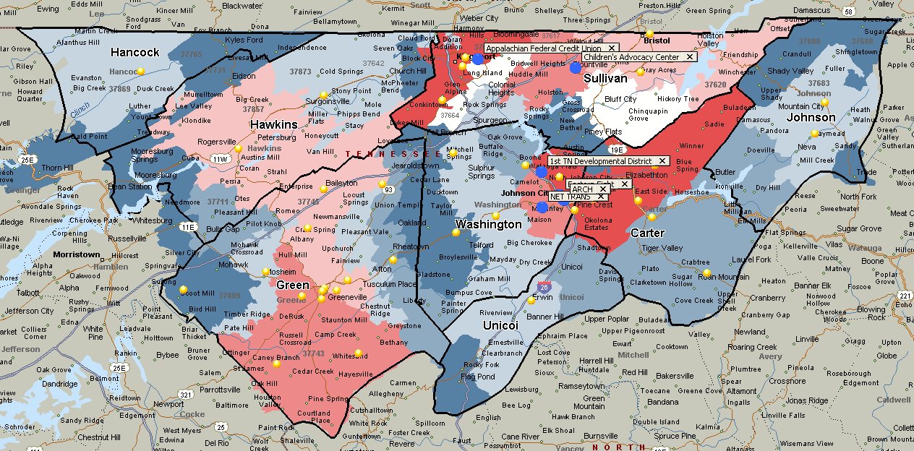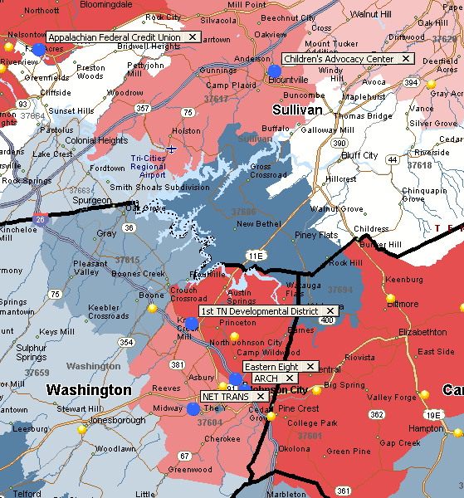

# Identification of Issues and Recommendations

1. **Become an active and influential partner in regional efforts to lead economic and social development.**

***Situation.*** All counties, expect for one, within the UETHDA service area, experienced a decrease in population in recent years. Current Census reports show similar population trends in Rural America, which has seen slower population growth as more young people move to urban and suburban areas for jobs, and aging retirees seek out more populated places to live. Economic and social consequences of this population decrease are reductions of tax base for the governments and a greater challenge recruiting skilled workers. Most recent economic development plans in rural TN focus on the need to retain and develop a future workforce that could function in a “knowledge economy,” stay competitive and offer companies a better environment for investment.

***Recommendation.*** UETHDA should focus on becoming an active and engaged network of local leaders that could make tangible recommendations and contributions to the future of dislocated workers and single female head of households. These are two unique and important groups in the region that need particular attention and concentrated backing from leaders in the community.

The dislocated workers represent a unique workforce that has limited opportunities due economic changes that lost traditional manufacturing jobs needing a lower skills’ workforce. For many long-term, older and low skill residents, the possibility to relocate to find employment opportunities is not an option. These are not only the more permanent residents, but also those that the program could serve and enlist to recruit other neighbors, family members and friends that are experiencing similar needs and challenges.

Economic development could also benefit from UETHDA’s efforts to highlight the importance of helping young mothers starting a family, raising the future workforce of the region and living in poverty. There is strong evidence that early childhood development directly influences economic, health and social outcomes for individuals and society. Furthermore, unfavorable early environments create deficits in skills and abilities that drive down productivity and increase social costs, adding to financial deficits experienced by the families.

To support the investment on dislocated workers and single female head of households, UETHDA CSBG staff could benefit from studying and familiarizing themselves with the following work:

1. Family Economic Success Planning Process. This research and application is supported by the Annie E. Casey Foundation, which aims at connecting people to jobs that pay family supporting wages and provide opportunities for advancement—the goal of a place-based workforce development strategy. This research and implementation builds on workforce development strategies that focus on regional labor markets—whether in terms of job readiness, job search or short and long-term training.
2. Investing in early childhood education (particularly the work of [Dr. James J. Heckman](http://heckmanequation.org/about-professor-heckman)) that suggests that is a cost-effective strategy for promoting economic growth.

The economic future for many residents with unique needs and challenges might be influenced by UETHDA interventions to provide the tools for upward mobility and building necessary workforce skills.

1. **Identify the critical prerequisites of workforce skill needs and resources.**

**Situation:** It can be extremely helpful for regional economic development efforts to identify the critical prerequisites needed to any effective workforce development. The comprehensive Community Assessment identified some directly and indirectly related needs or gaps faced by low income residents: poverty, educational attainment, limited transportation, lack childcare, housing condition or limitations, etc. However, it is important to identify gaps that might limit success and measure progress on necessary preconditions to boosting regional prosperity.

**Recommendation:** UETHDA could lead the effort to bring key partners from the region to establish broad-based workforce partnership that focus specifically on the clients they serve; these partners may include:

* Employers – especially in fields with persistent identified workforce shortages
* The regional Workforce Investment Board
* Technical, community and four-year colleges and universities
* Other workforce training organizations
* Welfare (TANF) and related work-first programs
* Disability employment programs
* Childcare service providers and resource and referral agencies
* Other programs serving and supporting working families

Follow up steps in order to maintain partnership collaboration active may include:

* Create stronger cross-sector and cross-organization collaboration
* Conduct a preliminary and ongoing assessments of the status of working families and the various supporting services in the community

This process could generate a customer focused training and employment plan for all. Given the complexity of an effective economic prosperity initiative, it helps to understand, assess, plan, organize and evaluate all of these questions together.

# Appendices

### Parents Community Needs Survey

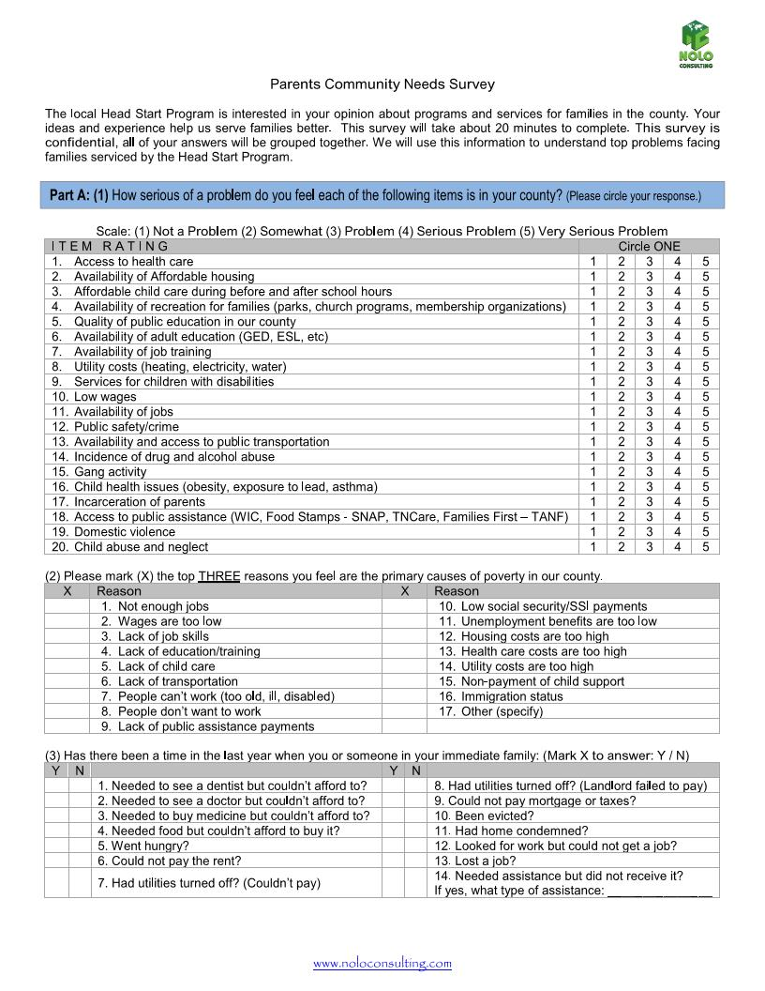

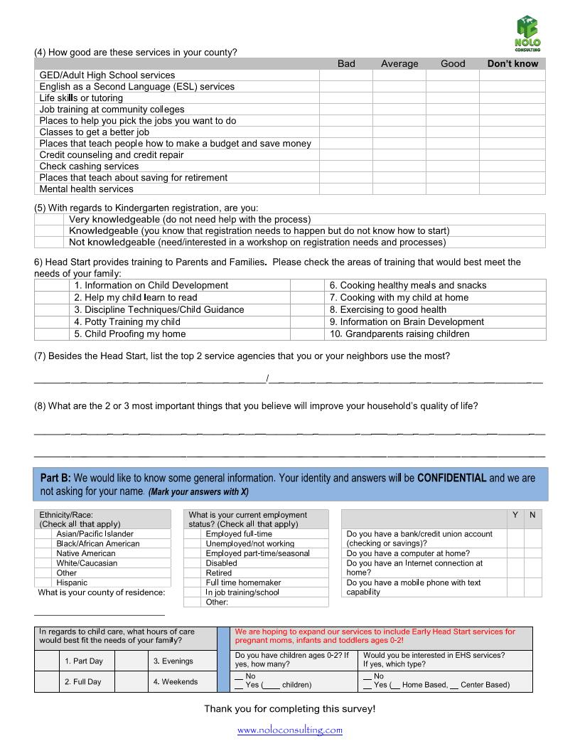

### Key Informant Survey

As a leader and expert in your county and state, we value your input and feedback to the following open-ended questions. Your answers are confidential and will be added to the answers of other key informants. Our objective is to study and use your input in order to design a more relevant and comprehensive plan that assist low income residents in Carter, Greene, Hancock, Hawkins, Johnson, Sullivan, Unicoi and Washington Counties. This survey will take between 20-30 minutes of your time. Thank you for taking time to provide your knowledge!

1. What do you see as the top priority issues affecting economic self-sufficiency during the next four years in your city and/or community?
2. What do you see as the top priority issues affecting adult education during the next four years in your city and/or community?
3. What do you perceive to be the number one priority issue or concern for the city and/or community leaders during the next four years? (i.e. environmental, economic, health, and social) Please explain.
4. In your opinion, what are the top two to three strengths of your city and/or community?
5. What is the status of employment and training services in your city and/or community? Please explain.
6. Do you have any advice for UETHDA's leadership staff regarding community partnership and involvement?

Bottom of Form

### Population by Age (2014 ACS 5-Year Estimates)

Take me back to Age and Sex

### Regulated Child Care Programs in UETHDA Service Area

|  | Provider Name | Capacity | Min Age | Max Age | Open Time | Close Time |
| --- | --- | --- | --- | --- | --- | --- |
| Carter County | [CHILDREN'S CTR OF SYCAMORE SHOALS HOSP](http://www.tn.gov/accweb/faces/stateMapPage.jsp) | 78 | 6 WK | 5 YR | 6:30 AM | 6:00 PM |
| 408 BEMBERG ROAD |  |  |  |  |  |
| ELIZABETHTON, TN 37643 |  |  |  |  |  |
| [Eastside Day care & learning Center](http://www.tn.gov/accweb/faces/stateMapPage.jsp) | 57 | 12 MO | 5 YR | 6:00 AM | 6:00 PM |
| 206 OLD SIAM ROAD |  |  |  |  |  |
| ELIZABETHTON, TN 37643 |  |  |  |  |  |
| [HAROLD MCCORMICK - ESP (-E-)](http://www.tn.gov/accweb/faces/stateMapPage.jsp) | 250 | 4 YR | 12 YR | 2:45 PM | 6:00 PM |
| 226 S. CEDAR AVENUE |  |  |  |  |  |
| ELIZABETHTON, TN 37643 |  |  |  |  |  |
| [Heavens Little Miracles](http://www.tn.gov/accweb/faces/stateMapPage.jsp) | 49 | 6 WK | 5 YR | 6:00 AM | 6:00 PM |
| 2058 Valentine Street |  |  |  |  |  |
| Elizabethton, TN 37643 |  |  |  |  |  |
| [HUNTER FIRST BAPTIST DC & LN CT I](http://www.tn.gov/accweb/faces/stateMapPage.jsp) | 29 | 6 WK | 2 YR | 6:30 AM | 6:00 PM |
| 693 HIGHWAY 91 |  |  |  |  |  |
| ELIZABETHTON, TN 37643 |  |  |  |  |  |
| [HUNTER FIRST BAPTIST DC & LN CT II](http://www.tn.gov/accweb/faces/stateMapPage.jsp) | 75 | 3 YR | 12 YR | 6:30 AM | 6:00 PM |
| 693 HIGHWAY 91 |  |  |  |  |  |
| ELIZABETHTON, TN 37643 |  |  |  |  |  |
| [Tennessee Tots Learning Center](http://www.tn.gov/accweb/faces/stateMapPage.jsp) | 60 | 6 WK | 12 YR | 7:00 AM | 5:30 PM |
| 440 Blue Ridge Drive |  |  |  |  |  |
| Elizabethton, TN 37643 |  |  |  |  |  |
| [TODDLER TIME DAY CARE CENTER](http://www.tn.gov/accweb/faces/stateMapPage.jsp) | 38 | 6 WK | 5 YR | 7:00 AM | 5:30 PM |
| 435 HIGHWAY 321 |  |  |  |  |  |
| HAMPTON, TN 37658 |  |  |  |  |  |
| Green County | [ASBURY CHILD ENRICHMENT CENTER](http://www.tn.gov/accweb/faces/stateMapPage.jsp) | 82 | 6 WK | 5 YR | 6:30 AM | 5:30 PM |
| 205 SOUTH MAIN ST. |  |  |  |  |  |
| GREENEVILLE, TN 37743 |  |  |  |  |  |
| [CHILDREN'S CENTER OF HOLSTON HOME](http://www.tn.gov/accweb/faces/stateMapPage.jsp) | 90 | 6 WK | 6 YR | 6:30 AM | 5:30 PM |
| 119 FAIRGROUNDS CIRCLE |  |  |  |  |  |
| GREENEVILLE, TN 37745 |  |  |  |  |  |
| [CHUCKEY ELEMENTARY ESP (-E-)](http://www.tn.gov/accweb/faces/stateMapPage.jsp) | 60 | 4 YR | 14 YR | 3:00 PM | 6:00 PM |
| 1605 CHUCKEY HWY. |  |  |  |  |  |
| CHUCKEY, TN 37641 |  |  |  |  |  |
| [DEBUSK ELEMENTARY - ESP (-E-)](http://www.tn.gov/accweb/faces/stateMapPage.jsp) | 30 | 4 YR | 14 YR | 3:00 PM | 6:00 PM |
| 740 DEBUSK ROAD |  |  |  |  |  |
| GREENEVILLE, TN 37743 |  |  |  |  |  |
| [DEBUSK PRE-K (-E-)](http://www.tn.gov/accweb/faces/stateMapPage.jsp) | 20 | 4 YR | 5 YR | 8:00 AM | 2:00 PM |
| 740 DEBUSK ROAD |  |  |  |  |  |
| GREENEVILLE, TN 37743 |  |  |  |  |  |
| [It's All About Kids Childcare](http://www.tn.gov/accweb/faces/stateMapPage.jsp) | 50 | 6 WK | 12 YR | 6:45 AM | 5:45 PM |
| 1421 Tusculum Blvd. |  |  |  |  |  |
| Greeneville, TN 37745 |  |  |  |  |  |
| [NOAH'S ARK DAY CARE & PRE-SCHOOL](http://www.tn.gov/accweb/faces/stateMapPage.jsp) | 91 | 6 WK | 5 YR | 6:00 AM | 5:30 PM |
| 1505 WEST MAIN STREET |  |  |  |  |  |
| GREENEVILLE, TN 37743 |  |  |  |  |  |
| [Small Miracles](http://www.tn.gov/accweb/faces/stateMapPage.jsp) | 99 | 6 WK | 5 YR | 6:30 AM | 5:30 PM |
| 2001 West Main Street |  |  |  |  |  |
| Greeneville, TN 37743 |  |  |  |  |  |
| [TENDER HEART DAY CARE CENTER](http://www.tn.gov/accweb/faces/stateMapPage.jsp) | 59 | 6 WK | 12 YR | 5:30 AM | 5:15 PM |
| 310 WEST GREENE DR. |  |  |  |  |  |
| MOSHEIM, TN 37818 |  |  |  |  |  |
| [The Learning Tree Children’s Center](http://www.tn.gov/accweb/faces/stateMapPage.jsp) | 50 | 6 WK | 5 YR | 6:30 AM | 5:30 PM |
| 150 Marshall Lane |  |  |  |  |  |
| Greeneville, TN 37743 |  |  |  |  |  |
| [THE WOODEN SHOE](http://www.tn.gov/accweb/faces/stateMapPage.jsp) | 54 | 6 WK | 14 YR | 6:15 AM | 5:15 PM |
| 437 EAST BERNARD AVENUE |  |  |  |  |  |
| GREENEVILLE, TN 37745 |  |  |  |  |  |
| Hancock County | N/A |  |  |  |  |  |
| Hawkins County | [ALLANDALE EARLY LEARNING CENTER](http://www.tn.gov/accweb/faces/stateMapPage.jsp;jsessionid=D869979621D89A7C71CDC8337987CA78) | 99 | 12 MO | 12 YR | 6:00 AM | 6:00 PM |
| 905 UNIVERSITY BLVD |  |  |  |  |  |
| KINGSPORT, TN 37660 |  |  |  |  |  |
| [FRIENDS AT PLAY PRESCHOOL](http://www.tn.gov/accweb/faces/stateMapPage.jsp;jsessionid=D869979621D89A7C71CDC8337987CA78) | 45 | 3 YR | 5 YR | 9:00 AM | 12:00 PM |
| 110 COLONIAL ROAD |  |  |  |  |  |
| ROGERSVILLE, TN 37857 |  |  |  |  |  |
| [MT. CARMEL DAY CARE CENTER](http://www.tn.gov/accweb/faces/stateMapPage.jsp;jsessionid=D869979621D89A7C71CDC8337987CA78) | 37 | 12 MO | 12 YR | 6:00 AM | 5:00 PM |
| 510 WEST MAIN STREET |  |  |  |  |  |
| MT. CARMEL, TN 37645 |  |  |  |  |  |
| [PROMISES CHILD CARE CENTER](http://www.tn.gov/accweb/faces/stateMapPage.jsp;jsessionid=D869979621D89A7C71CDC8337987CA78) | 24 | 6 WK | 6 YR | 7:00 AM | 5:30 PM |
| 493 BUREM RD. |  |  |  |  |  |
| ROGERSVILLE, TN 37857 |  |  |  |  |  |
| [PROMISES TOO! CHILD CARE & PRESCHOOL](http://www.tn.gov/accweb/faces/stateMapPage.jsp;jsessionid=D869979621D89A7C71CDC8337987CA78) | 70 | 6 WK | 12 YR | 6:00 AM | 6:00 PM |
| 307 SOUTH DEPOT STREET |  |  |  |  |  |
| ROGERSVILLE, TN 37857 |  |  |  |  |  |
| [WEE CARE DAY CARE CENTER](http://www.tn.gov/accweb/faces/stateMapPage.jsp;jsessionid=D869979621D89A7C71CDC8337987CA78) | 49 | 6 WK | 12 YR | 6:00 AM | 6:00 PM |
| 116 BURTON ROAD |  |  |  |  |  |
| ROGERSVILLE, TN 37857 |  |  |  |  |  |
| [WONDERLAND CHILD CARE CENTER](http://www.tn.gov/accweb/faces/stateMapPage.jsp;jsessionid=D869979621D89A7C71CDC8337987CA78) | 72 | 36 MO | 12 YR | 5:30 AM | 5:30 PM |
| 3321 HIGHWAY 11 WEST |  |  |  |  |  |
| SURGOINSVILLE, TN 37873 |  |  |  |  |  |
| Johnson County | [In the Beginning Learning & Care Center](http://www.tn.gov/accweb/faces/stateMapPage.jsp;jsessionid=D869979621D89A7C71CDC8337987CA78) | 24 | 3 MO | 5 YR | 6:30 AM | 6:00 PM |
| 2477 South Shady Street |  |  |  |  |  |
| Mountain City, TN 37683 |  |  |  |  |  |
| [KID'S CORRAL SCH-AGE CC PROGRAM@ROAN CRK (-E-)](http://www.tn.gov/accweb/faces/stateMapPage.jsp;jsessionid=D869979621D89A7C71CDC8337987CA78) | 100 | 4 YR | 12 YR | 6:30 AM | 6:00 PM |
| 2410 ROAN CREEK ROAD |  |  |  |  |  |
| MOUNTAIN CITY, TN 37683 |  |  |  |  |  |
| [KIDS' COUNTRY CHILDCARE (-E-)](http://www.tn.gov/accweb/faces/stateMapPage.jsp;jsessionid=D869979621D89A7C71CDC8337987CA78) | 100 | 4 YR | 12 YR | 6:00 AM | 6:00 PM |
| 301 DONNELLY STREET |  |  |  |  |  |
| MOUNTAIN CITY, TN 37683 |  |  |  |  |  |
| [PANTHER DEN SACC PROGRAM (-E-)](http://www.tn.gov/accweb/faces/stateMapPage.jsp;jsessionid=D869979621D89A7C71CDC8337987CA78) | 30 | 6 WK | 12 YR | 6:00 AM | 6:00 PM |
| 300 GENTRY CREEK RD |  |  |  |  |  |
| LAUREL BLOOMERY, TN 37683 |  |  |  |  |  |
| Sullivan County | [ALL ABOUT KIDS](http://www.tn.gov/accweb/faces/providerZipList.jsp) | 48 | 6 WK | 12 YR | 6:30 AM | 5:30 PM |
| 3070A HWY. 126 |  |  |  |  |  |
| BLOUNTVILLE, TN 37617 |  |  |  |  |  |
| [Country Kids Highway 126](http://www.tn.gov/accweb/faces/providerZipList.jsp) | 48 | 6 WK | 12 YR | 6:00 AM | 6:00 PM |
| 106 Mottern Drive |  |  |  |  |  |
| Blountville, TN 37617 |  |  |  |  |  |
| [FIRST BAPTIST KID'S CARE](http://www.tn.gov/accweb/faces/providerZipList.jsp) | 35 | 3 YR | 5 YR | 7:00 AM | 5:00 PM |
| 3358 HIGHWAY 126 |  |  |  |  |  |
| BLOUNTVILLE, TN 37617 |  |  |  |  |  |
| [TED E. BEAR ACADEMY](http://www.tn.gov/accweb/faces/providerZipList.jsp) | 29 | 6 WK | 12 YR | 6:00 AM | 6:00 PM |
| 4918 HWY 126 |  |  |  |  |  |
| BLOUNTVILLE, TN 37617 |  |  |  |  |  |
| [WHEELER UNITED METHODIST CHILD CARE C.](http://www.tn.gov/accweb/faces/providerZipList.jsp) | 70 | 6 WK | 13 YR | 7:00 AM | 6:00 PM |
| 211 N. SANDERS STREET |  |  |  |  |  |
| BLOUNTVILLE, TN 37617 |  |  |  |  |  |
| [Piney Bluff Child Care Center](http://www.tn.gov/accweb/faces/providerZipList.jsp) | 99 | 6 WK | 12 YR | 7:00 AM | 6:00 PM |
| 4429 Bluff City Hwy. |  |  |  |  |  |
| Bluff City, TN 37618 |  |  |  |  |  |
| [BY-PASS DAY CARE CENTER, INC.](http://www.tn.gov/accweb/faces/providerZipList.jsp) | 52 | 6 WK | 5 YR | 6:30 AM | 5:30 PM |
| 105 HATCHALL WAY |  |  |  |  |  |
| BRISTOL, TN 37620 |  |  |  |  |  |
| [LITTLE HANDS CHRISTIAN CHILD CARE CENTER](http://www.tn.gov/accweb/faces/providerZipList.jsp) | 99 | 6 WK | 12 YR | 5:30 AM | 6:00 PM |
| 1864 HOLSTON DR. |  |  |  |  |  |
| BRISTOL, TN 37620 |  |  |  |  |  |
| [LITTLEST ANGEL CHILD CARE CENTER](http://www.tn.gov/accweb/faces/providerZipList.jsp) | 150 | 6 WK | 14 YR | 7:00 AM | 5:30 PM |
| 2417 VOLUNTEER PARKWAY |  |  |  |  |  |
| BRISTOL, TN 37620 |  |  |  |  |  |
| [WELLMONT CHILD DEVELOPMENT CENTER](http://www.tn.gov/accweb/faces/providerZipList.jsp) | 120 | 6 WK | 12 YR | 6:30 AM | 7:30 PM |
| 281 STEELES ROAD |  |  |  |  |  |
| BRISTOL, TN 37620 |  |  |  |  |  |
| [YWCA CHILDREN'S CENTER](http://www.tn.gov/accweb/faces/providerZipList.jsp) | 84 | 6 WK | 5 YR | 7:00 AM | 5:30 AM |
| 106 STATE STREET |  |  |  |  |  |
| BRISTOL, TN 37620 |  |  |  |  |  |
| [BLOOMINGDALE LEARNING CENTER](http://www.tn.gov/accweb/faces/providerZipList.jsp) | 24 | 6 WK | 5 YR | 7:00 AM | 5:30 PM |
| 3333 BLOOMINGDALE ROAD |  |  |  |  |  |
| KINGSPORT, TN 37660 |  |  |  |  |  |
| [CHRISTIAN LIFE CHILD LEARNING CENTER](http://www.tn.gov/accweb/faces/providerZipList.jsp) | 69 | 6 WK | 5 YR | 6:00 AM | 6:00 PM |
| 2401 JOHN B. DENNIS HWY. |  |  |  |  |  |
| KINGSPORT, TN 37660 |  |  |  |  |  |
| [CHURCH CIRCLE FIRST PRESBYTERIAN](http://www.tn.gov/accweb/faces/providerZipList.jsp) | 75 | 6 WK | 5 YR | 7:15 AM | 5:30 PM |
| 100 WEST CHURCH CIRCLE |  |  |  |  |  |
| KINGSPORT, TN 37660 |  |  |  |  |  |
| [FIRST BROAD STREET CHILD CARE CENTER](http://www.tn.gov/accweb/faces/providerZipList.jsp) | 99 | 6 WK | 5 YR | 7:15 AM | 5:30 PM |
| 200 EAST CHURCH CIRCLE |  |  |  |  |  |
| KINGSPORT, TN 37660 |  |  |  |  |  |
| [GEORGE WASHINGTON SCH/EARLY CHILDHOOD (-E-)](http://www.tn.gov/accweb/faces/providerZipList.jsp) | 55 | 6 WK | 5 YR | 7:15 AM | 5:30 PM |
| 1100 BELLINGHAM DRIVE |  |  |  |  |  |
| KINGSPORT, TN 37660 |  |  |  |  |  |
| [KINDERCARE LEARNING CENTERS, LLC](http://www.tn.gov/accweb/faces/providerZipList.jsp) | 94 | 6 WK | 12 YR | 6:30 AM | 6:00 PM |
| 2000 AMERICAN WAY |  |  |  |  |  |
| KINGSPORT, TN 37660 |  |  |  |  |  |
| [KINGSPORT CHILD DEVELOPMENT CENTER](http://www.tn.gov/accweb/faces/providerZipList.jsp) | 99 | 6 WK | 5 YR | 6:30 AM | 5:30 PM |
| 118 CLAY STREET |  |  |  |  |  |
| KINGSPORT, TN 37660 |  |  |  |  |  |
| [ST. PAUL'S DAY SCHOOL & KINDERGARTEN (-E-)](http://www.tn.gov/accweb/faces/providerZipList.jsp) | 75 | 2 YR | 5 YR | 7:00 AM | 6:00 PM |
| 160 E. SEVIER AVENUE |  |  |  |  |  |
| KINGSPORT, TN 37660 |  |  |  |  |  |
| [THE PLAY CENTER NURSERY SCHOOL, INC.](http://www.tn.gov/accweb/faces/providerZipList.jsp) | 150 | 6 WK | 12 YR | 5:30 AM | 6:00 PM |
| 364 REVERE STREET |  |  |  |  |  |
| KINGSPORT, TN 37660 |  |  |  |  |  |
| [MIDWAY PRESCHOOL AND DAY CARE](http://www.tn.gov/accweb/faces/providerZipList.jsp) | 72 | 6 WK | 12 YR | 6:00 AM | 6:00 PM |
| 102 POST OAK DRIVE |  |  |  |  |  |
| KINGSPORT, TN 37663 |  |  |  |  |  |
| [KIDDIE KOLLEGE, INC.](http://www.tn.gov/accweb/faces/providerZipList.jsp) | 20 | 12 MO | 8 YR | 6:30 AM | 5:30 PM |
| 2308 SHERWOOD ROAD |  |  |  |  |  |
| KINGSPORT, TN 37664 |  |  |  |  |  |
| [Rock Springs Elementary Pre-K Academy (-E-)](http://www.tn.gov/accweb/faces/providerZipList.jsp) | 20 | 2 YR | 5 YR | 8:15 AM | 1:45 PM |
| 1238 Moreland Drive |  |  |  |  |  |
| Kingsport, TN 37664 |  |  |  |  |  |
| [WAVERLY ROAD CHILD CARE CENTER, INC.](http://www.tn.gov/accweb/faces/providerZipList.jsp) | 60 | 6 WK | 5 YR | 7:15 AM | 5:30 PM |
| 1415 WAVERLY RD |  |  |  |  |  |
| KINGSPORT, TN 37664 |  |  |  |  |  |
| [JOYCE ALBRIGHT DAY CARE CENTER](http://www.tn.gov/accweb/faces/providerZipList.jsp) | 32 | 12 MO | 6 YR | 7:00 AM | 5:30 PM |
| 436 ROAN STREET |  |  |  |  |  |
| KINGSPORT, TN 37665 |  |  |  |  |  |
| [SMILING SPROUTS ACADEMY, LLC.](http://www.tn.gov/accweb/faces/providerZipList.jsp) | 99 | 6 WK | 12 YR | 5:30 AM | 11:30 PM |
| 1697 LYNN GARDEN DRIVE |  |  |  |  |  |
| KINGSPORT, TN 37665 |  |  |  |  |  |
| Unicoi County | [UNICOI CHILD CARE CENTER](http://www.tn.gov/accweb/faces/stateMapPage.jsp;jsessionid=D869979621D89A7C71CDC8337987CA78) | 65 | 6 WK | 12 YR | 6:00 AM | 5:30 PM |
| 4029 UNICOI DRIVE |  |  |  |  |  |
| UNICOI, TN 37692 |  |  |  |  |  |
| Washington County | [BOONES CREEK CHILD DEV. CENTER](http://www.tn.gov/accweb/faces/stateMapPage.jsp;jsessionid=D869979621D89A7C71CDC8337987CA78) | 99 | 6 WK | 5 YR | 6:00 AM | 6:00 PM |
| 1806 OLD GRAY STATION RD |  |  |  |  |  |
| JOHNSON CITY, TN 37615 |  |  |  |  |  |
| [EARLY LEARNING CENTER-FIRST UN. METH.CH.](http://www.tn.gov/accweb/faces/stateMapPage.jsp;jsessionid=D869979621D89A7C71CDC8337987CA78) | 98 | 6 WK | 5 YR | 7:00 AM | 5:30 PM |
| 900 SPRING STREET |  |  |  |  |  |
| JOHNSON CITY, TN 37604 |  |  |  |  |  |
| [ETSU CHILD STUDY CENTER](http://www.tn.gov/accweb/faces/stateMapPage.jsp;jsessionid=D869979621D89A7C71CDC8337987CA78) | 133 | 3 MO | 5 YR | 7:30 AM | 5:30 PM |
| 2101 SIGNAL DRIVE |  |  |  |  |  |
| JOHNSON CITY, TN 37604 |  |  |  |  |  |
| [FAIRMONT ELEMENTARY - EDUCARE (-E-)](http://www.tn.gov/accweb/faces/stateMapPage.jsp;jsessionid=D869979621D89A7C71CDC8337987CA78) | 150 | 4 YR | 11 YR | 7:00 AM | 6:00 PM |
| 1405 LESTER HARRIS ROAD |  |  |  |  |  |
| JOHNSON CITY, TN 37601 |  |  |  |  |  |
| [GRAY UNITED METHODIST CHURCH PRESCHOOL](http://www.tn.gov/accweb/faces/stateMapPage.jsp;jsessionid=D869979621D89A7C71CDC8337987CA78) | 29 | 30 MO | 5 YR | 7:30 AM | 6:00 PM |
| 2108 OAK STREET |  |  |  |  |  |
| GRAY, TN 37615 |  |  |  |  |  |
| [HOSPITOTS CHILD CARE CENTER](http://www.tn.gov/accweb/faces/stateMapPage.jsp;jsessionid=D869979621D89A7C71CDC8337987CA78) | 125 | 6 WK | 5 YR | 6:10 AM | 7:40 PM |
| 1719 WEST MARKET STREET |  |  |  |  |  |
| JOHNSON CITY, TN 37604 |  |  |  |  |  |
| [JOHNSON CITY KIDZ CLUBHOUSE, INC](http://www.tn.gov/accweb/faces/stateMapPage.jsp;jsessionid=D869979621D89A7C71CDC8337987CA78) | 46 | 6 WK | 5 YR | 6:00 AM | 6:00 PM |
| 408 WEST MARKET ST. |  |  |  |  |  |
| JOHNSON CITY, TN 37604 |  |  |  |  |  |
| [KINDER CARE LEARNING CENTERS, LLC](http://www.tn.gov/accweb/faces/stateMapPage.jsp;jsessionid=D869979621D89A7C71CDC8337987CA78) | 94 | 6 WK | 12 YR | 6:30 AM | 6:00 PM |
| 906 SUNSET DRIVE |  |  |  |  |  |
| JOHNSON CITY, TN 37604 |  |  |  |  |  |
| [LAKE RIDGE ELEMENTARY - EDUCARE (-E-)](http://www.tn.gov/accweb/faces/stateMapPage.jsp;jsessionid=D869979621D89A7C71CDC8337987CA78) | 125 | 3 YR | 11 YR | 7:00 AM | 6:00 PM |
| 1001 LAKE RIDGE SQUARE |  |  |  |  |  |
| JOHNSON CITY, TN 37601 |  |  |  |  |  |
| [LAKE RIDGE ELEMENTARY - PRESCHOOL (-E-)](http://www.tn.gov/accweb/faces/stateMapPage.jsp;jsessionid=D869979621D89A7C71CDC8337987CA78) | 50 | 3 YR | 4 YR | 8:30 AM | 12:30 PM |
| 1001 LAKE RIDGE SQUARE |  |  |  |  |  |
| JOHNSON CITY, TN 37601 |  |  |  |  |  |
| [LITTLE BO PEEP LEARNING CENTER](http://www.tn.gov/accweb/faces/stateMapPage.jsp;jsessionid=D869979621D89A7C71CDC8337987CA78) | 32 | 6 WK | 8 YR | 6:00 AM | 6:00 PM |
| 305 WEST MAIN |  |  |  |  |  |
| JONESBOROUGH, TN 37659 |  |  |  |  |  |
| [LITTLE BUCCANEERS STUDENT CHILD CARE CTR](http://www.tn.gov/accweb/faces/stateMapPage.jsp;jsessionid=D869979621D89A7C71CDC8337987CA78) | 82 | 3 MO | 5 YR | 7:45 AM | 4:00 PM |
| 128 NORTH DOSSETT DRIVE |  |  |  |  |  |
| JOHNSON CITY, TN 37604 |  |  |  |  |  |
| [PARKWAY PRESCHOOL](http://www.tn.gov/accweb/faces/stateMapPage.jsp;jsessionid=D869979621D89A7C71CDC8337987CA78) | 50 | 6 WK | 12 YR | 7:00 AM | 5:30 PM |
| 116 CLAUDE SIMMONS ROAD |  |  |  |  |  |
| JOHNSON CITY, TN 37604 |  |  |  |  |  |
| [PlayStation](http://www.tn.gov/accweb/faces/stateMapPage.jsp;jsessionid=D869979621D89A7C71CDC8337987CA78) | 84 | 6 WK | 12 YR | 6:00 AM | 6:00 PM |
| 1006 South Broadway |  |  |  |  |  |
| Johnson City, TN 37601 |  |  |  |  |  |
| [Princeton Prep Inc.](http://www.tn.gov/accweb/faces/stateMapPage.jsp;jsessionid=D869979621D89A7C71CDC8337987CA78) | 95 | 6 WK | 12 YR | 7:00 AM | 6:00 PM |
| 504 Princeton Road |  |  |  |  |  |
| Johnson City, TN 37601 |  |  |  |  |  |
| [SCIENCE HILL PRESCHOOL (-E-)](http://www.tn.gov/accweb/faces/stateMapPage.jsp;jsessionid=D869979621D89A7C71CDC8337987CA78) | 50 | 6 WK | 4 YR | 7:00 AM | 4:30 PM |
| TECHNOLOGY CENTER |  |  |  |  |  |
| JOHNSON CITY, TN 37601 |  |  |  |  |  |
| [SHEPHERD'S PASTURE PRESCHOOL](http://www.tn.gov/accweb/faces/stateMapPage.jsp;jsessionid=D869979621D89A7C71CDC8337987CA78) | 24 | 30 MO | 5 YR | 7:30 AM | 2:30 PM |
| 1112 CHEROKEE ROAD |  |  |  |  |  |
| JOHNSON CITY, TN 37604 |  |  |  |  |  |
| [Shining Stars Christian Learning Center](http://www.tn.gov/accweb/faces/stateMapPage.jsp;jsessionid=D869979621D89A7C71CDC8337987CA78) | 85 | 6 WK | 5 YR | 7:00 AM | 6:00 PM |
| 2615 South Roan Street |  |  |  |  |  |
| Johnson City, TN 37604 |  |  |  |  |  |
| [SMALL STEPS CHILDREN'S ACADEMY](http://www.tn.gov/accweb/faces/stateMapPage.jsp;jsessionid=D869979621D89A7C71CDC8337987CA78) | 42 | 6 WK | 5 YR | 7:00 AM | 5:30 PM |
| 1201 EAST CHILHOWIE AVE. |  |  |  |  |  |
| JOHNSON CITY, TN 37601 |  |  |  |  |  |
| [Splash Early Learning Center](http://www.tn.gov/accweb/faces/stateMapPage.jsp;jsessionid=D869979621D89A7C71CDC8337987CA78) | 48 | 12 MO | 5 YR | 6:30 AM | 6:00 PM |
| 216 East Market Street |  |  |  |  |  |
| Johnson City, TN 37601 |  |  |  |  |  |
| [SULPHUR SPRINGS COMMUNITY CHILD CARE](http://www.tn.gov/accweb/faces/stateMapPage.jsp;jsessionid=D869979621D89A7C71CDC8337987CA78) | 50 | 6 WK | 5 YR | 7:00 AM | 6:00 PM |
| 1432 GRAY-SULPHUR SPRINGS RD. |  |  |  |  |  |
| JONESBOROUGH, TN 37659 |  |  |  |  |  |
| [Sundale Preschool](http://www.tn.gov/accweb/faces/stateMapPage.jsp;jsessionid=D869979621D89A7C71CDC8337987CA78) | 99 | 6 WK | 5 YR | 6:00 AM | 6:00 PM |
| 2106 Sundale Road |  |  |  |  |  |
| Johnson City, TN 37604 |  |  |  |  |  |
| [TINY TOWN, INC.](http://www.tn.gov/accweb/faces/stateMapPage.jsp;jsessionid=D869979621D89A7C71CDC8337987CA78) | 65 | 6 WK | 12 YR | 7:00 AM | 5:30 PM |
| 1012 KNOB CREEK ROAD |  |  |  |  |  |
| JOHNSON CITY, TN 37604 |  |  |  |  |  |
| [TRI-CITIES CHRISTIAN PRESCHOOL & AC-GRAY (-E-)](http://www.tn.gov/accweb/faces/stateMapPage.jsp;jsessionid=D869979621D89A7C71CDC8337987CA78) | 87 | 2 YR | 10 YR | 6:30 AM | 6:00 PM |
| 2102 MAPLE DR |  |  |  |  |  |
| GRAY, TN 37615 |  |  |  |  |  |
| [WESLEY MEMORIAL UMC PRESCHOOL](http://www.tn.gov/accweb/faces/stateMapPage.jsp;jsessionid=D869979621D89A7C71CDC8337987CA78) | 72 | 2 YR | 5 YR | 8:00 AM | 4:00 PM |
| 225 PRINCETON ROAD |  |  |  |  |  |
| JOHNSON CITY, TN 37601 |  |  |  |  |  |

# END NOTES

1. Out of Reach 2016: Tennessee. Retrieved from National Low Income Housing Coalition: http://nlihc.org/oor/tennessee
2. American Community Survey (ACS). Retrieved from United States Census Bureau: <https://www.census.gov/acs/www/about_the_survey/american_community_survey/>
3. Tennessee District Profiles. Retrieved from: <http://www.tn.gov/education/topic/data-downloads>
4. <http://www.tn.gov/education/topic/data-downloads>
5. Local Area Unemployment Statistics Map. Retrieved from United States Department of Labor Bureau of Labor Statistics: <http://data.bls.gov/map/MapToolServlet?survey=la>
6. The National Center for Children in Poverty: <http://nccp.org/>
7. Ibid
8. <http://tennessee.gov/humanserv/adfam/afs_tanf.html>
9. <https://www.ssa.gov/policy/docs/statcomps/ssi_sc/2014/>
10. Out of Reach 2016: Tennessee. Retrieved from National Low Income Housing Coalition: http://nlihc.org/oor/tennessee
11. <http://portal.hud.gov/hudportal/HUD?src=/program_offices/public_indian_housing/systems/pic/50058/rcr>
12. Point-in-Time Count Data. (2015). Retrieved from HUD Exchange CoC Homeless Populations and Subpopulations Reports:

    <https://www.hudexchange.info/manage-a-program/coc-homeless-populations-and-subpopulations-reports>
13. **U.S. Department of Education Guidance: Education for Homeless Children and Youth Program**
14. Ed Data Express: Data about elementary & secondary schools in the U.S. Retrieved from Ed.gov: <http://eddataexpress.ed.gov/state-tables-main.cfm>
15. Reese, N. (2016, July 7). Tennessee’s broadband: stats & figures. Retrieved from: <http://broadbandnow.com/Tennessee>
16. Tennessee Department of Transportation. (2016, July 9). Public Transit Services. Retrieved from: <https://www.tn.gov/tdot/article/public-transit-services>
17. Johnson City Transit. (2016 July 9). Retrieved from: <http://www.johnsoncitytransit.org/>
18. Kingsport Transit. (2016 July 9). Retrieved from: <http://www.kingsporttransit.org/>
19. Bristol Tennessee Transit. (2016 July 9). Retrieved from: <http://www.bristoltn.org/142/Transit>
20. Net Trans. (2016 July 9). Retrieved from: <http://nettrans.org/>
21. STATE OF TENNESSEE ANNUAL STATISTICAL REPORT OF THE DEPARTMENT OF EDUCATION FOR THE SCHOLASTIC YEAR ENDING JUNE 30, 2015. Retrieved from: <https://www.tn.gov/education/article/2015-annual-statistical-report>
22. Disabilities. Retrieved from Center for Parent Information and Resources: <http://nichcy.org/disability/categories>
23. Building Capacity for High-Quality IDEA Data. Retrieved from IDC Idea Data Center: <https://www.ideadata.org/>
24. DHHS Office on Women's Health. (2014). *Health Disparities Profiles 2014 Edition.* Washington, D.C.
25. Health Resources and Services Administration. (n.d.). HPSA Find. Retrieved from HRSA Data Warehouse: <http://datawarehouse.hrsa.gov/tools/analyzers/hpsafind.aspx>
26. Health Resources and Services Administration. (n.d.). MUA Find. Retrieved from MUA Data Warehouse: <http://datawarehouse.hrsa.gov/tools/analyzers/muafind.aspx>
27. University of Wisconsin Population Health Institute (2014). County Health Rankings. Retrieved from <http://www.countyhealthrankings.org/>.
28. University of Wisconsin Population Health Institute (2014). County Health Rankings – Tennessee. Retrieved from <http://www.countyhealthrankings.org/app/tennessee/2016/overview>.
29. US Census Bureau. (2014). American Community Survey: 2010-2014 ACS 5-year data profiles – Economic Characteristics. Retrieved from <http://www.census.gov/acs/www/data/data-tables-and-tools/data-profiles/2014/>.
30. US Census Bureau. (2014). American Community Survey: 2010-2014 ACS 5-year data profiles – Economic Characteristics. Retrieved from <http://www.census.gov/acs/www/data/data-tables-and-tools/data-profiles/2014/>.
31. Kaiser Family Foundation. (2016). Analysis of 2016 Premium changes in the Affordable Health Care Act’s Health Insurance Marketplaces. Retrieved from <http://kff.org/health-reform/fact-sheet/analysis-of-2016-premium-changes-in-the-affordable-care-acts-health-insurance-marketplaces/>.
32. Tennessee Department of Health. (2014). Births, Tennessee. Retrieved from <https://hit.health.tn.gov/BirthRateDetail.aspx>.
33. Tennessee Department of Health. (2013). Number of live births with number and percent low birthweight, by race of mother and county of residence of mother, Tennessee, 2013. Retrieved from <https://www.tn.gov/assets/entities/health/attachments/LowWeight2013.pdf>
34. Robert Wood Johnson Foundation. (2015). The state of obesity in Tennessee. Retrieved from <http://stateofobesity.org/states/tn/>.
35. Tennessee Department of Economic and Community Development. (2015). Three Star Scorecards. Retrieved from <http://www.tn.gov/ecd/topic/threestar-scorecards>.
36. US Department of Health and Human Services, Centers for Disease Control and Prevention. (2015). Community Health Status Indicators: CHSI 2015. Retrieved from <http://wwwn.cdc.gov/CommunityHealth/home>.
37. Data Resource Center for Child & Adolescent Health. National Survey of Children’s Health. Retrieved from: <http://childhealthdata.org/browse/survey>
38. Tennessee Department of Human Services. SNAP Participation (June 2016). Retrieved from: <http://tennessee.gov/assets/entities/humanservices/attachments/SNAP_Participation_June_2016.pdf>
39. Tennessee Department of Health. Women, Infants, and Children. Retrieved from <http://www.tn.gov/health/topic/wic>.
40. <https://www.tn.gov/education/topic/school-nutrition>
41. USDA Food and Nutrition Service Child Nutrition Tables. Retrieve from: <http://www.fns.usda.gov/pd/child-nutrition-tables>
42. Tennessee Department of Education (2014). Profile Data Files Updated 11/25/15. Retrieved from <https://www.tn.gov/education/topic/data-downloads>.
43. Feeding America. (2014). Food insecurity. Retrieved from <http://feedingamerica.org/>
44. USDA, Economic Research Service. (March 11, 2015). Food Access Research Atlas. Retrieved from <http://www.ers.usda.gov/data-products/food-access-research-atlas/go-to-the-atlas.aspx>
45. Annie E Casey Foundation. (2014). Kids Count Data Center: Child Abuse, Tennessee. Retrieved from <http://datacenter.kidscount.org/data/tables/3023-reported-child-abuse-cases?loc=44&loct=2#detailed/2/any/false/869,36,868,867,133/any/13283,12701>.
46. Department of Children’s Services. (2014-2015). Annual Report. Retrieved from <http://tn.gov/assets/entities/dcs/attachments/Annual+Report+2014-2015.pdf>.
47. Parents and the High Cost of Childcare (2015) Retrieved from: <http://usa.childcareaware.org/>
48. <http://www.tn.gov/accweb/faces/stateMapPage.jsp>